Slide 1: The 2023-2024 Fluency Report: Mental Health

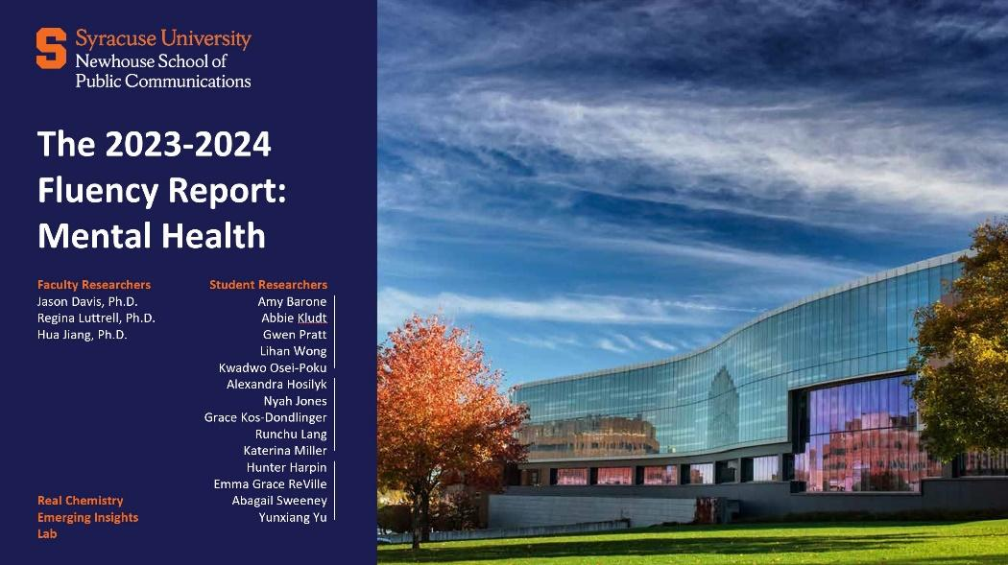

Slide 1: The 2023-2024 Fluency Report: Mental Health

Faculty Researchers
Jason Davis, Ph.D.
Regina Luttrell, Ph.D.
Hua Jiang, Ph.D.

Student Researchers
Amy Barone
Abbie Kludt
Gwen Pratt
Lihan Wong
Kwadwo Osei-Poku
Alexandra Hosilyk
Nyah Jones
Grace Kos-Dondlinger
Runchu Lang
Katerina Miller
Hunter Harpin
Emma Grace ReVille
Abagail Sweeney
Yunxiang Yu

Real Chemistry Emerging Insights Lab

Photo of the S.I. Newhouse School Of Public Communications at Syracuse University.
Slide 2: Table of Contents

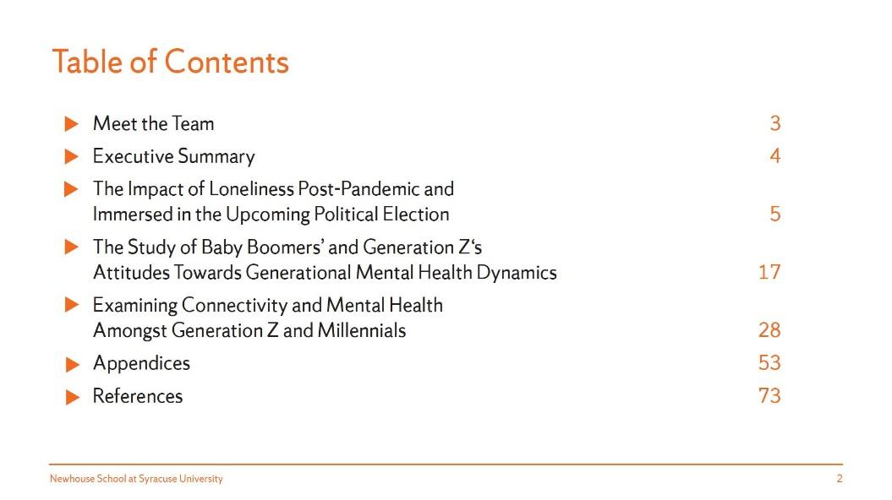

Slide 2: Table of Contents

Meet the Team 3

Executive Summary 4

The Impact of Loneliness Post-Pandemic and Immersed in the Upcoming Political Election 5

The Study of Baby Boomers’ and Generation Z‘s Attitudes Towards Generational Mental
Health Dynamics 17

Examining Connectivity and Mental Health Amongst Generation Z and Millennials 28

Appendices 53

References 73

Slide 3: Meet the Teams

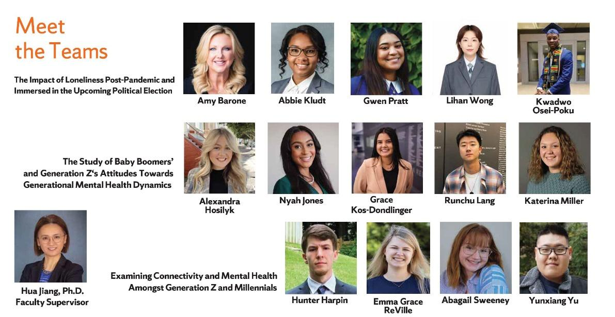

Slide 3: Meet the Teams

The Impact of Loneliness Post-Pandemic and Immersed in the Upcoming Political Election

Amy Barone
Abbie Kludt
Gwen Pratt
Lihan Wong
Kwadwo Osei-Poku

The Study of Baby Boomers’ and Generation Z‘s Attitudes Towards Generational Mental Health Dynamics

Alexandra Hosilyk
Nyah Jones
Grace Kos-Dondlinger
Runchu Lang
Katerina Miller

Examining Connectivity and Mental Health Amongst Generation Z and Millennials

Hunter Harpin
Emma Grace ReVille
Abagail Sweeney
Yunxiang Yu

Hua Jiang, Ph.D.
Faculty Supervisor

Photos of the student researchers from each of the three studies and Hua Jiang.

Slide 4: Executive Summary

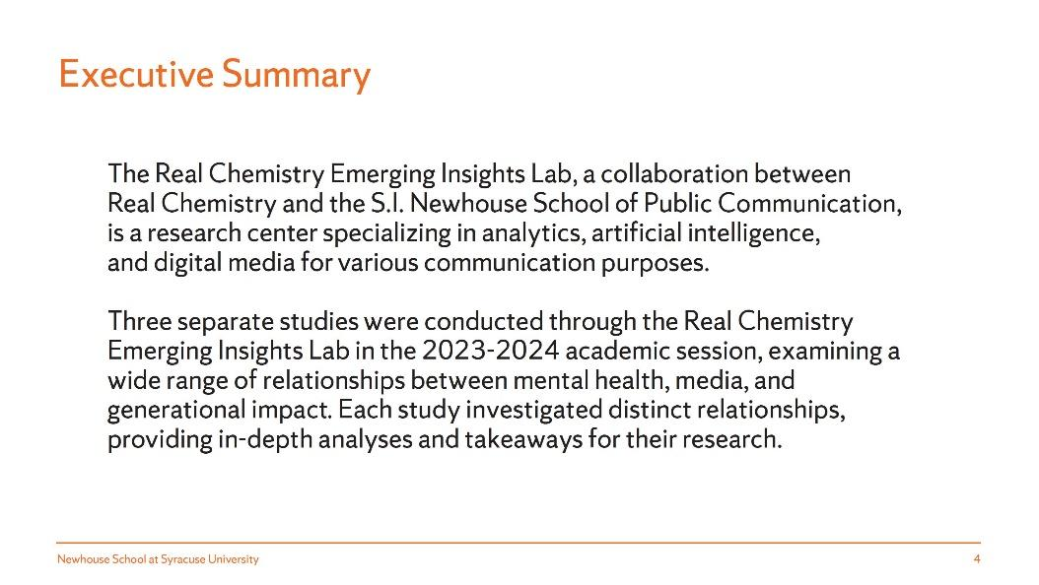

Slide 4: Executive Summary

The Real Chemistry Emerging Insights Lab, a collaboration between Real Chemistry and the S.I. Newhouse School of Public Communication, is a research center specializing in analytics, artificial intelligence, and digital media for various communication purposes.

Three separate studies were conducted through the Real Chemistry Emerging Insights Lab in the 2023-2024 academic session, examining a wide range of relationships between mental health, media, and generational impact. Each study investigated distinct relationships, providing in-depth analyses and takeaways for their research.

Slide 5: The Impact of Loneliness Post-Pandemic and Immersed in the Upcoming Political Election

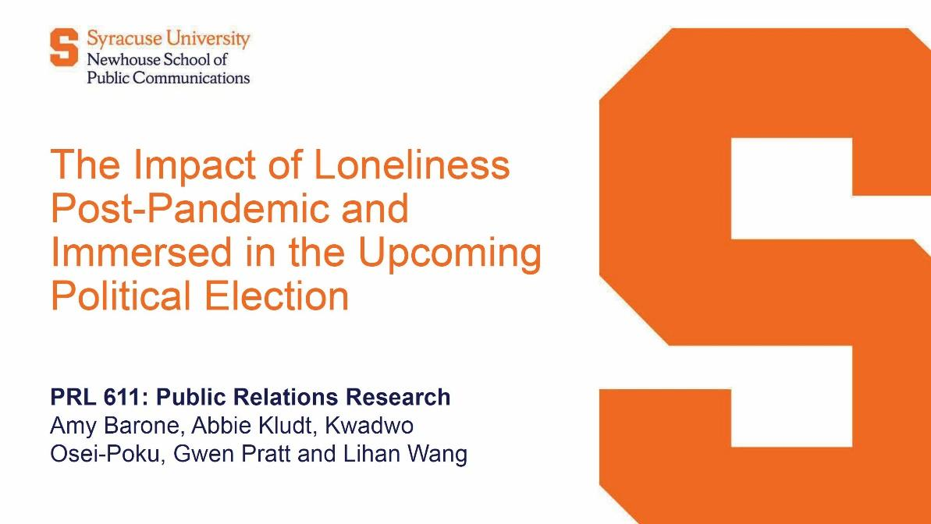

Slide 5: The Impact of Loneliness Post-Pandemic and Immersed in the Upcoming Political Election

PRL 611: Public Relations Research

Amy Barone, Abbie Kludt, Kwadwo Osei-Poku, Gwen Pratt, and Lihan Wong

Slide 6: Executive Summary

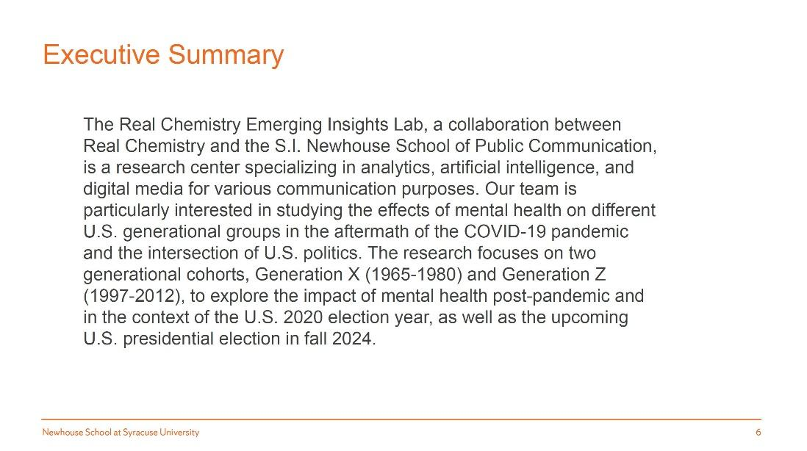

Slide 6: Executive Summary

The Real Chemistry Emerging Insights Lab, a collaboration between Real Chemistry and the S.I. Newhouse School of Public Communication, is a research center specializing in analytics, artificial intelligence, and digital media for various communication purposes. Our team is particularly interested in studying the effects of mental health on different U.S. generational groups in the aftermath of the COVID-19 pandemic and the intersection of U.S. politics. The research focuses on two generational cohorts, Generation X (1965-1980) and Generation Z (1997-2012), to explore the impact of mental health post-pandemic and in the context of the U.S. 2020 election year, as well as the upcoming U.S. presidential election in fall 2024.

Slide 7: Situation Analysis

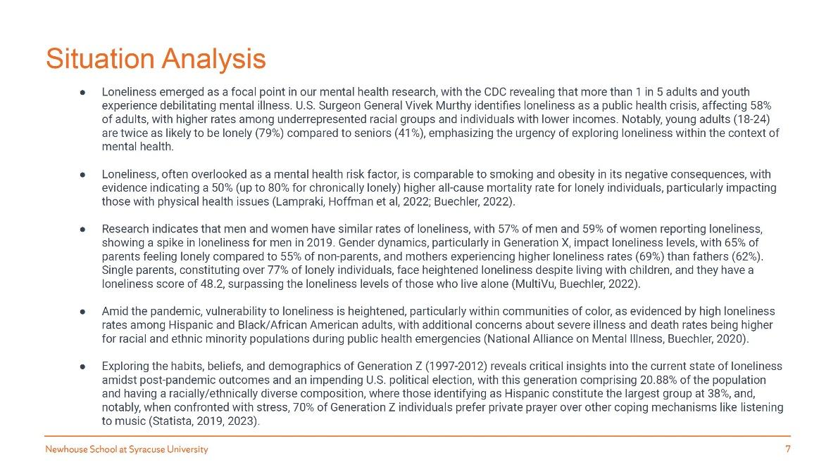

Slide 7: Situation Analysis

Loneliness emerged as a focal point in our mental health research, with the CDC revealing that
more than 1 in 5 adults and youth experience debilitating mental illness. U.S. Surgeon General Vivek Murthy identifies loneliness as a public health crisis, affecting 58% of adults, with higher rates among underrepresented racial groups and individuals with lower incomes. Notably, young adults (18-24) are twice as likely to be lonely (79%) compared to seniors (41%), emphasizing the urgency of exploring loneliness within the context of mental health.

Loneliness, often overlooked as a mental health risk factor, is comparable to smoking and obesity in its negative consequences, with evidence indicating a 50% (up to 80% for chronically lonely) higher all-cause mortality rate for lonely individuals, particularly impacting
those with physical health issues (Lampraki, Hoffman et al, 2022; Buechler, 2022).

Research indicates that men and women have similar rates of loneliness, with 57% of men and 59% of women reporting loneliness, showing a spike in loneliness for men in 2019. Gender dynamics, particularly in Generation X, impact loneliness levels, with 65% of parents feeling lonely compared to 55% of non-parents, and mothers experiencing higher loneliness rates (69%) than fathers (62%). Single parents, constituting over 77% of lonely individuals, face heightened loneliness despite living with children, and they have a loneliness score of 48.2, surpassing the loneliness levels of those who live alone (MultiVu, Buechler, 2022).

Amid the pandemic, vulnerability to loneliness is heightened, particularly within communities of
color, as evidenced by high loneliness rates among Hispanic and Black / African American adults, with additional concerns about severe illness and death rates being higher for racial and ethnic minority populations during public health emergencies (National Alliance on Mental Illness, Buechler, 2020).

Exploring the habits, beliefs, and demographics of Generation Z (1997-2012) reveals critical insights into the current state of loneliness amidst post-pandemic outcomes and an impending U.S. political election, with this generation comprising 20.88% of the population and having a racially / ethnically diverse composition, where those identifying as Hispanic constitute the largest group at 38%, and, notably, when confronted with stress, 70% of Generation Z individuals prefer private prayer over other coping mechanisms like listening to music (Statista, 2019, 2023).

Slide 8: Situation Analysis Continued

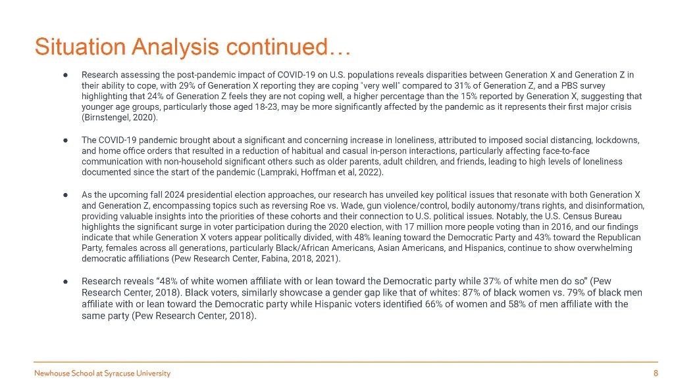

Slide 8: Situation Analysis Continued

Research assessing the post-pandemic impact of COVID-19 on U.S. populations reveals disparities between Generation X and Generation Z in their ability to cope, with 29% of Generation X reporting they are coping "very well" compared to 31% of Generation Z, and a PBS survey highlighting that 24% of Generation Z feels they are not coping well, a higher percentage than the 15% reported by Generation X, suggesting that younger age groups, particularly those aged 18-23, may be more significantly affected by the pandemic as it represents their first major crisis (Birnstengel, 2020).

The COVID-19 pandemic brought about a significant and concerning increase in loneliness, attributed to imposed social distancing, lockdowns, and home office orders that resulted in a reduction of habitual and casual in-person interactions, particularly affecting face-to-face communication with non-household significant others such as older parents, adult children, and friends, leading to high levels of loneliness documented since the start of the pandemic (Lampraki, Hoffman et al, 2022).

As the upcoming fall 2024 presidential election approaches, our research has unveiled key political issues that resonate with both Generation X and Generation Z, encompassing topics such as reversing Roe vs. Wade, gun violence / control, bodily autonomy / trans rights, and disinformation, providing valuable insights into the priorities of these cohorts and their connection to U.S. political issues. Notably, the U.S. Census Bureau highlights the significant surge in voter participation during the 2020 election, with 17 million more people voting than in 2016, and our findings indicate that while Generation X voters appear politically divided, with 48% leaning toward the Democratic Party and 43% toward the Republican Party, females across all generations, particularly Black / African Americans, Asian Americans, and Hispanics, continue to show overwhelming democratic affiliations (Pew Research Center, Fabina, 2018, 2021).

Research reveals "48% of white women affiliate with or lean toward the Democratic party while 37% of white men do so” (Pew Research Center, 2018). Black voters, similarly showcase a gender gap like that of whites: 87% of black women vs. 79% of black men affiliate with or lean toward the Democratic party while Hispanic voters identified 66% of women and 58% of men affiliate with the same party (Pew Research Center, 2018).

Slide 9: Demographic Analysis

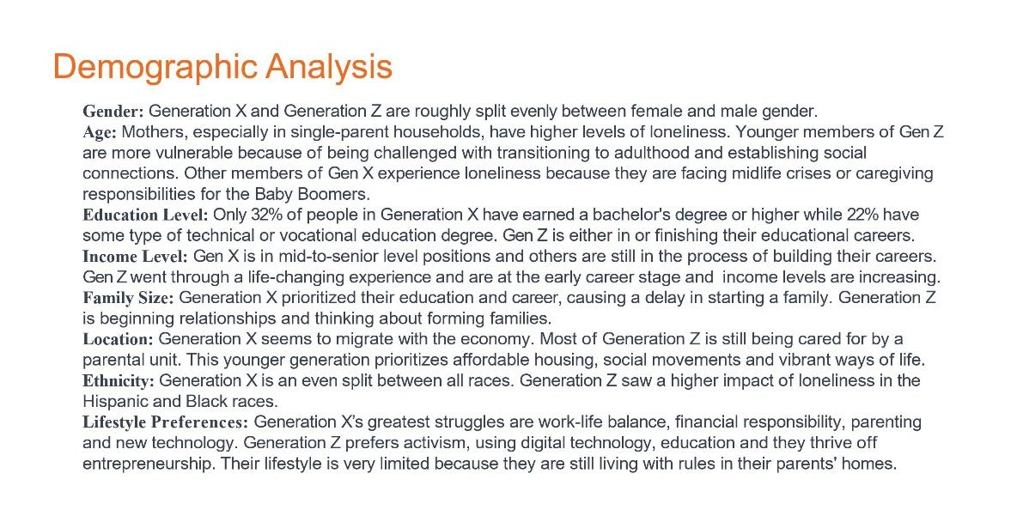

Slide 9: Demographic Analysis

Gender

Generation X and Generation Z are roughly split evenly between female and male gender.

Age

Mothers, especially in single-parent households, have higher levels of loneliness. Younger members of Gen Z are more vulnerable because of being challenged with transitioning to adulthood and establishing social connections. Other members of Gen X experience loneliness because they are facing midlife crises or caregiving responsibilities for the Baby Boomers.

Education Level

Only 32% of people in Generation X have earned a bachelor's degree or higher while 22% have some type of technical or vocational education degree. Gen Z is either in or finishing their educational careers.

Income Level

Gen X is in mid-to-senior level positions and others are still in the process of building their careers. Gen Z went through a life-changing experience and are at the early career stage and income levels are increasing.

Family Size

Generation X prioritized their education and career, causing a delay in starting a family. Generation Z is beginning relationships and thinking about forming families.

Location

Generation X seems to migrate with the economy. Most of Generation Z is still being cared for by a parental unit. This younger generation prioritizes affordable housing, social movements and vibrant ways of life.

Ethnicity

Generation X is an even split between all races. Generation Z saw a higher impact of loneliness in the Hispanic and Black races.

Lifestyle Preferences

Generation X’s greatest struggles are work-life balance, financial responsibility, parenting and new technology. Generation Z prefers activism, using digital technology, education and they thrive off entrepreneurship. Their lifestyle is very limited because they are still living with rules in their parents' homes.

Slide 10: Research Objectives

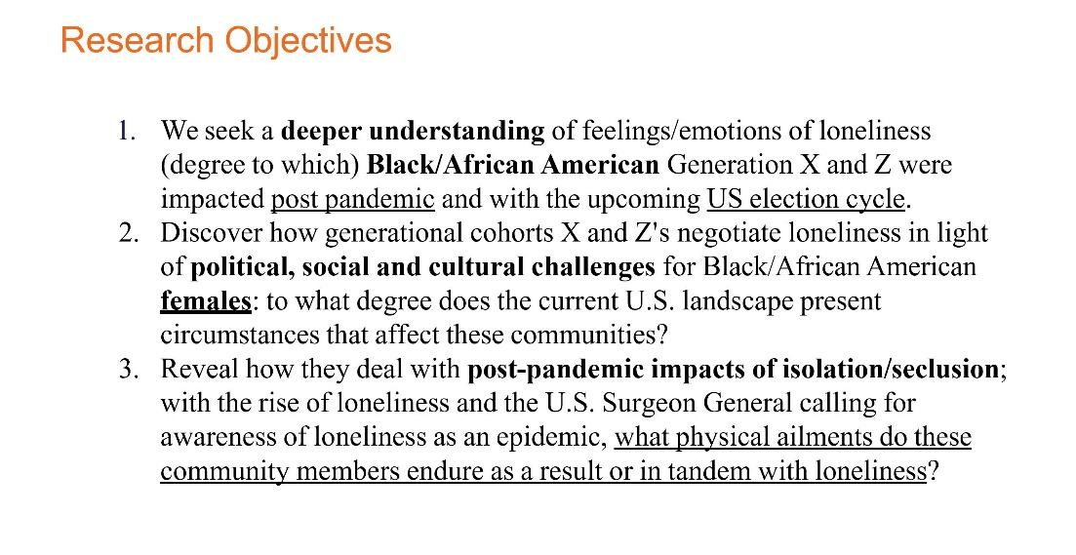

Slide 10: Research Objectives

We seek a deeper understanding of feelings / emotions of loneliness (degree to which) Black / African American Generation X and Z were impacted post pandemic and with the upcoming US election cycle.

Discover how generational cohorts X and Z's negotiate loneliness in light of political, social and cultural challenges for Black / African American females: to what degree does the current U.S. landscape present circumstances that affect these communities?

Reveal how they deal with post-pandemic impacts of isolation / seclusion; with the rise of loneliness and the U.S. Surgeon General calling for awareness of loneliness as an epidemic, what physical ailments do these community members endure as a result or in tandem with loneliness?

Slide 11: Research Methodology

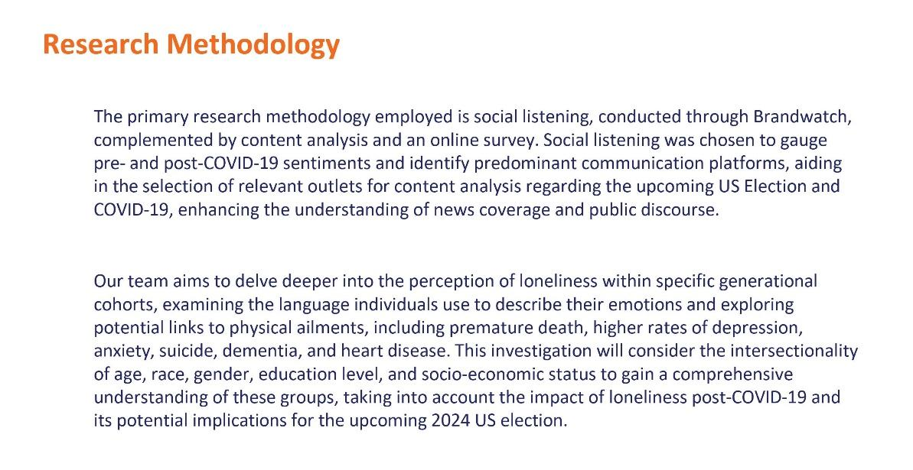

Slide 11: Research Methodology

The primary research methodology employed is social listening, conducted through Brandwatch, complemented by content analysis and an online survey. Social listening was chosen to gauge pre- and post-COVID-19 sentiments and identify predominant communication platforms, aiding in the selection of relevant outlets for content analysis regarding the upcoming US Election and COVID-19, enhancing the understanding of news coverage and public discourse.

Our team aims to delve deeper into the perception of loneliness within specific generational cohorts, examining the language individuals use to describe their emotions and exploring potential links to physical ailments, including premature death, higher rates of depression, anxiety, suicide, dementia, and heart disease. This investigation will consider the intersectionality of age, race, gender, education level, and socio-economic status to gain a comprehensive understanding of these groups, taking into account the impact of loneliness post-COVID-19 and its potential implications for the upcoming 2024 US election.

Slide 12: Research Results

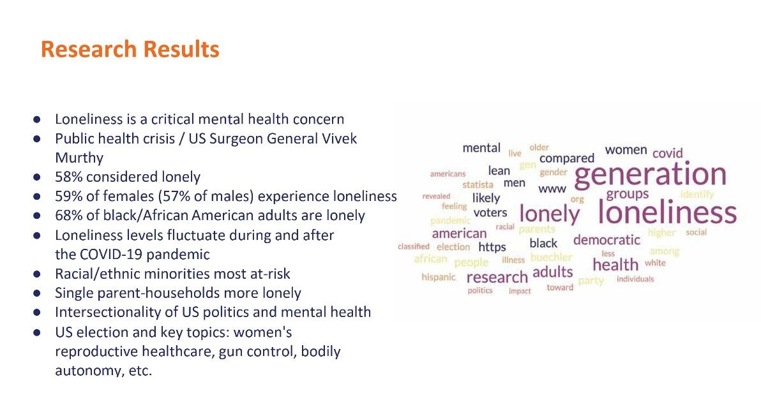

Slide 12: Research Results

Loneliness is a critical mental health concern

Public health crisis / US Surgeon General Vivek Murthy

58% considered lonely

59% of females (57% of males) experience loneliness

68% of black / African American adults are lonely

Loneliness levels fluctuate during and after the COVID-19 pandemic

Racial / ethnic minorities most at-risk

Single parent-households more lonely

Intersectionality of US politics and mental health

US election and key topics: women's reproductive healthcare, gun control, bodily autonomy, etc.

Word cloud visualization of most widely-found keywords in regard to loneliness research.

Slide 13: Research Analysis

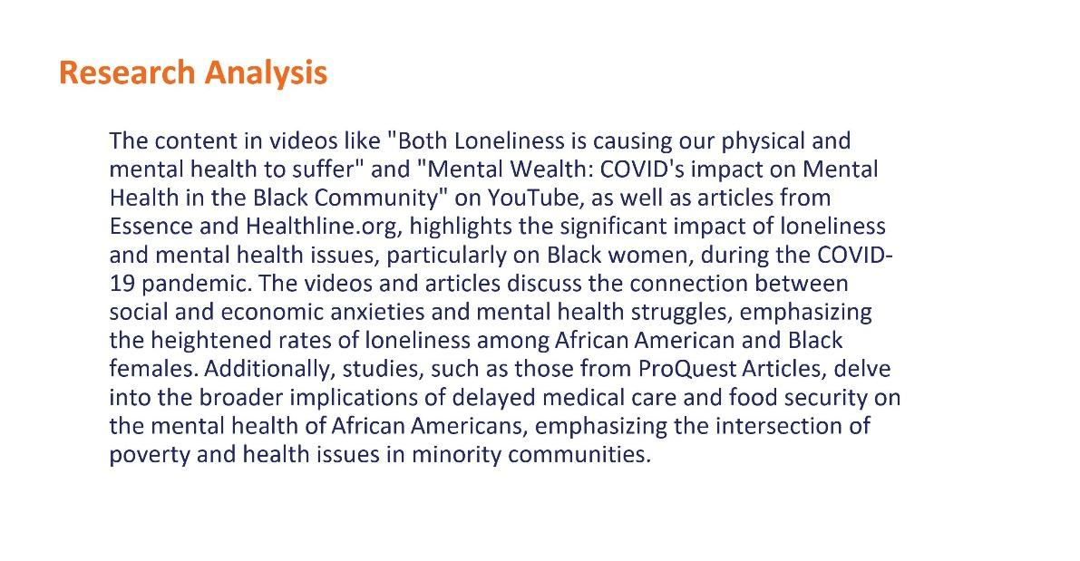

Slide 13: Research Analysis

The content in videos like "Both Loneliness is causing our physical and mental health to suffer" and "Mental Wealth: COVID's impact on Mental Health in the Black Community" on YouTube, as well as articles from Essence and Healthline.org, highlights the significant impact of loneliness and mental health issues, particularly on Black women, during the COVID-19 pandemic. The videos and articles discuss the connection between social and economic anxieties and mental health struggles, emphasizing the heightened rates of loneliness among African American and Black females. Additionally, studies, such as those from ProQuest Articles, delve into the broader implications of delayed medical care and food security on the mental health of African Americans, emphasizing the intersection of poverty and health issues in minority communities.

Slide 14: Social Listening and Content Analysis

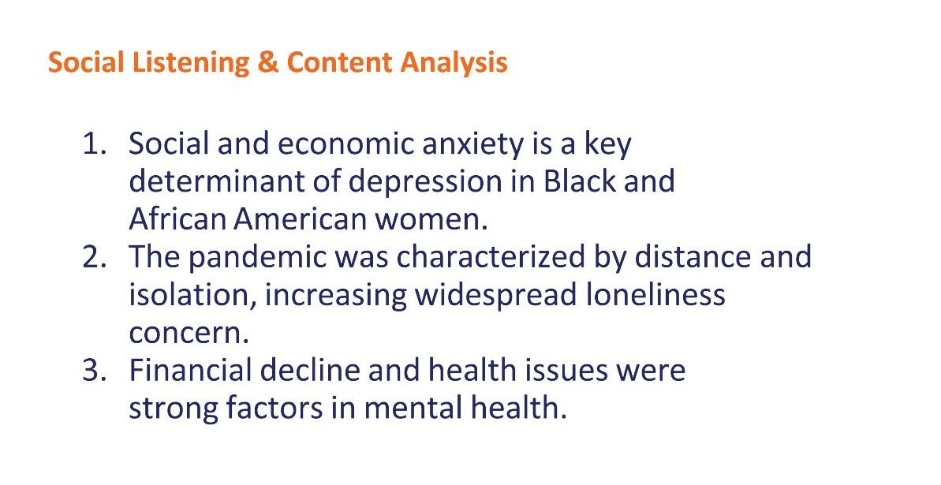

Slide 14: Social Listening and Content Analysis

Social and economic anxiety is a key determinant of depression in Black and African American
women.

The pandemic was characterized by distance and isolation, increasing widespread loneliness
concern.

Financial decline and health issues were strong factors in mental health.

Slide 15: Recommendations



Slide 15: Recommendations

Photo of students at graduation ceremony.

Slide 16: Recommendations

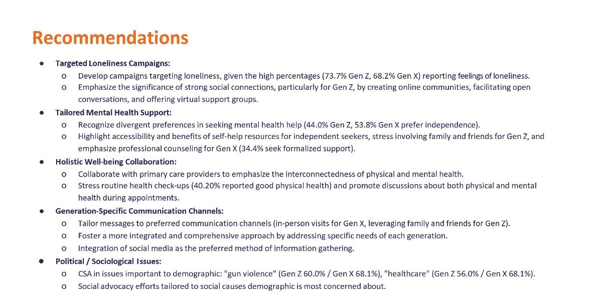

Slide 16: Recommendations

Targeted Loneliness Campaigns:

Develop campaigns targeting loneliness, given the high percentages (73.7% Gen Z, 68.2% Gen X) reporting feelings of loneliness.

Emphasize the significance of strong social connections, particularly for Gen Z, by
creating online communities, facilitating open conversations, and offering virtual support groups.

Tailored Mental Health Support:

Recognize divergent preferences in seeking mental health help (44.0% Gen Z,
53.8% Gen X prefer independence).

Highlight accessibility and benefits of self-help resources for independent seekers,
stress involving family and friends for Gen Z, and emphasize professional counseling for
Gen X (34.4% seek formalized support).

Holistic Well-being Collaboration:

Collaborate with primary care providers to emphasize the interconnectedness of physical and mental health.

Stress routine health check-ups (40.20% reported good physical health) and promote
discussions about both physical and mental health during appointments.

Generation-Specific Communication Channels:

Tailor messages to preferred communication channels (in-person visits for Gen X,
leveraging family and friends for Gen Z).

Foster a more integrated and comprehensive approach by addressing specific needs of
each generation.

Integration of social media as the preferred method of information gathering.

Political / Sociological Issues:

CSA in issues important to demographic: "gun violence" (Gen Z 60.0% / Gen X 68.1%), "healthcare" (Gen Z 56.0% / Gen X 68.1%).

Social advocacy efforts tailored to social causes demographic is most concerned about.

Slide 17: The Study of Baby Boomers' and Generation Z's Attitudes Towards Generational Mental Health Dynamics

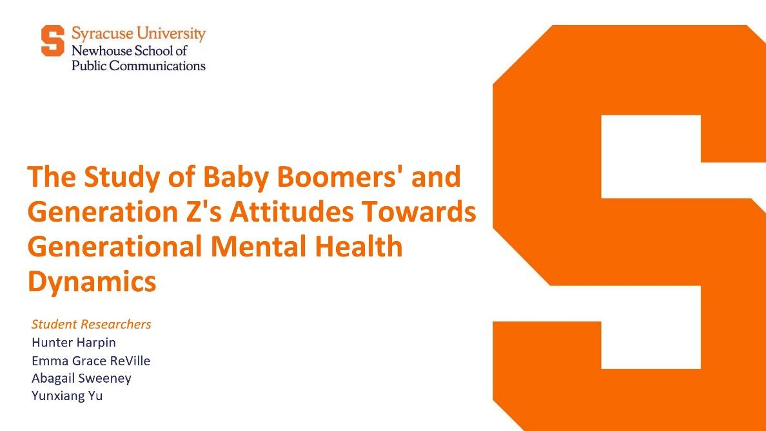

Slide 17: The Study of Baby Boomers' and Generation Z's Attitudes Towards Generational Mental Health
Dynamics

Student Researchers

Hunter Harpin
Emma Grace ReVille
Abagail Sweeney
Yunxiang Yu

Slide 18: Research Focus

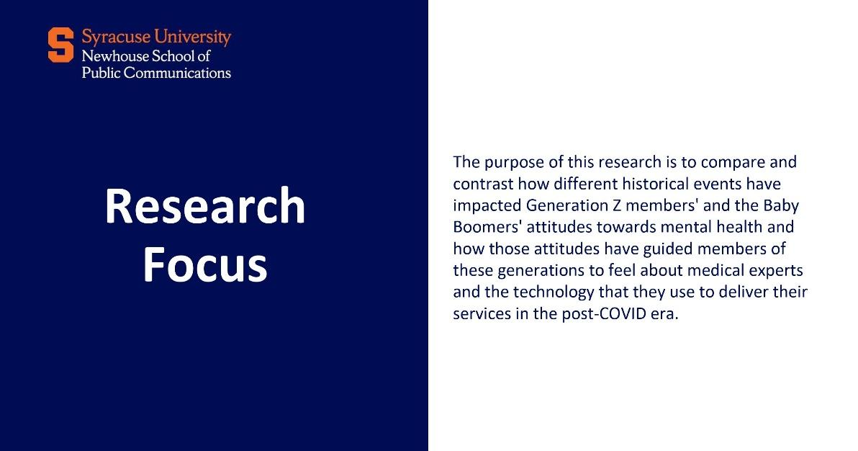

Slide 18: Research Focus

The purpose of this research is to compare and contrast how different historical events have impacted Generation Z members' and the Baby Boomers' attitudes towards mental health and how those attitudes have guided members of these generations to feel about medical experts and the technology that they use to deliver their services in the post-COVID era.

Slide 19: Methodology

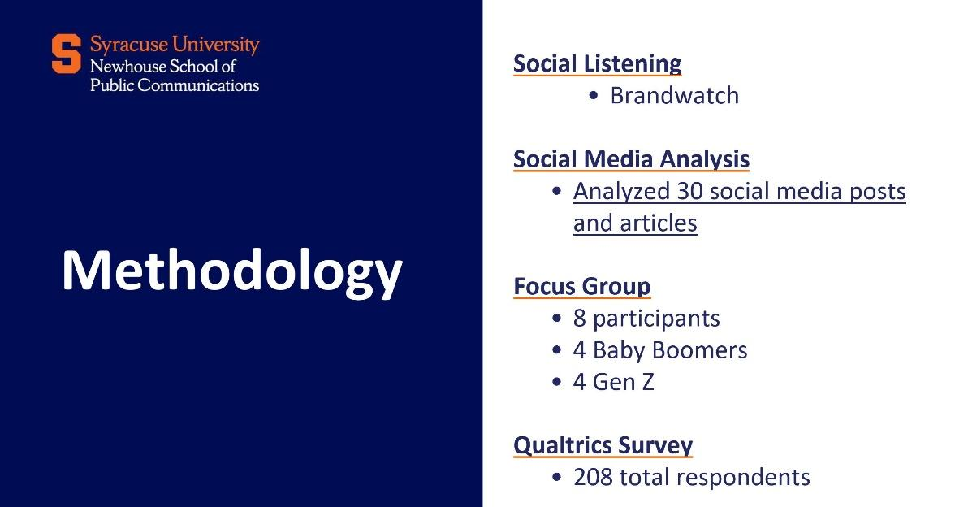

Slide 19: Methodology

Social Listening
Brandwatch

Social Media Analysis
Analyzed 30 social media posts and articles

Focus Group
8 participants
4 Baby Boomers
4 Gen Z

Qualtrics Survey
208 total respondents

Slide 20: Demographics

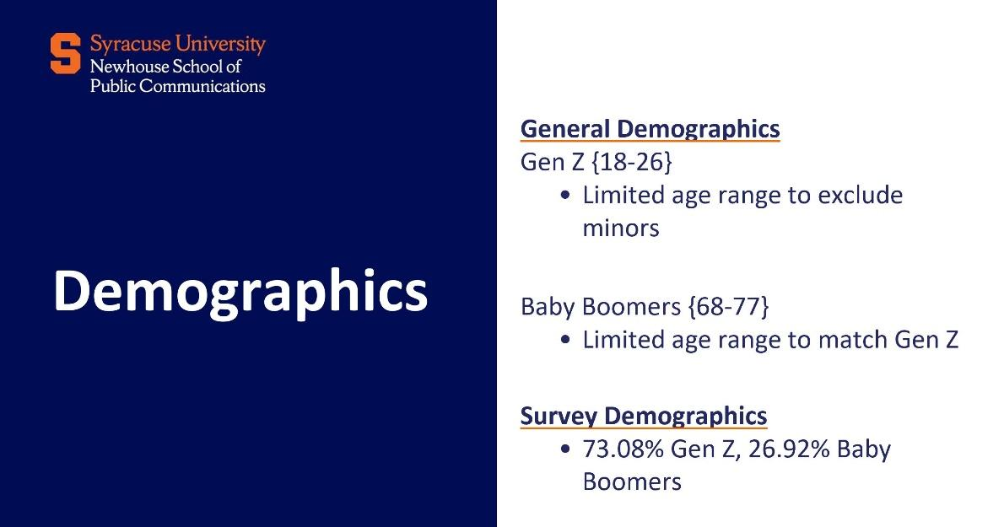

Slide 20: Demographics

General Demographics

Gen Z (18-26)
Limited age range to exclude minors

Baby Boomers (68-77)
Limited age range to match Gen Z

Survey Demographics

73.08% Gen Z
26.92% Baby Boomers

Slide 21: Key Findings - Impact of Historical Events

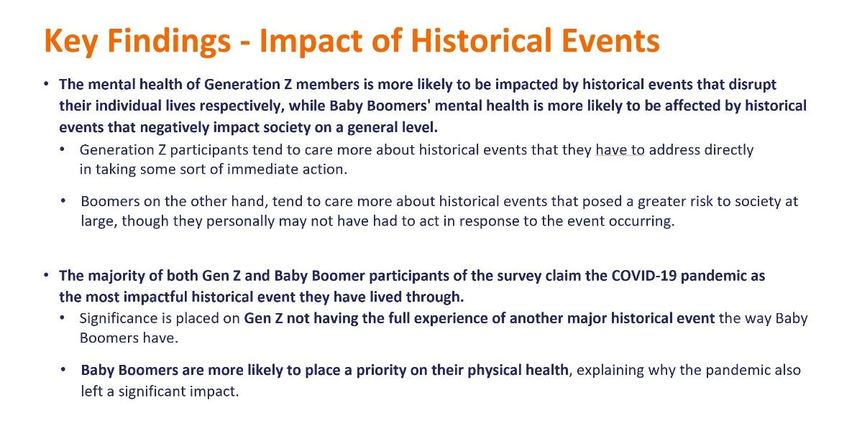

Slide 21: Key Findings - Impact of Historical Events

The mental health of Generation Z members is more likely to be impacted by historical events that disrupt their individual lives respectively, while Baby Boomers' mental health is more likely to be affected by historical events that negatively impact society on a general level.

Generation Z participants tend to care more about historical events that they have to address directly in taking some sort of immediate action.

Boomers on the other hand, tend to care more about historical events that posed a greater risk to society at large, though they personally may not have had to act in response to the event occurring.

The majority of both Gen Z and Baby Boomer participants of the survey claim the COVID-19 pandemic as the most impactful historical event they have lived through.

Significance is placed on Gen Z not having the full experience of another major historical event the way Baby Boomers have.

Baby Boomers are more likely to place a priority on their physical health, explaining why the pandemic also left a significant impact.

Slide 22: Key Findings - Perception of Medical Expertise

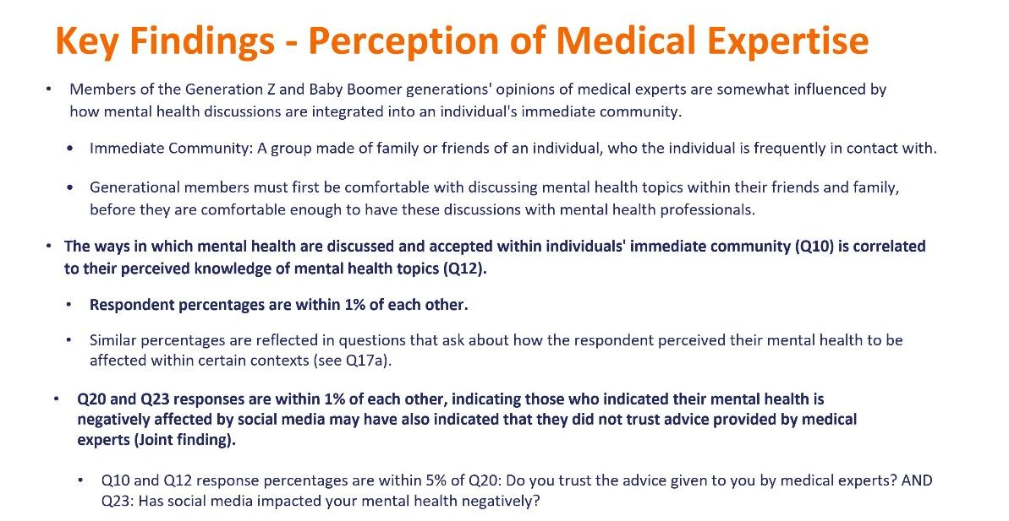

Slide 22: Key Findings - Perception of Medical Expertise

Members of the Generation Z and Baby Boomer generations' opinions of medical experts are somewhat influenced by how mental health discussions are integrated into an individual's immediate community.

Immediate Community: A group made of family or friends of an individual, who the individual is frequently in contact with.

Generational members must first be comfortable with discussing mental health topics within their friends and family, before they are comfortable enough to have these discussions with mental health professionals.

The ways in which mental health are discussed and accepted within individuals' immediate community (Q10) is correlated to their perceived knowledge of mental health topics (Q12}.

Respondent percentages are within 1% of each other.

Similar percentages are reflected in questions that ask about how the respondent perceived their mental health to be affected within certain contexts (see Q17a}.

Q20 and Q23 responses are within 1% of each other, indicating those who indicated their mental health is negatively affected by social media may have also indicated that they did not trust advice provided by medical experts (Joint finding}.

Q10 and Q12 response percentages are within 5% of Q20: Do you trust the advice given to you by medical experts? AND Q23: Has social media impacted your mental health negatively?

Slide 23: Key Findings - Technology in the Post COVID-19 Era

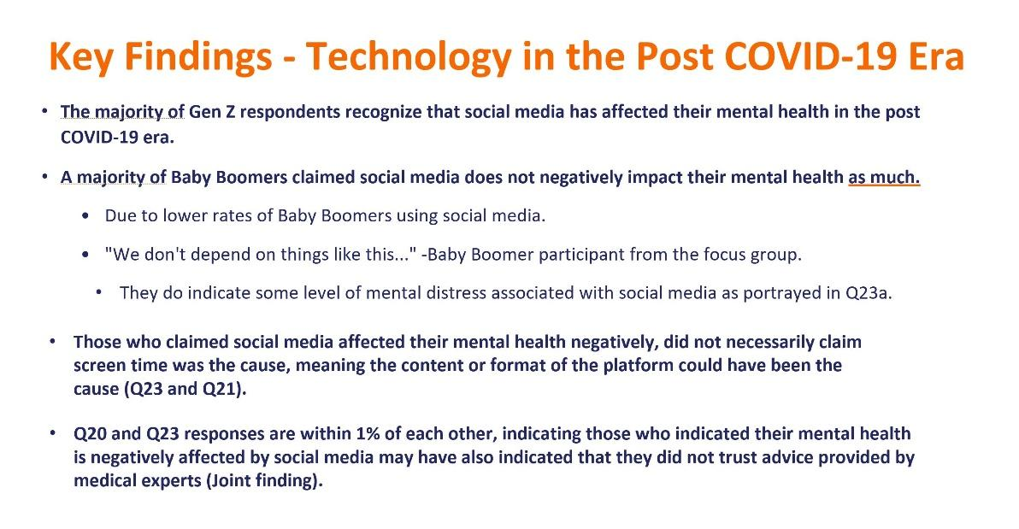

Slide 23: Key Findings - Technology in the Post COVID-19 Era

The majority of Gen Z respondents recognize that social media has affected their mental health in the post COVID-19 era.

A majority of Baby Boomers claimed social media does not negatively impact their mental health as much.

Due to lower rates of Baby Boomers using social media.

"We don't depend on things like this..." -Baby Boomer participant from the focus group.

They do indicate some level of mental distress associated with social media as portrayed in Q23a.

Those who claimed social media affected their mental health negatively, did not necessarily claim screen time was the cause, meaning the content or format of the platform could have been the cause (Q23 and Q21).

Q20 and Q23 responses are within 1% of each other, indicating those who indicated their mental health is negatively affected by social media may have also indicated that they did not trust advice provided by medical experts (Joint finding).

Slide 24: Recommendations

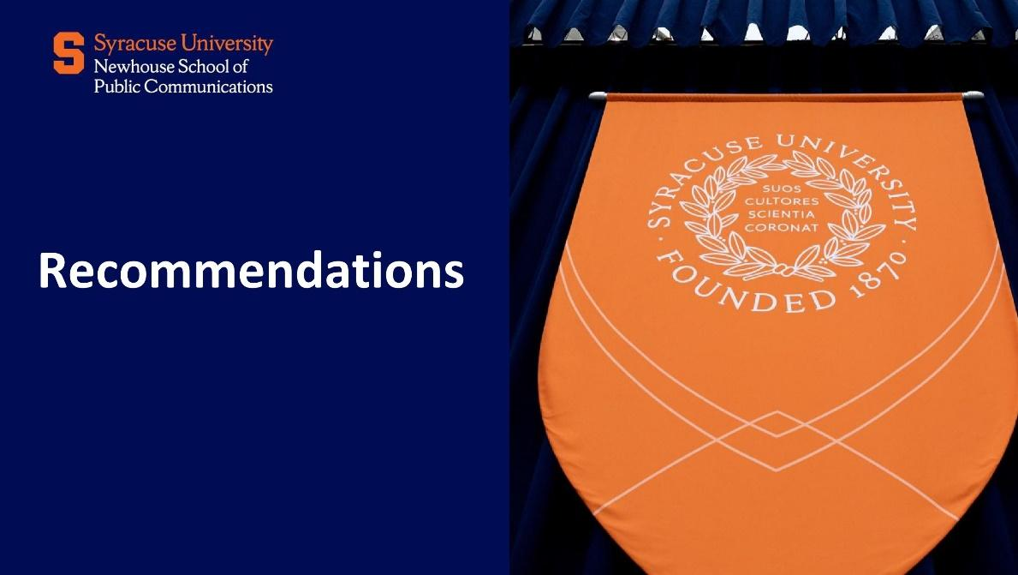

Slide 24: Recommendations

Photo of a Syracuse University banner.
Slide 25: General Recommendations

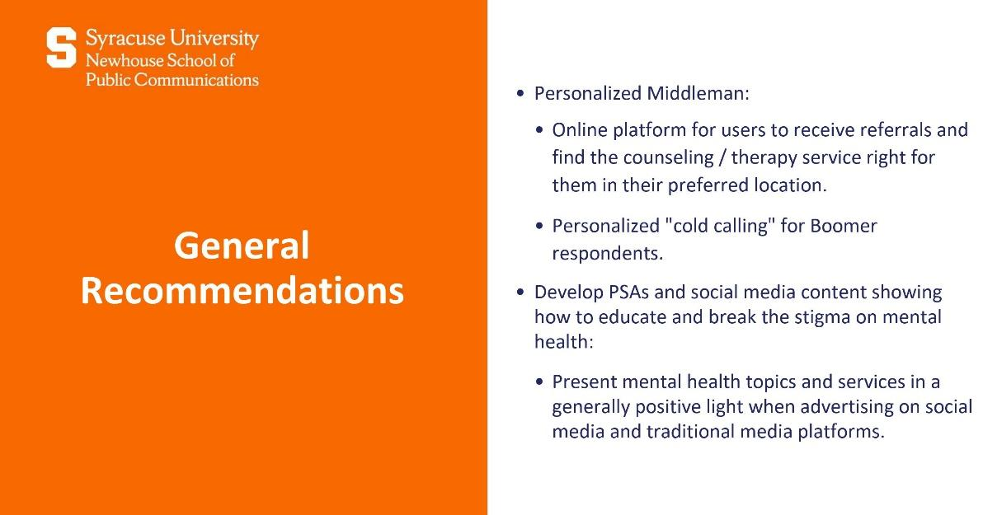

Slide 25: General Recommendations

Personalized Middleman:

Online platform for users to receive referrals and find the counseling / therapy service right for them in their preferred location.

Personalized "cold calling" for Boomer respondents.

Develop PSAs and social media content showing how to educate and break the stigma on mental health.

Present mental health topics and services in a generally positive light when advertising on social media and traditional media platforms.

Slide 26: Recommendations for Baby Boomers

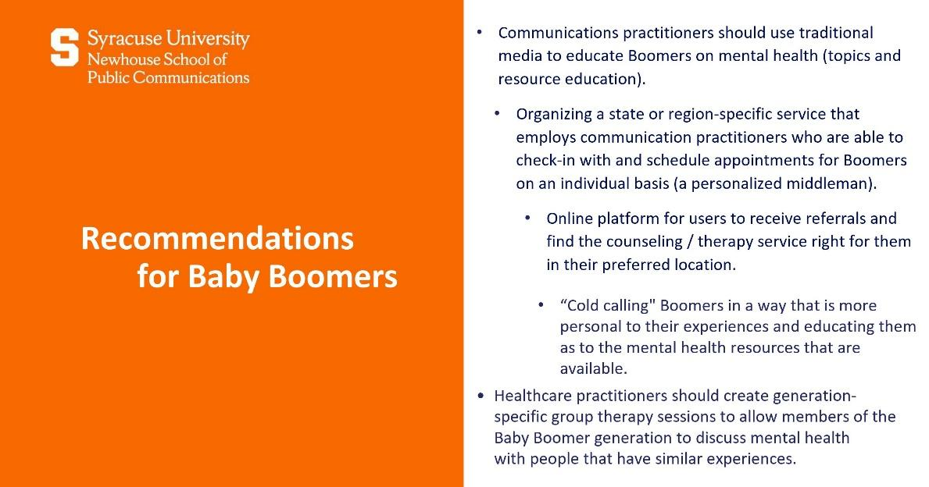

Slide 26: Recommendations for Baby Boomers

Communications practitioners should use traditional media to educate Boomers on mental health (topics and resource education).

Organizing a state or region-specific service that employs communication practitioners who are able to check-in with and schedule appointments for Boomers on an individual basis (a personalized middleman).

Online platform for users to receive referrals and find the counseling / therapy service right for them in their preferred location.

“Cold calling" Boomers in a way that is more personal to their experiences and educating them as to the mental health resources that are available.

Healthcare practitioners should create generation-specific group therapy sessions to allow members of the Baby Boomer generation to discuss mental health with people that have similar experiences.
Slide 27: Recommendations for Generation Z

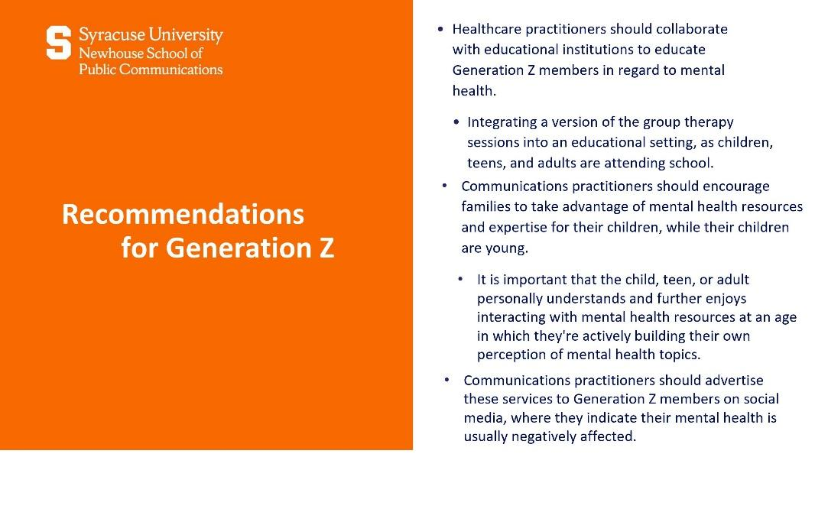

Slide 27: Recommendations for Generation Z

Healthcare practitioners should collaborate with educational institutions to educate Generation Z members in regard to mental health.

Integrating a version of the group therapy sessions into an educational setting, as children, teens, and adults are attending school.

Communications practitioners should encourage families to take advantage of mental health resources and expertise for their children, while their children are young.

It is important that the child, teen, or adult personally understands and further enjoys interacting with mental health resources at an age in which they're actively building their own perception of mental health topics.

Communications practitioners should advertise these services to Generation Z members on social media, where they indicate their mental health is usually negatively affected.

Slide 28: Examining Connectivity and Mental Health Amongst Generation Z and Millennials

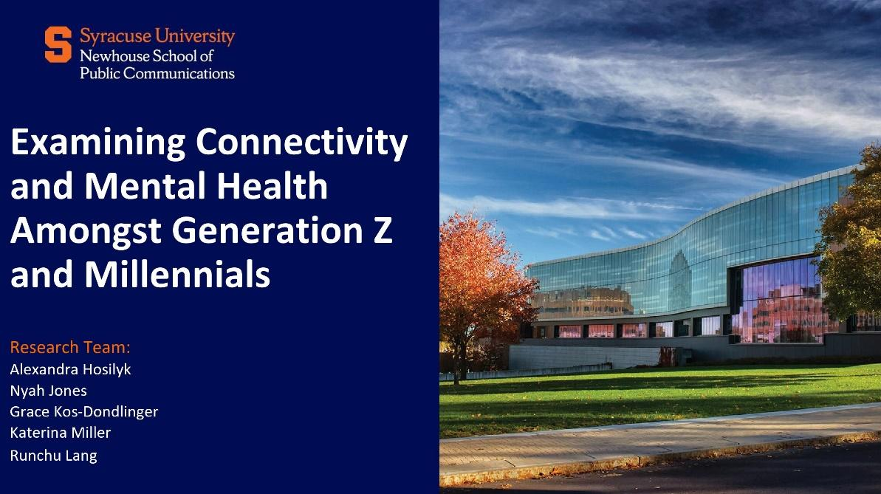

Slide 28: Examining Connectivity and Mental Health Amongst Generation Z and Millennials

Research Team

Alexandra Hosilyk
Nyah Jones
Grace Kos-Dondlinger
Katerina Miller
Runchu Lang

Photo of the S.I. Newhouse School Of Public Communications at Syracuse University.

Slide 29: Examining the Situation: Connectivity

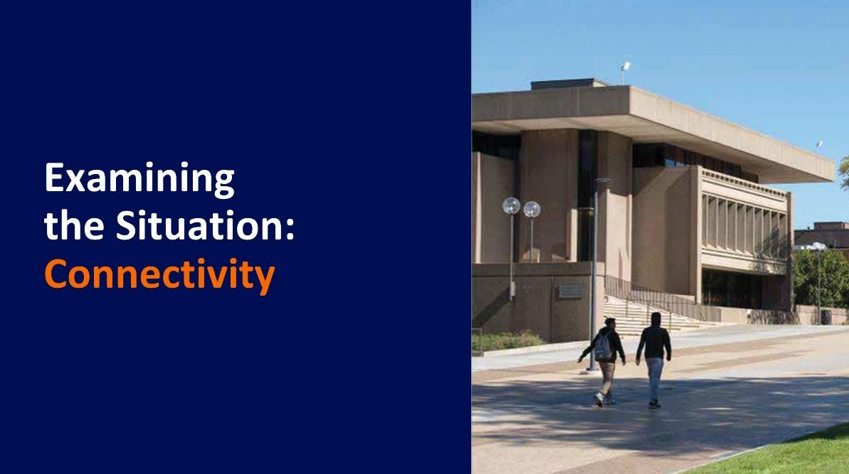

Slide 29: Examining the Situation: Connectivity

Photo of two people walking by the S.I. Newhouse School Of Public Communications at Syracuse University.

Slide 30: Secondary Research

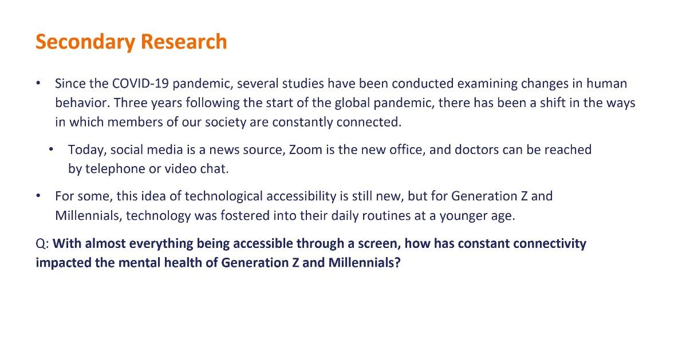

Slide 30: Secondary Research

Since the COVID-19 pandemic, several studies have been conducted examining changes in human behavior. Three years following the start of the global pandemic, there has been a shift in the ways in which members of our society are constantly connected.

Today, social media is a news source, Zoom is the new office, and doctors can be reached by telephone or video chat.

For some, this idea of technological accessibility is still new, but for Generation Z and Millennials, technology was fostered into their daily routines at a younger age.

Q: With almost everything being accessible through a screen, how has constant connectivity impacted the mental health of Generation Z and Millennials?

Slide 31: Secondary Research: Defining Connectivity

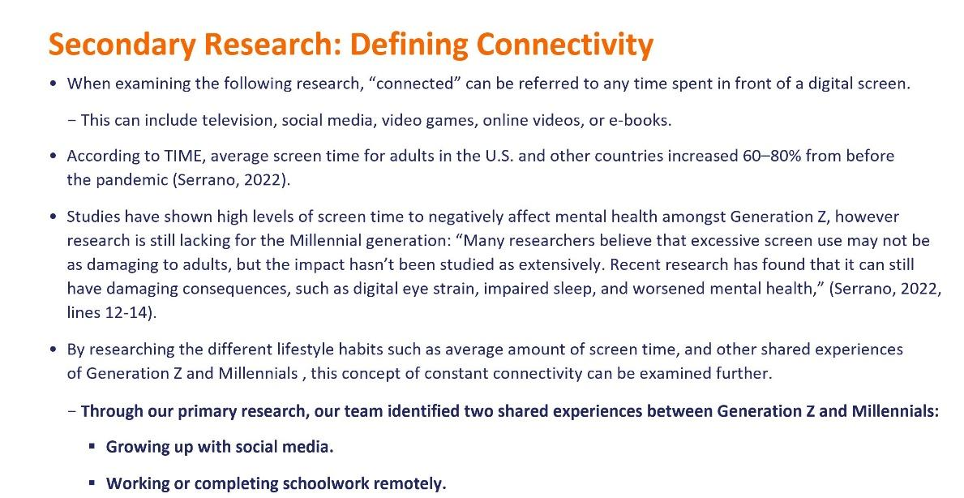

Slide 31: Secondary Research: Defining Connectivity

When examining the following research, “connected” can be referred to any time spent in front of a digital screen.

This can include television, social media, video games, online videos, or e-books.

According to TIME, average screen time for adults in the U.S. and other countries increased 60–80% from before the pandemic (Serrano, 2022).

Studies have shown high levels of screen time to negatively affect mental health amongst Generation Z, however research is still lacking for the Millennial generation: “Many researchers believe that excessive screen use may not be as damaging to adults, but the impact hasn’t been studied as extensively. Recent research has found that it can still have damaging consequences, such as digital eye strain, impaired sleep, and worsened mental health,” (Serrano, 2022, lines 12-14).

By researching the different lifestyle habits such as average amount of screen time, and other shared experiences of Generation Z and Millennials , this concept of constant connectivity can be examined further.

Through our primary research, our team identified two shared experiences between Generation Z and Millennials:

Growing up with social media.

Working or completing schoolwork remotely.

Slide 32: Secondary Research: Shared Experiences

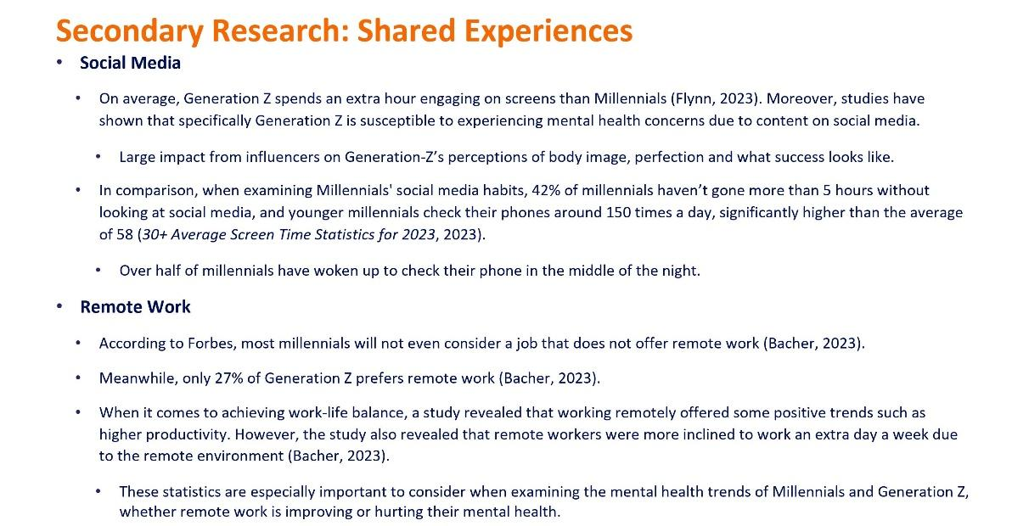

Slide 32: Secondary Research: Shared Experiences

Social Media

On average, Generation Z spends an extra hour engaging on screens than Millennials (Flynn, 2023). Moreover, studies have shown that specifically Generation Z is susceptible to experiencing mental health concerns due to content on social media.

Large impact from influencers on Generation-Z’s perceptions of body image, perfection and what success looks like.

In comparison, when examining Millennials' social media habits, 42% of millennials haven’t gone more than 5 hours without looking at social media, and younger millennials check their phones around 150 times a day, significantly higher than the average of 58 (30+ Average Screen Time Statistics for 2023, 2023).

Over half of millennials have woken up to check their phone in the middle of the night.

Remote Work

According to Forbes, most millennials will not even consider a job that does not offer remote work (Bacher, 2023).

Meanwhile, only 27% of Generation Z prefers remote work (Bacher, 2023).

When it comes to achieving work-life balance, a study revealed that working remotely offered some positive trends such as higher productivity. However, the study also revealed that remote workers were more inclined to work an extra day a week due to the remote environment (Bacher, 2023).

These statistics are especially important to consider when examining the mental health trends of Millennials and Generation Z, whether remote work is improving or hurting their mental health.

Slide 33: Secondary Research: Examining Mental Health Amongst Generation Z

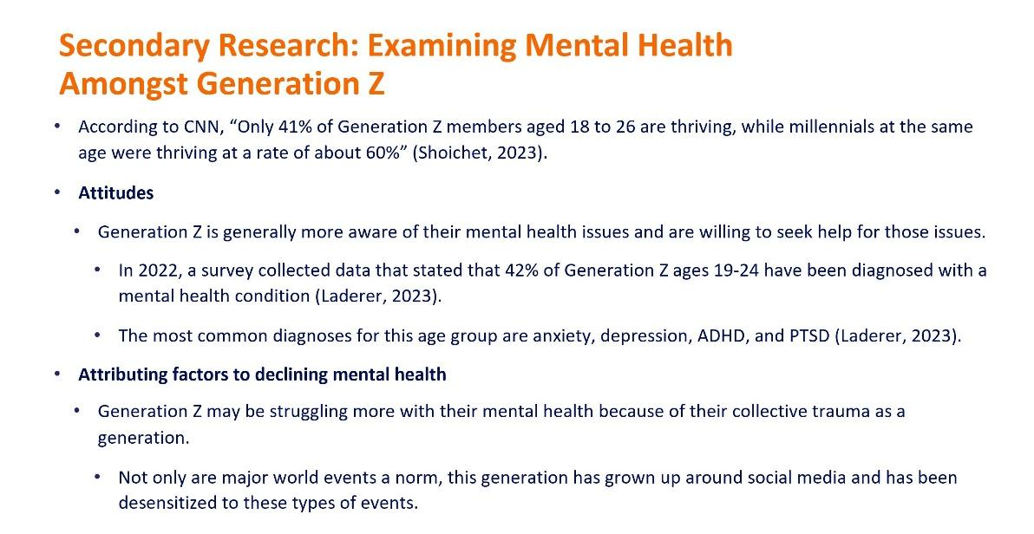

Slide 33: Secondary Research: Examining Mental Health Amongst Generation Z

According to CNN, “Only 41% of Generation Z members aged 18 to 26 are thriving, while millennials at the same age were thriving at a rate of about 60%” (Shoichet, 2023).

Attitudes

Generation Z is generally more aware of their mental health issues and are willing to seek help for those issues.

In 2022, a survey collected data that stated that 42% of Generation Z ages 19-24 have been diagnosed with a mental health condition (Laderer, 2023).

The most common diagnoses for this age group are anxiety, depression, ADHD, and PTSD (Laderer, 2023).

Attributing factors to declining mental health

Generation Z may be struggling more with their mental health because of their collective trauma as a generation.

Not only are major world events a norm, this generation has grown up around social media and has been desensitized to these types of events.

Slide 34: Secondary Research: Examining Mental Health Amongst Millennials

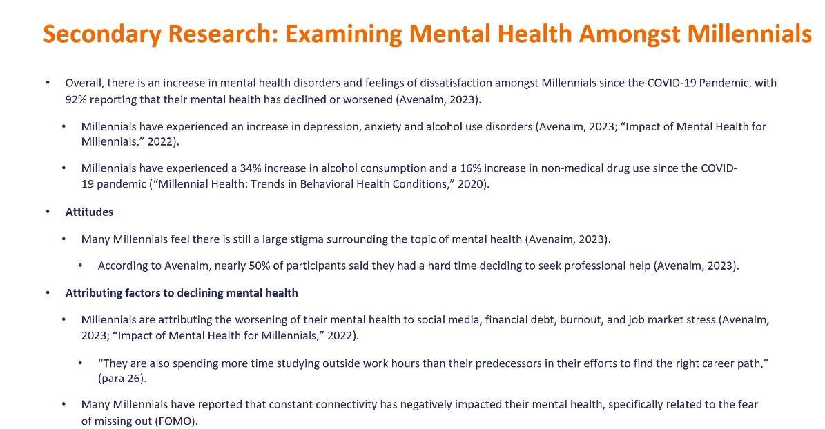

Slide 34: Secondary Research: Examining Mental Health Amongst Millennials

Overall, there is an increase in mental health disorders and feelings of dissatisfaction amongst Millennials since the COVID-19 Pandemic, with 92% reporting that their mental health has declined or worsened (Avenaim, 2023).

Millennials have experienced an increase in depression, anxiety and alcohol use disorders (Avenaim, 2023; “Impact of Mental Health for Millennials,” 2022).

Millennials have experienced a 34% increase in alcohol consumption and a 16% increase in non-medical drug use since the COVID-19 pandemic (“Millennial Health: Trends in Behavioral Health Conditions,” 2020).

Attitudes

Many Millennials feel there is still a large stigma surrounding the topic of mental health (Avenaim, 2023).

According to Avenaim, nearly 50% of participants said they had a hard time deciding to seek professional help (Avenaim, 2023).

Attributing factors to declining mental health

Millennials are attributing the worsening of their mental health to social media, financial debt, burnout, and job market stress (Avenaim, 2023; “Impact of Mental Health for Millennials,” 2022).

“They are also spending more time studying outside work hours than their predecessors in their efforts to find the right career path,” (para 26).

Many Millennials have reported that constant connectivity has negatively impacted their mental health, specifically related to the fear of missing out (FOMO).
Slide 35: Secondary Research: Impact of COVID-19 and the United States Political Cycle

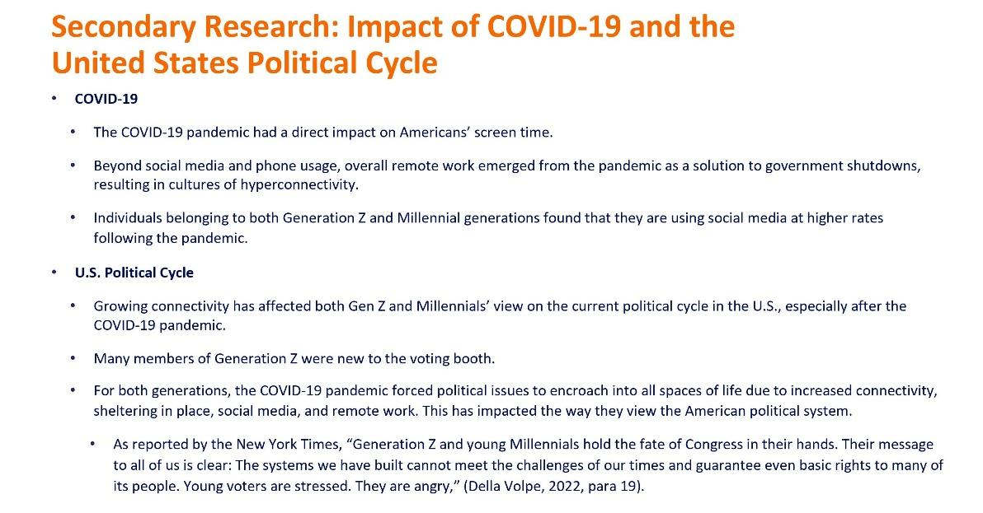

Slide 35: Secondary Research: Impact of COVID-19 and the United States Political Cycle

COVID-19

The COVID-19 pandemic had a direct impact on Americans’ screen time.

Beyond social media and phone usage, overall remote work emerged from the pandemic as a solution to government shutdowns, resulting in cultures of hyperconnectivity.

Individuals belonging to both Generation Z and Millennial generations found that they are using social media at higher rates following the pandemic.

U.S. Political Cycle

Growing connectivity has affected both Gen Z and Millennials’ view on the current political cycle in the U.S., especially after the COVID-19 pandemic.

Many members of Generation Z were new to the voting booth.

For both generations, the COVID-19 pandemic forced political issues to encroach into all spaces of life due to increased connectivity, sheltering in place, social media, and remote work. This has impacted the way they view the American political system.

As reported by the New York Times, “Generation Z and young Millennials hold the fate of Congress in their hands. Their message to all of us is clear: The systems we have built cannot meet the challenges of our times and guarantee even basic rights to many of its people. Young voters are stressed. They are angry,” (Della Volpe, 2022, para 19).

Slide 36: Research Objectives



Slide 36: Research Objectives

Photo of two people walking by the S.I. Newhouse School Of Public Communications at Syracuse University.

Slide 37: Research Objectives

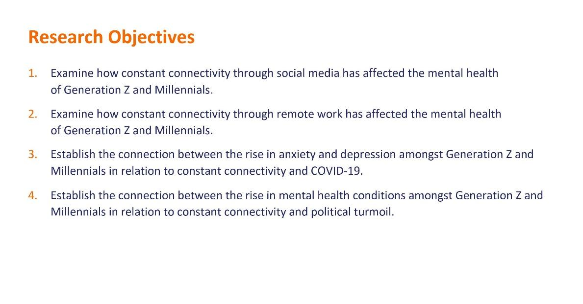

Slide 37: Research Objectives

Examine how constant connectivity through social media has affected the mental health of Generation Z and Millennials.

Examine how constant connectivity through remote work has affected the mental health of Generation Z and Millennials.

Establish the connection between the rise in anxiety and depression amongst Generation Z and Millennials in relation to constant connectivity and COVID-19.

Establish the connection between the rise in mental health conditions amongst Generation Z and Millennials in relation to constant connectivity and political turmoil.

Slide 38: Research Methodology



Slide 38: Research Methodology

Photo of two people walking by the S.I. Newhouse School Of Public Communications at Syracuse University.

Slide 39: Research Methodology

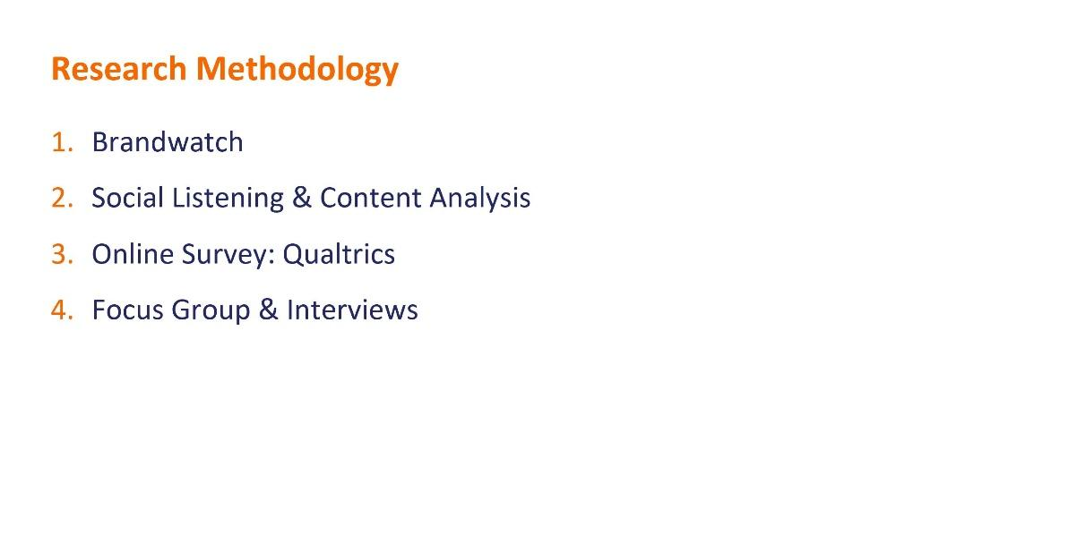

Slide 39: Research Methodology

Brandwatch

Social Listening and Content Analysis

Online Survey: Qualtrics

Focus Group and Interviews

Slide 40: Research Methodology: Brandwatch

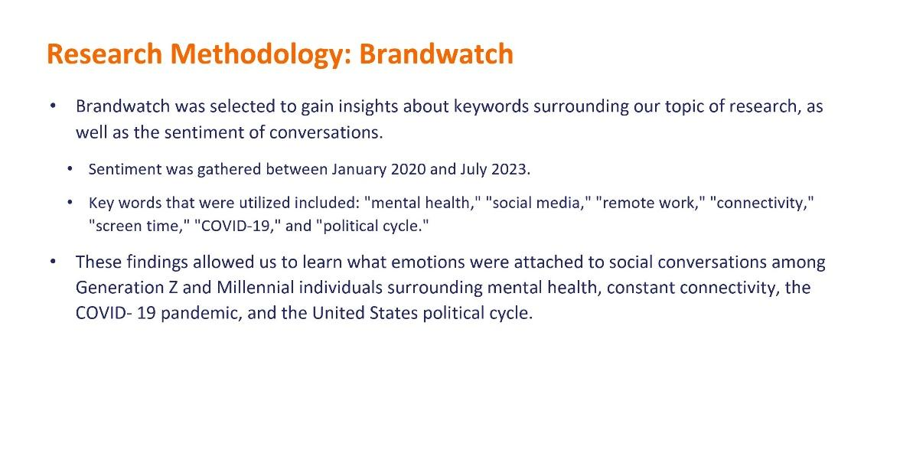

Slide 40: Research Methodology: Brandwatch

Brandwatch was selected to gain insights about keywords surrounding our topic of research, as well as the sentiment of conversations.

Sentiment was gathered between January 2020 and July 2023.

Key words that were utilized included: "mental health," "social media," "remote work," "connectivity," "screen time," "COVID-19," and "political cycle."

These findings allowed us to learn what emotions were attached to social conversations among Generation Z and Millennial individuals surrounding mental health, constant connectivity, the COVID- 19 pandemic, and the United States political cycle.

Slide 41: Research Methodology: Social Listening and Content Analysis

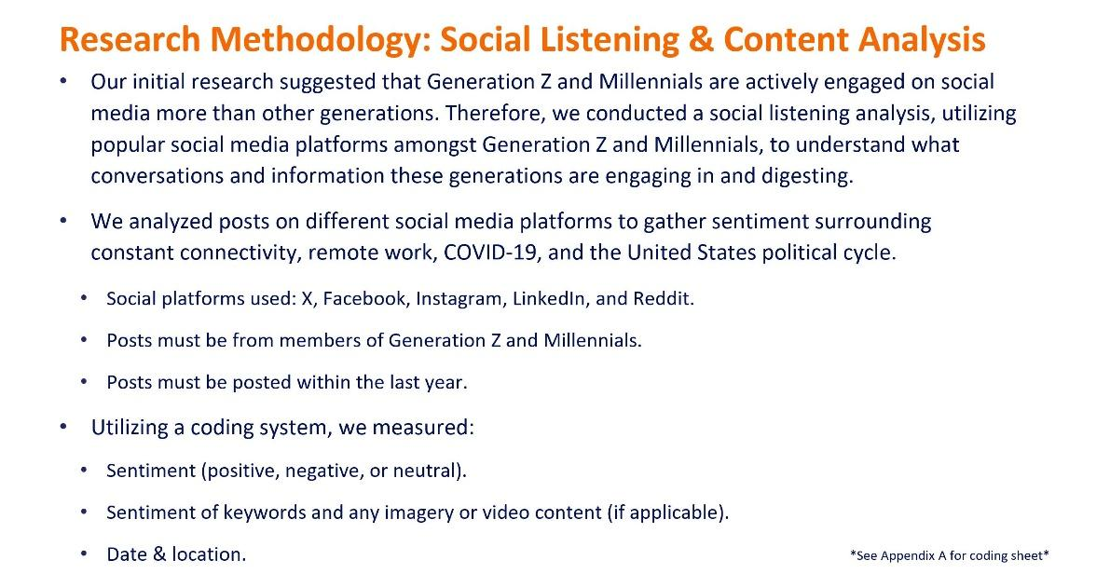

Slide 41: Research Methodology: Social Listening and Content Analysis

Our initial research suggested that Generation Z and Millennials are actively engaged on social media more than other generations. Therefore, we conducted a social listening analysis, utilizing popular social media platforms amongst Generation Z and Millennials, to understand what conversations and information these generations are engaging in and digesting.

We analyzed posts on different social media platforms to gather sentiment surrounding constant connectivity, remote work, COVID-19, and the United States political cycle.

Social platforms used: X, Facebook, Instagram, LinkedIn, and Reddit.
Posts must be from members of Generation Z and Millennials.
Posts must be posted within the last year.

Utilizing a coding system, we measured:

Sentiment (positive, negative, or neutral).
Sentiment of keywords and any imagery or video content (if applicable).
Date and location.

See Appendix A for coding sheet.

Slide 42: Research Methodology: Online Qualtrics Survey

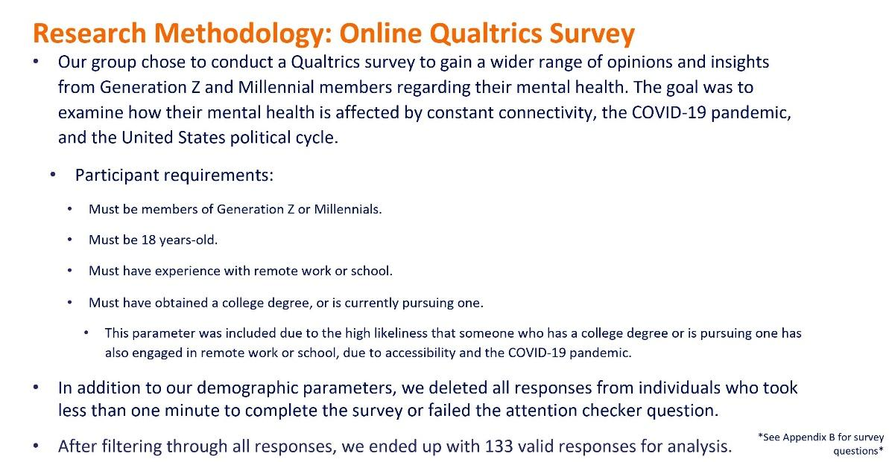

Slide 42: Research Methodology: Online Qualtrics Survey

Our group chose to conduct a Qualtrics survey to gain a wider range of opinions and insights from Generation Z and Millennial members regarding their mental health. The goal was to examine how their mental health is affected by constant connectivity, the COVID-19 pandemic, and the United States political cycle.

Participant requirements:

Must be members of Generation Z or Millennials.
Must be 18 years-old.
Must have experience with remote work or school.
Must have obtained a college degree, or is currently pursuing one.

This parameter was included due to the high likeliness that someone who has a college degree or is pursuing one has also engaged in remote work or school, due to accessibility and the COVID-19 pandemic.

In addition to our demographic parameters, we deleted all responses from individuals who took less than one minute to complete the survey or failed the attention checker question.

After filtering through all responses, we ended up with 133 valid responses for analysis.

See Appendix B for survey questions.
Slide 43: Research Methodology: Focus Group

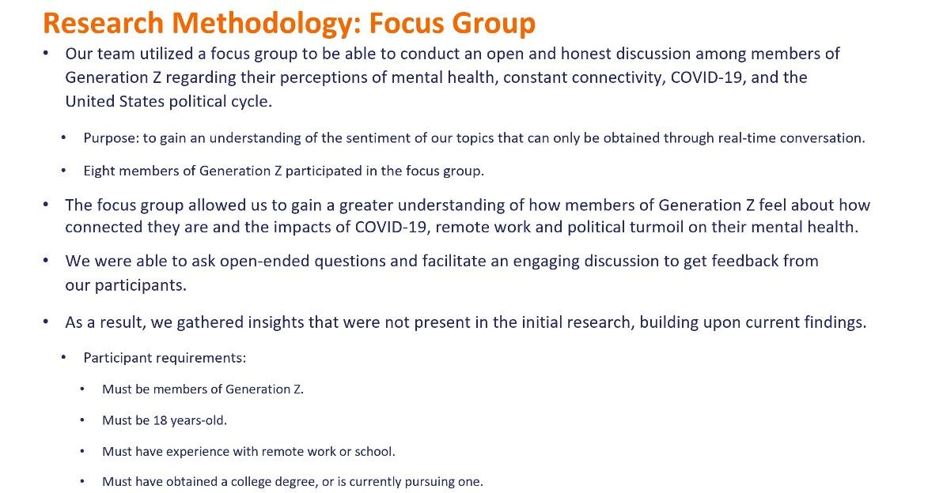

Slide 43: Research Methodology: Focus Group

Our team utilized a focus group to be able to conduct an open and honest discussion among members of Generation Z regarding their perceptions of mental health, constant connectivity, COVID-19, and the United States political cycle.

Purpose: to gain an understanding of the sentiment of our topics that can only be obtained through real-time conversation.

Eight members of Generation Z participated in the focus group.

The focus group allowed us to gain a greater understanding of how members of Generation Z feel about how connected they are and the impacts of COVID-19, remote work and political turmoil on their mental health.

We were able to ask open-ended questions and facilitate an engaging discussion to get feedback from our participants.

As a result, we gathered insights that were not present in the initial research, building upon current findings.

Participant requirements:

Must be members of Generation Z.
Must be 18 years-old.
Must have experience with remote work or school.
Must have obtained a college degree, or is currently pursuing one.

Slide 44: Research Methodology: Interviews

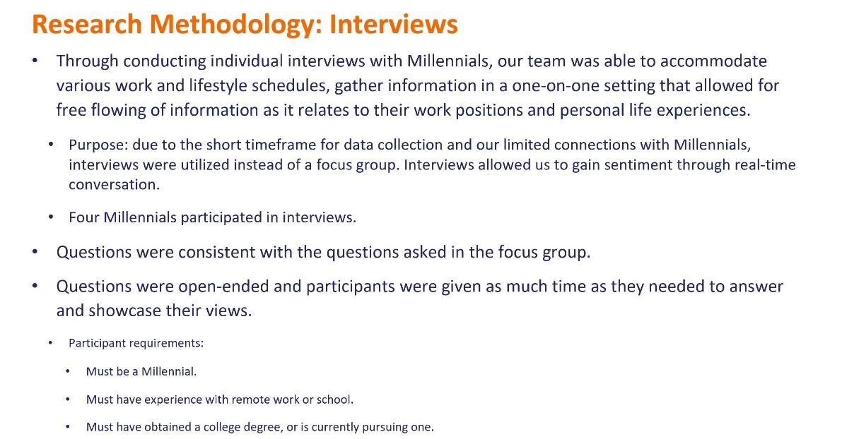

Slide 44: Research Methodology: Interviews

Through conducting individual interviews with Millennials, our team was able to accommodate various work and lifestyle schedules, gather information in a one-on-one setting that allowed for free flowing of information as it relates to their work positions and personal life experiences.

Purpose: due to the short timeframe for data collection and our limited connections with Millennials, interviews were utilized instead of a focus group. Interviews allowed us to gain sentiment through real-time conversation.

Four Millennials participated in interviews.

Questions were consistent with the questions asked in the focus group.

Questions were open-ended and participants were given as much time as they needed to answer and showcase their views.

Participant requirements:

Must be a Millennial.
Must have experience with remote work or school.
Must have obtained a college degree, or is currently pursuing one.

Slide 45: Focus Group and Interview Questions

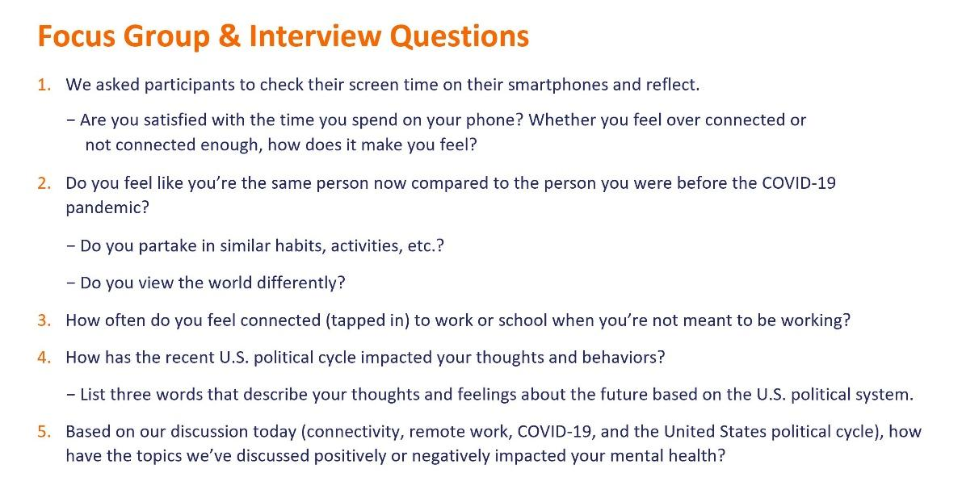

Slide 45: Focus Group and Interview Questions

1. We asked participants to check their screen time on their smartphones and reflect.

Are you satisfied with the time you spend on your phone? Whether you feel over connected or not connected enough, how does it make you feel?

2. Do you feel like you’re the same person now compared to the person you were before the COVID-19 pandemic?

Do you partake in similar habits, activities, etc.?
Do you view the world differently?

3. How often do you feel connected (tapped in) to work or school when you’re not meant to be working?

4. How has the recent U.S. political cycle impacted your thoughts and behaviors?

List three words that describe your thoughts and feelings about the future based on the U.S. political system.

5. Based on our discussion today (connectivity, remote work, COVID-19, and the United States political cycle), how have the topics we’ve discussed positively or negatively impacted your mental health?
Slide 46: Key Takeaways

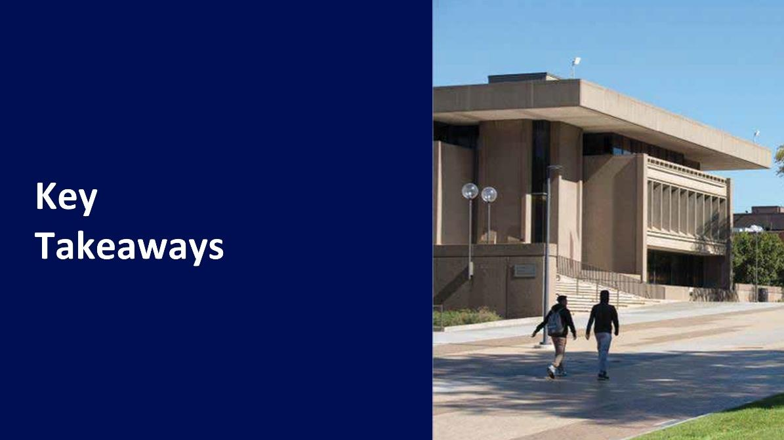

Slide 46: Key Takeaways

Photo of two people walking by the S.I. Newhouse School Of Public Communications at Syracuse University.

Slide 47: Key Takeaways

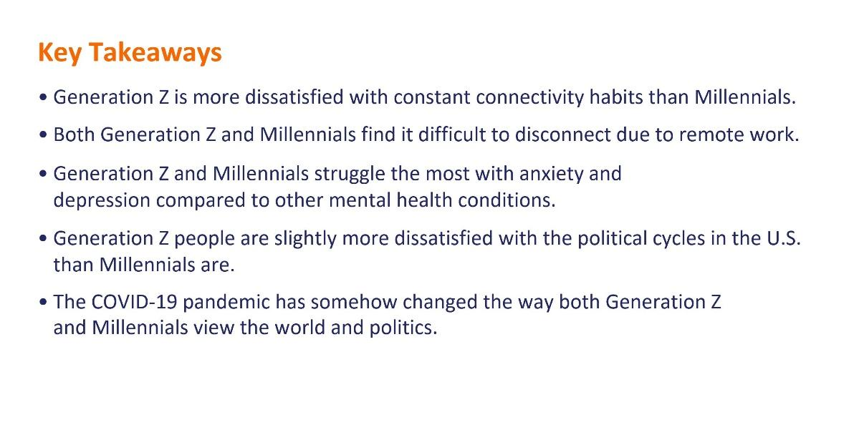

Slide 47: Key Takeaways

Generation Z is more dissatisfied with constant connectivity habits than Millennials.

Both Generation Z and Millennials find it difficult to disconnect due to remote work.

Generation Z and Millennials struggle the most with anxiety and depression compared to other mental health conditions.

Generation Z people are slightly more dissatisfied with the political cycles in the U.S. than Millennials are.

The COVID-19 pandemic has somehow changed the way both Generation Z and Millennials view the world and politics.

Slide 48: Recommendations

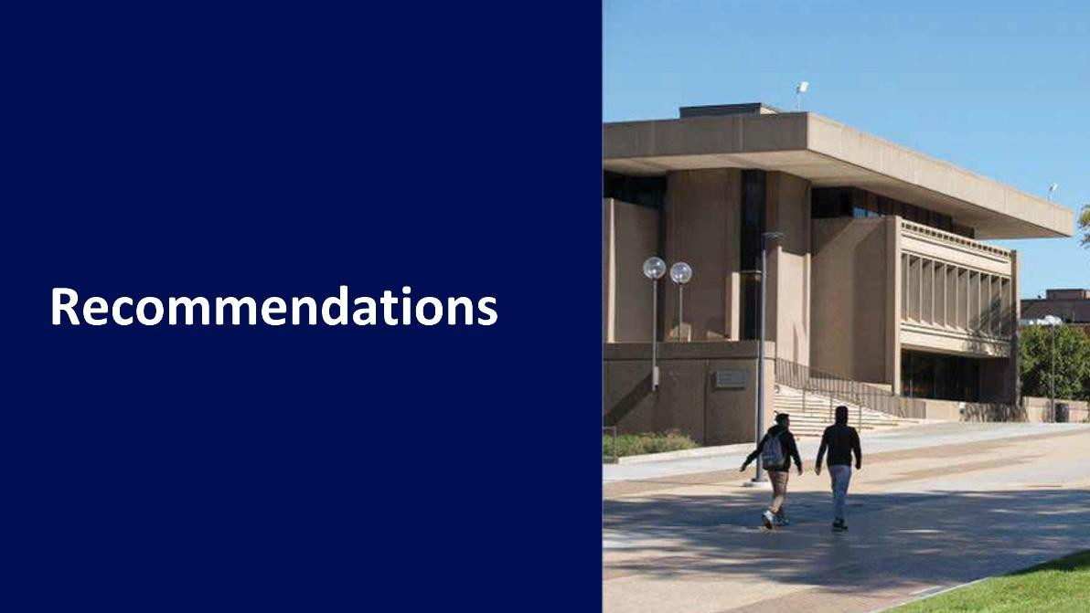

Slide 48: Recommendations

Photo of two people walking by the S.I. Newhouse School Of Public Communications at Syracuse University.

Slide 49: Recommendations

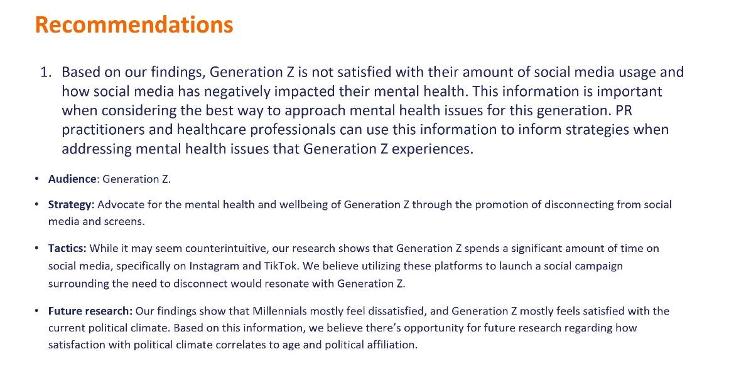

Slide 49: Recommendations

Based on our findings, Generation Z is not satisfied with their amount of social media usage and how social media has negatively impacted their mental health. This information is important when considering the best way to approach mental health issues for this generation. PR practitioners and healthcare professionals can use this information to inform strategies when addressing mental health issues that Generation Z experiences.

Audience: Generation Z.

Strategy: Advocate for the mental health and wellbeing of Generation Z through the promotion of disconnecting from social media and screens.

Tactics: While it may seem counterintuitive, our research shows that Generation Z spends a significant amount of time on social media, specifically on Instagram and TikTok. We believe utilizing these platforms to launch a social campaign surrounding the need to disconnect would resonate with Generation Z.

Future research: Our findings show that Millennials mostly feel dissatisfied, and Generation Z mostly feels satisfied with the current political climate. Based on this information, we believe there’s opportunity for future research regarding how satisfaction with political climate correlates to age and political affiliation.

Slide 50: Recommendations (Continued)

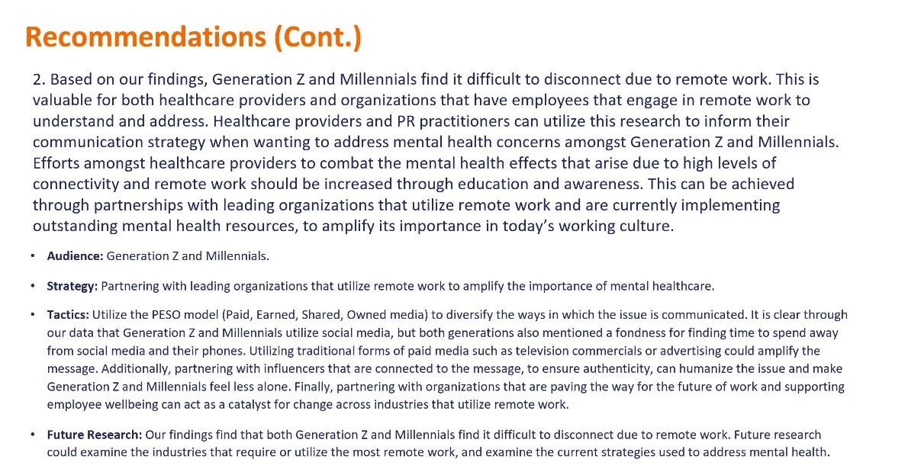

Slide 50: Recommendations (Continued)

Based on our findings, Generation Z and Millennials find it difficult to disconnect due to remote work. This is valuable for both healthcare providers and organizations that have employees that engage in remote work to understand and address. Healthcare providers and PR practitioners can utilize this research to inform their communication strategy when wanting to address mental health concerns amongst Generation Z and Millennials. Efforts amongst healthcare providers to combat the mental health effects that arise due to high levels of connectivity and remote work should be increased through education and awareness. This can be achieved through partnerships with leading organizations that utilize remote work and are currently implementing outstanding mental health resources, to amplify its importance in today’s working culture.

Audience: Generation Z and Millennials.

Strategy: Partnering with leading organizations that utilize remote work to amplify the importance of mental healthcare.

Tactics: Utilize the PESO model (Paid, Earned, Shared, Owned media) to diversify the ways in which the issue is communicated. It is clear through our data that Generation Z and Millennials utilize social media, but both generations also mentioned a fondness for finding time to spend away from social media and their phones. Utilizing traditional forms of paid media such as television commercials or advertising could amplify the message. Additionally, partnering with influencers that are connected to the message, to ensure authenticity, can humanize the issue and make Generation Z and Millennials feel less alone. Finally, partnering with organizations that are paving the way for the future of work and supporting employee wellbeing can act as a catalyst for change across industries that utilize remote work.

Future Research: Our findings find that both Generation Z and Millennials find it difficult to disconnect due to remote work. Future research could examine the industries that require or utilize the most remote work, and examine the current strategies used to address mental health.

Slide 51: Recommendations (Continued)

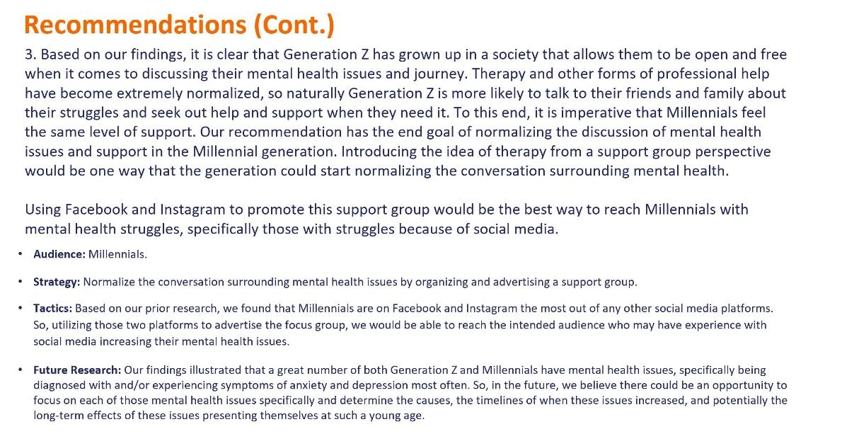

Slide 51: Recommendations (Continued)

Based on our findings, it is clear that Generation Z has grown up in a society that allows them to be open and free when it comes to discussing their mental health issues and journey. Therapy and other forms of professional help have become extremely normalized, so naturally Generation Z is more likely to talk to their friends and family about their struggles and seek out help and support when they need it. To this end, it is imperative that Millennials feel the same level of support. Our recommendation has the end goal of normalizing the discussion of mental health issues and support in the Millennial generation. Introducing the idea of therapy from a support group perspective would be one way that the generation could start normalizing the conversation surrounding mental health.

Using Facebook and Instagram to promote this support group would be the best way to reach Millennials with mental health struggles, specifically those with struggles because of social media.

Audience: Millennials.

Strategy: Normalize the conversation surrounding mental health issues by organizing and advertising a support group.

Tactics: Based on our prior research, we found that Millennials are on Facebook and Instagram the most out of any other social media platforms. So, utilizing those two platforms to advertise the focus group, we would be able to reach the intended audience who may have experience with social media increasing their mental health issues.

Future Research: Our findings illustrated that a great number of both Generation Z and Millennials have mental health issues, specifically being diagnosed with and / or experiencing symptoms of anxiety and depression most often. So, in the future, we believe there could be an opportunity to focus on each of those mental health issues specifically and determine the causes, the timelines of when these issues increased, and potentially the long-term effects of these issues presenting themselves at such a young age.

Slide 52: Recommendations (Continued)

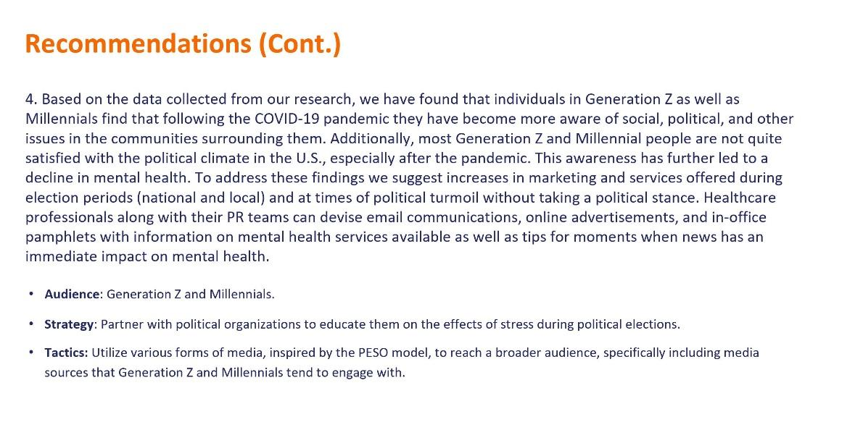

Slide 52: Recommendations (Continued)

Based on the data collected from our research, we have found that individuals in Generation Z as well as Millennials find that following the COVID-19 pandemic they have become more aware of social, political, and other issues in the communities surrounding them. Additionally, most Generation Z and Millennial people are not quite satisfied with the political climate in the U.S., especially after the pandemic. This awareness has further led to a decline in mental health. To address these findings we suggest increases in marketing and services offered during election periods (national and local) and at times of political turmoil without taking a political stance. Healthcare professionals along with their PR teams can devise email communications, online advertisements, and in-office pamphlets with information on mental health services available as well as tips for moments when news has an immediate impact on mental health.

Audience: Generation Z and Millennials.

Strategy: Partner with political organizations to educate them on the effects of stress during political elections.

Tactics: Utilize various forms of media, inspired by the PESO model, to reach a broader audience, specifically including media sources that Generation Z and Millennials tend to engage with.

Slide 53: Appendices

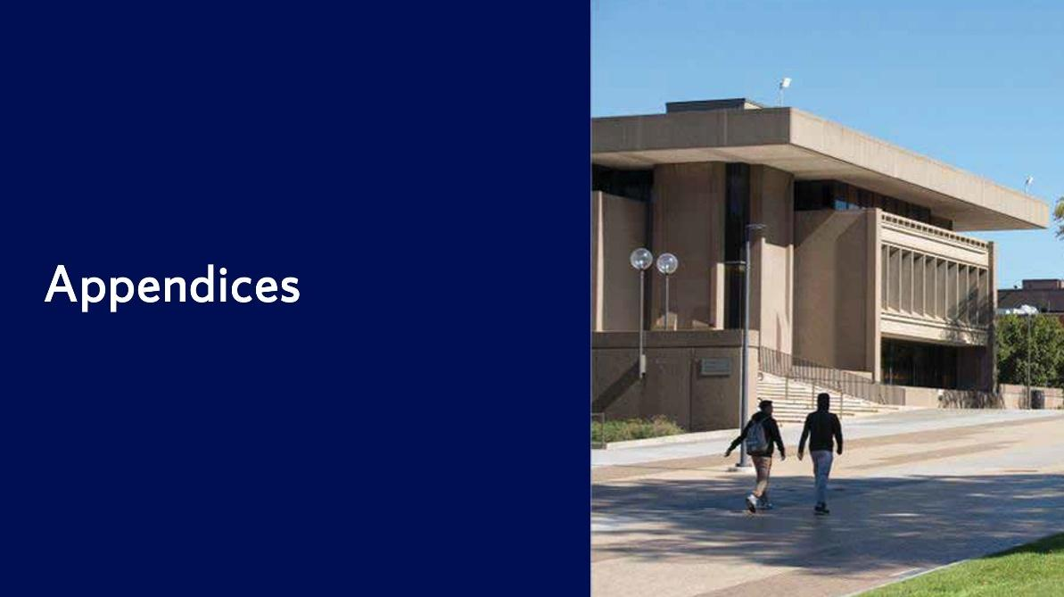

Slide 53: Appendices

Photo of two people walking by the S.I. Newhouse School Of Public Communications at Syracuse University.

Slide 54: Study 1: Appendix



Slide 54: Study 1: Appendix

Photo of two people walking by the S.I. Newhouse School Of Public Communications at Syracuse University.

Slide 55: Appendix A

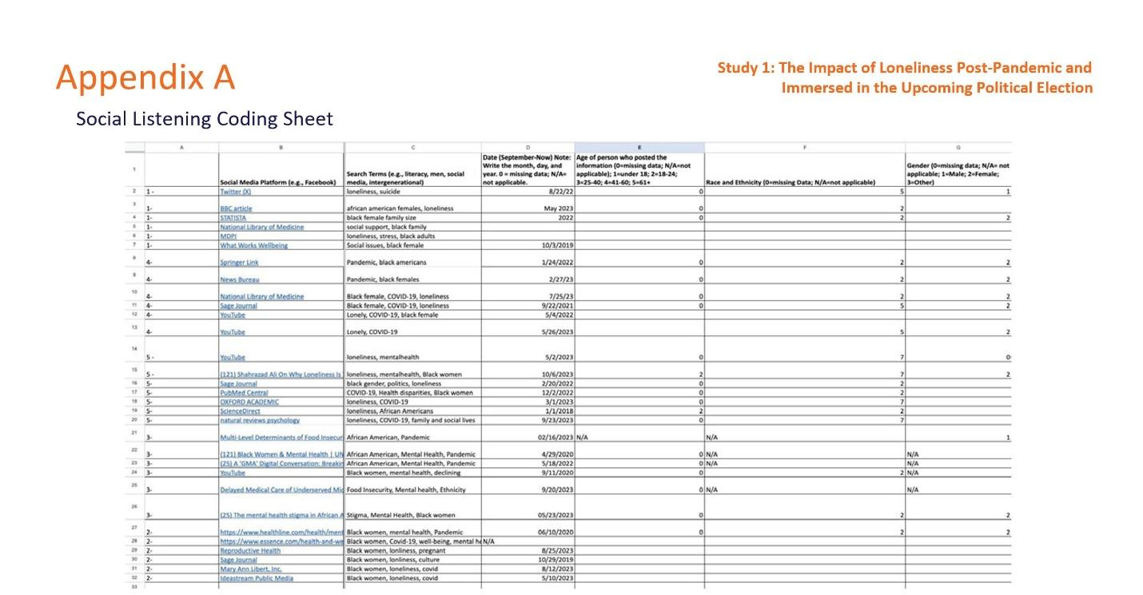

Slide 55: Appendix A

Social Listening Coding Sheet

Study 1: The Impact of Loneliness Post-Pandemic and Immersed in the Upcoming Political Election

Chart depicting a numerical value for each source post, the social media / media platform it was on, the search terms that were used, the date of the post, the age of the person who made the post, the race / ethnicity of the person who the post, and the gender of the person who made the post.

Slide 56: Appendix A (Continued)

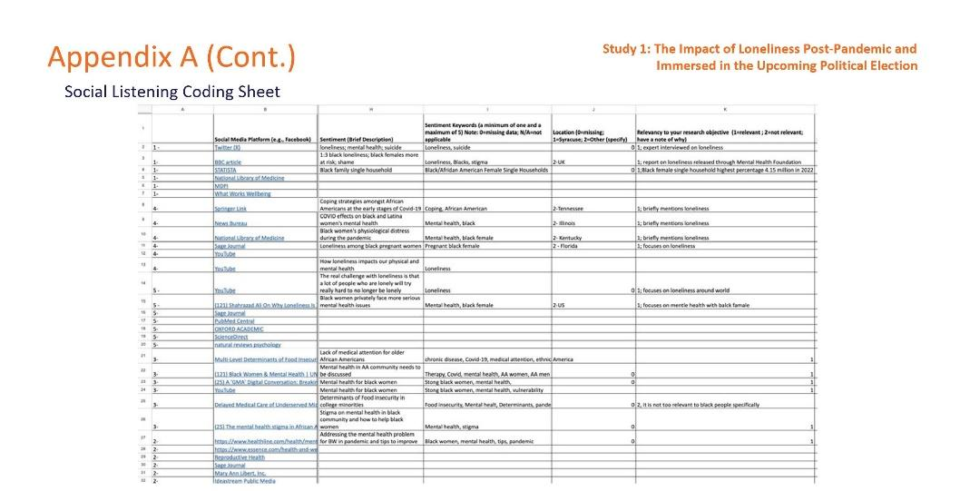

Slide 56: Appendix A (Continued)

Social Listening Coding Sheet

Study 1: The Impact of Loneliness Post-Pandemic and Immersed in the Upcoming Political Election

Chart depicting a numerical value for each source post, the social media / media platform it was on, a brief description of the sentiments expressed in the post, the sentiment keywords of the post, the physical location where the post was made, and the relevancy of the post to the research objective.

Slide 57: Appendix B

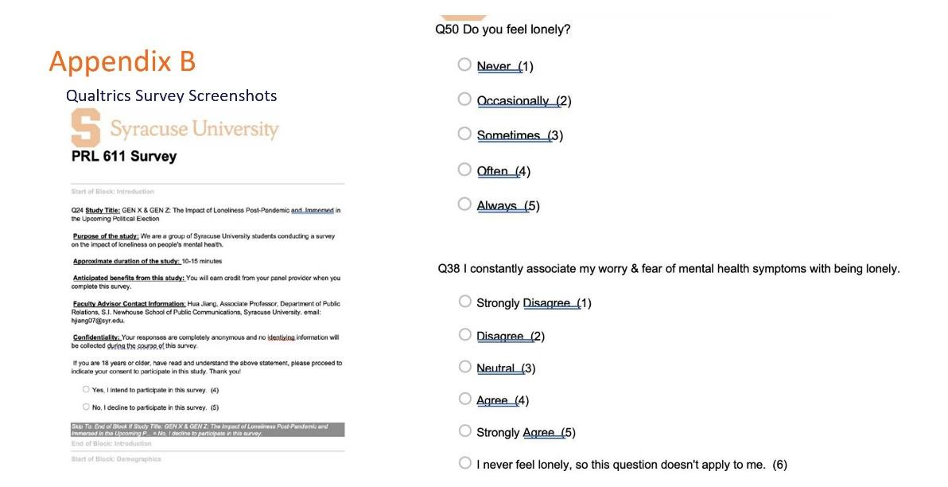

Slide 57: Appendix B

Qualtrics Survey Screenshots

Do you feel lonely?

Never.
Occasionally.
Sometimes.
Often.
Always.

I constantly associate my worry and fear of mental health symptoms with being lonely.

Strongly disagree.
Disagree.
Neutral.
Agree.
Strongly agree.
I never feel lonely, so this question doesn’t apply to me.

Screenshot depicting introduction page of Qualtrics survey; including information on study title, purpose, duration, anticipated benefits, advisor contact information, confidentiality, and consent.

Slide 58: Appendix B (Continued)

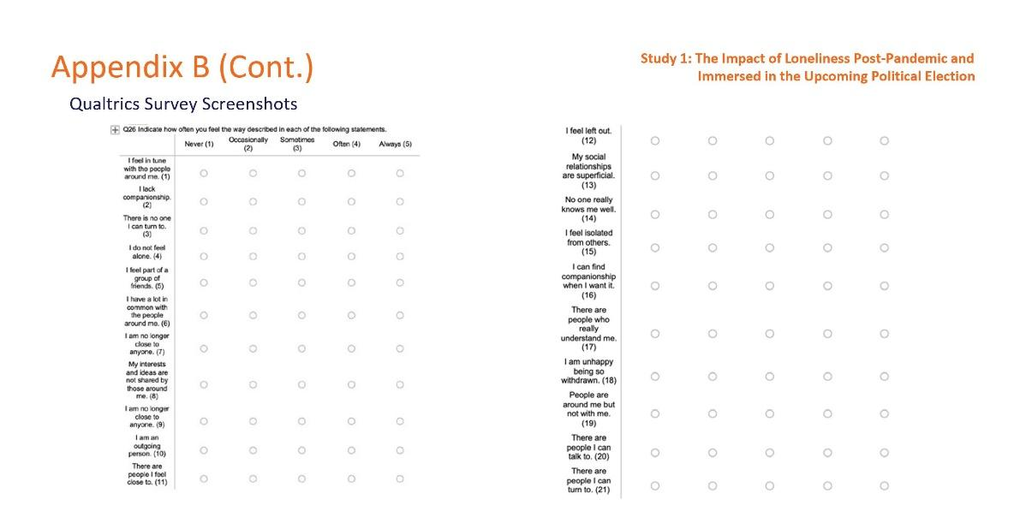

Slide 58: Appendix B (Continued)

Qualtrics Survey Screenshots

Study 1: The Impact of Loneliness Post-Pandemic and Immersed in the Upcoming Political Election

Indicate how often you feel the way described in each of the following statements.

Never.
Occasionally.
Sometimes.
Often.
Always.

I feel in tune with the people around me.
I lack companionship.
There is no one I can turn to.
I do not feel alone.
I feel part of a group of friends.
I have a lot in common with the people around me.
I am no longer close to anyone.
My interests and ideas are not shared by those around me.
I am no longer close to anyone.
I am an outgoing person.
There are people I feel close to.
I feel left out.
My social relationships are superficial.
No one really knows me well.
I feel isolated from others.
I can find companionship when I want it.
There are people who really understand me.
I am unhappy being so withdrawn.
People are around me, but not with me.
There are people I can talk to.
There are people I can turn to.

Slide 59: Appendix B (Continued)

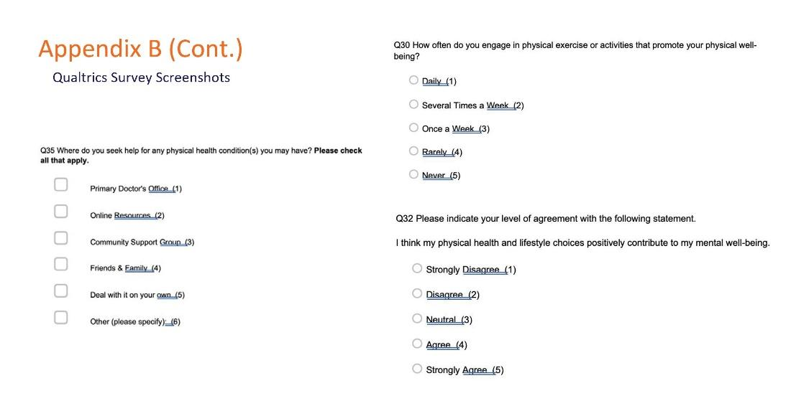

Slide 59: Appendix B (Continued)

Qualtrics Survey Screenshots

Where do you seek help for any physical health conditions you have? (Please check all that apply.)

Primary doctor’s office.
Online resources.
Community support group.
Friends and family.
Deal with it on your own.
Other. (Please specify.)

How often do you engage in physical exercise or activities that promote your physical well-being?

Daily.
Several times a week.
Once a week.
Rarely.
Never.

Please indicate your level of agreement with the following statement.

I think my physical health and lifestyle choices positively contribute to my mental well-being.

Strongly disagree.
Disagree.
Neutral.
Agree.
Strongly agree.

Slide 60: Appendix B (Continued)

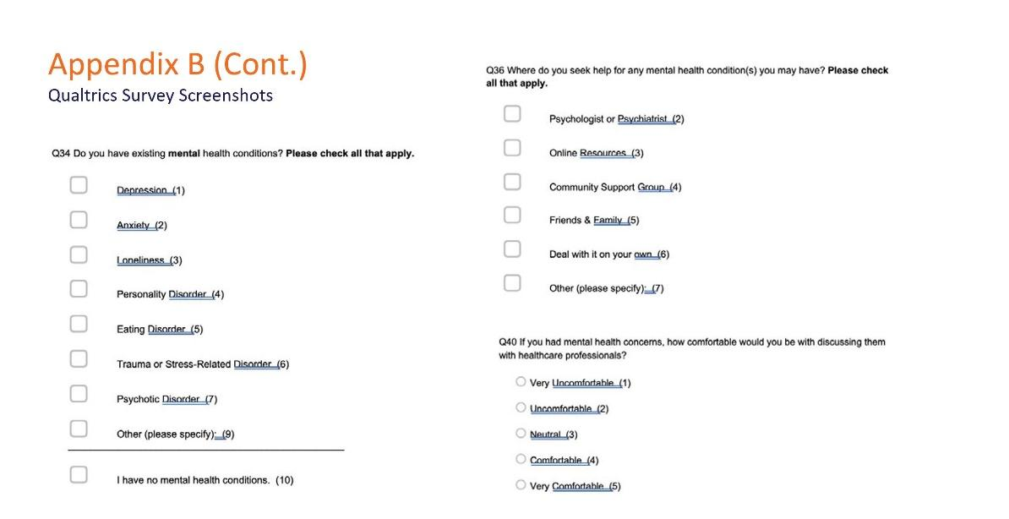

Slide 60: Appendix B (Continued)

Qualtrics Survey Screenshots

Do you have existing mental health conditions? (Please check all that apply.)

Depression.
Anxiety.
Loneliness.
Personality disorder.
Eating disorder.
Trauma or stress-related disorder.
Psychotic disorder.
Other. (Please specify.)
I have no mental health conditions.

Where do you seek help for any mental health conditions you may have? (Please check all that apply.)

Psychologist or psychiatrist.
Online resources.
Community support group.
Friends and family.
Deal with it on your own.
Other. (Please specify.)

If you had mental health concerns, how comfortable would you be discussing them with healthcare professionals?

Very uncomfortable.
Uncomfortable.
Neutral.
Comfortable.
Very comfortable.
Slide 61: Appendix B (Continued)

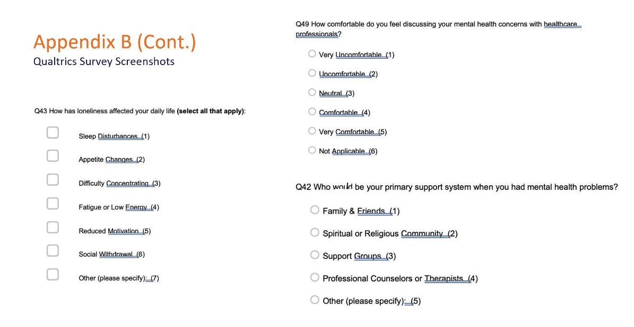

Slide 61: Appendix B (Continued)

Qualtrics Survey Screenshots

How has loneliness affected your daily life (select all that apply):

Sleep disturbances.
Appetite changes.
Difficulty concentrating.
Fatigue or low energy.
Reduced motivation.
Social withdrawal.
Other. (Please specify.)

How comfortable are you discussing your mental health concerns with healthcare professionals?

Very uncomfortable.
Uncomfortable.
Neutral.
Comfortable.
Very comfortable.
Not applicable.

Who would be your primary support system when you had mental health problems?

Friends and family.
Spiritual or religious community.
Support groups.
Professional counselors or therapists.
Other. (Please specify.)

Slide 62: Appendix C

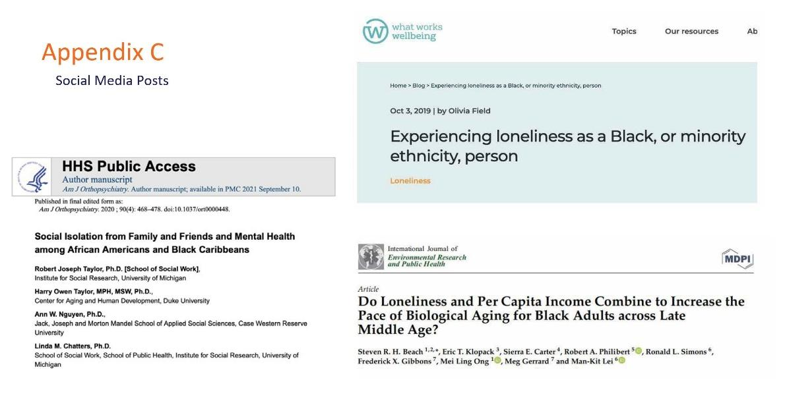

Slide 62: Appendix C

Social Media Posts

HHS Public Access

Social Isolation from Family and Friends and Mental Health among African Americans and Black Caribbeans

What Works Wellbeing

Experiencing loneliness as a Black, or minority ethnicity, person

International Journal of Environmental Research and Public Health

Do Loneliness and Per Capita Income Combine to Increase the Pace of Biological Aging for Black Adults across Late Middle Age?

Slide 63: Appendix C (Continued)

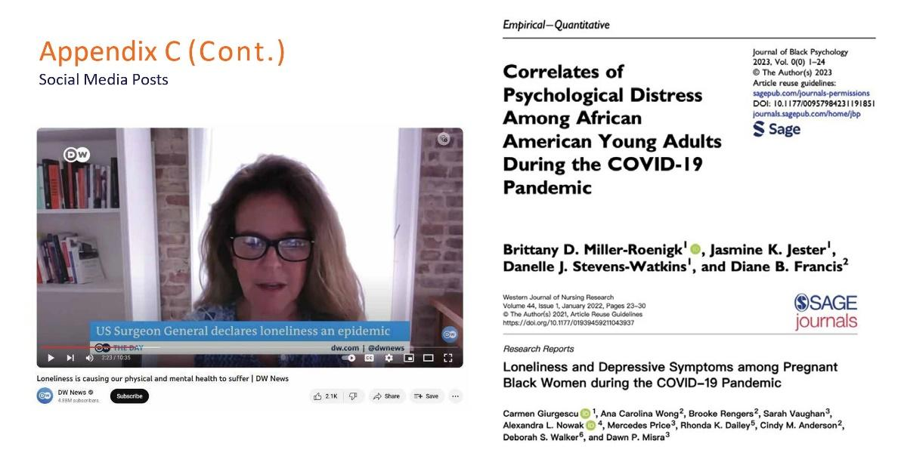

Slide 63: Appendix C (Continued)

Social Media Posts

DW News

Loneliness is causing our physical and mental health to suffer

Journal of Black Psychology

Correlates of Psychological Distress Among African American Young Adults During the COVID-19 Pandemic

Western Journal of Nursing Research

Loneliness and Depressive Symptoms among Pregnant Black Women during the COVID-19 Pandemic

Slide 64: Appendix C (Continued)

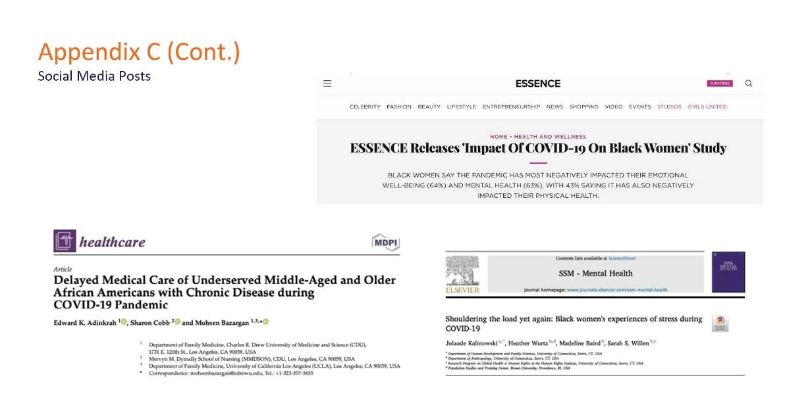

Slide 64: Appendix C (Continued)

Social Media Posts

MDPI Healthcare

Delayed Medical Care of Underserved Middle-Aged and Older African Americans with Chronic Disease during COVID-19 Pandemic

Essence

Essence Releases ‘Impact of COVID-19 on Black Women’ Study

SSM - Mental Health

Shouldering the load yet again: Black women’s experiences of stress during COVID-19

Slide 65: Study 3: Appendix

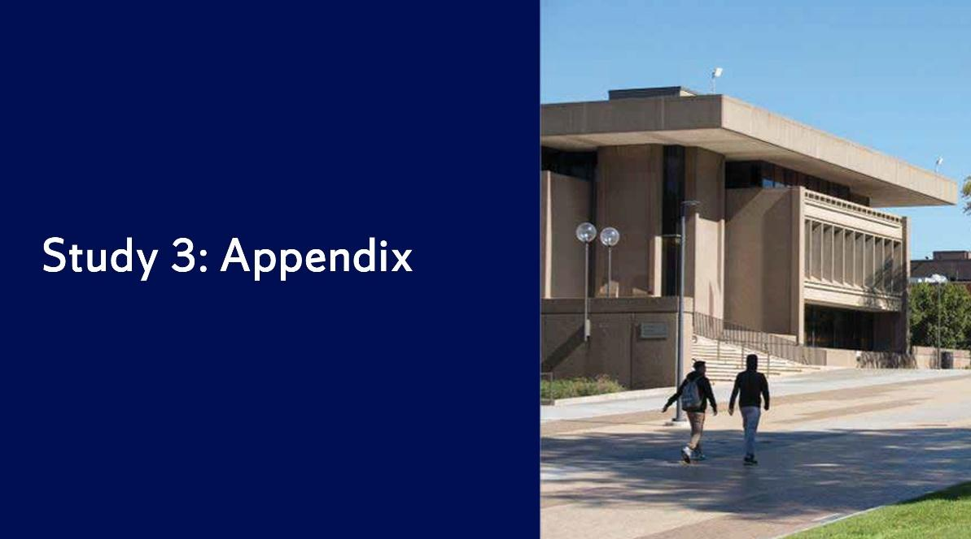

Slide 65: Study 3: Appendix

Photo of two people walking by the S.I. Newhouse School Of Public Communications at Syracuse University.

Slide 66: Appendix A

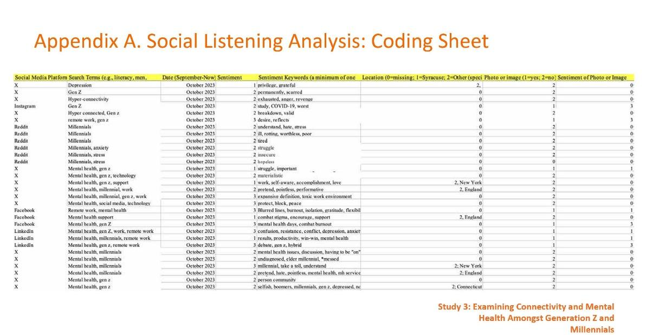

Slide 66: Appendix A

Social Listening Analysis: Coding Sheet

Study 3: Examining Connectivity and Mental Health Amongst Generation Z and Millennials

Chart depicting the social media platform for each source post, the search terms that were used, the date of the post, a number coding the sentiment expressed in the post, keywords of the sentiment expressed in the post, the location of the post, whether or not an image was included with the post, and a number coding the sentiment of the image if one was there.

Slide 67: Appendix B

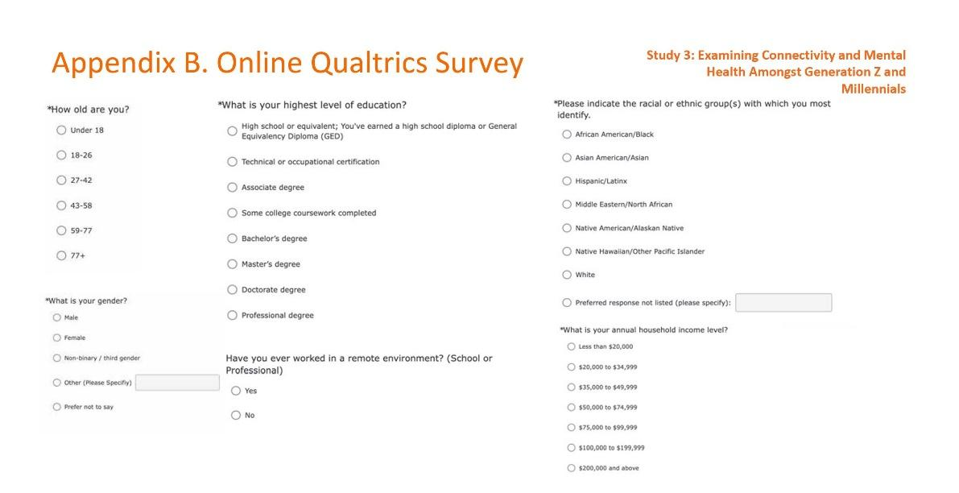

Slide 67: Appendix B

Online Qualtrics Survey

Study 3: Examining Connectivity and Mental Health Amongst Generation Z and Millennials

How old are you?

Under 18.
18-26.
27-42.
43-58.
59-77.
77 plus.

What is your gender?

Male.
Female.
Non-binary / third gender.
Other. (Please specify.)
Prefer not to say.

What is your highest level of education?

High school or equivalent.
Technical or occupational certificate.
Associate degree.
Some college coursework completed.
Bachelor’s degree.
Master’s degree.
Doctorate degree.
Professional degree.

Have you ever worked in a remote environment?

Yes.
No.

Please indicate the racial or ethnic groups with which you most identify.

African American / Black.
Asian American / Asian.
Hispanic / Latinx.
Middle Eastern / North African.
Native American / Alaskan Native.
Native Hawaiian / Other Pacific Islander.
White.
Preferred response not listed. (Please specify.)

What is your annual household income level?

Less than $20,000.
$20,000 to $34,999.
$35,000 to $49,999.
$50,000 to $74,999.
$75,000 to $99,999.
$100,000 to $199,999.
$200,000 and above.

Slide 68: Appendix B (Continued)

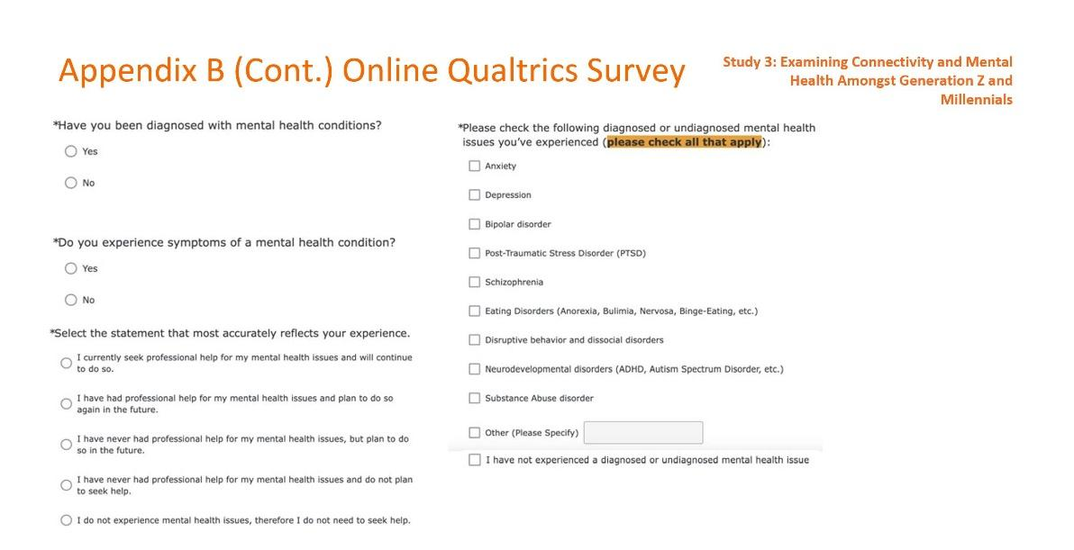

Slide 68: Appendix B (Continued)

Online Qualtrics Survey

Study 3: Examining Connectivity and Mental Health Amongst Generation Z and Millennials

Have you been diagnosed with mental health conditions?

Yes.
No.

Do you experience symptoms of a mental health condition?

Yes.
No.

Select the statement that most accurately reflects your experience.

I currently seek professional help for my mental health issues and will continue to do so.

I have had professional help for my mental health issues and plan to do so again in the future.

I have never had professional help for my mental health issues, but plan to do in the future.

I have never had professional help for my mental health issues and do not plan to seek help.

I do not experience mental health issues; therefore I do not need to seek help.

Please check the following diagnosed or undiagnosed mental health issues you’ve experienced. (Please check all that apply.)

Anxiety.
Depression.
Bipolar disorder.
Post-Traumatic Stress Disorder (PTSD).
Schizophrenia.
Eating disorders (Anorexia, Bulimia, Nervosa, Binge-Eating).
Disruptive behavior and dissocial disorders.
Neurodevelopmental disorders (ADHD, Autism Spectrum Disorder).
Substance abuse disorder.
Other. (Please specify.)
I have not experienced a diagnosed or undiagnosed mental health issue.

Slide 69: Appendix B (Continued)

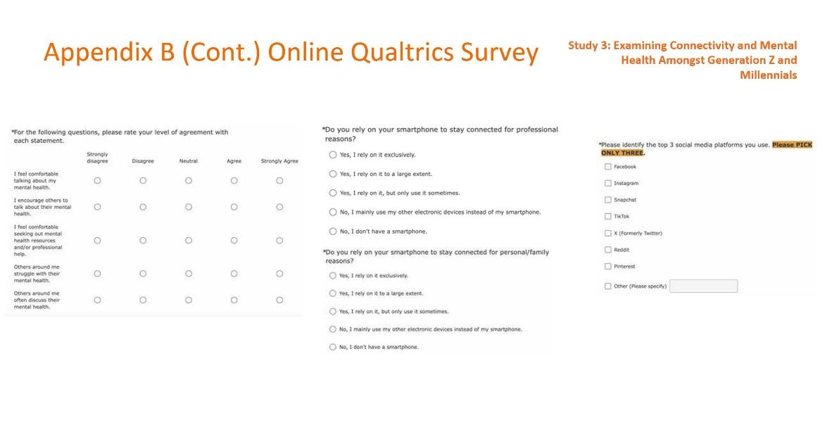

Slide 69: Appendix B (Continued)

Online Qualtrics Survey

Study 3: Examining Connectivity and Mental Health Amongst Generation Z and Millennials

For the following questions, please rate your level of agreement with each statement.

Strongly disagree.
Disagree.
Neutral.
Agree.
Strongly agree.

I feel comfortable talking about my mental health.

I encourage others to talk about their mental health.

I feel comfortable seeking out mental health resources and / or professional help.

Others around me struggle with their mental health.

Others around me often discuss their mental health.

Do you rely on your smartphone to stay connected for professional reasons?

Yes, I rely on it exclusively.
Yes, I rely on it to a large extent.
Yes, I rely on it, but I only use it sometimes.
No, I mainly use my other electronic devices instead of my smartphone.
No, I don’t have a smartphone.

Do you rely on your smartphone to stay connected for personal / family reasons?

Yes, I rely on it exclusively.
Yes, I rely on it to a large extent.
Yes, I rely on it, but I only use it sometimes.
No, I mainly use my other electronic devices instead of my smartphone.
No, I don’t have a smartphone.

Please identify the top three social media platforms you use. (Please pick only three.)

Facebook.
Instagram.
Snapchat.
TikTok.
X (formerly Twitter).
Reddit.
Pinterest.
Other. (Please specify.)

Slide 70: Appendix B (Continued)

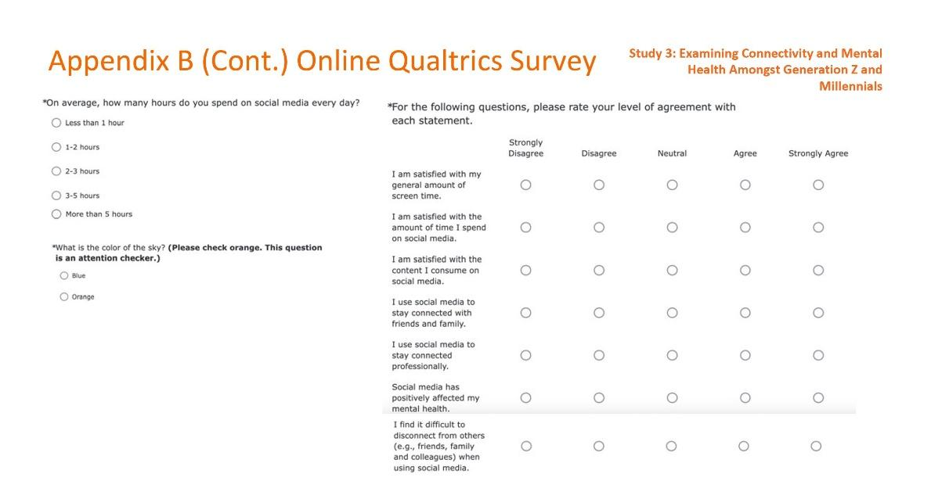

Slide 70: Appendix B (Continued)

Online Qualtrics Survey

Study 3: Examining Connectivity and Mental Health Amongst Generation Z and Millennials

On average, how many hours do you spend on social media every day?

Less than 1 hour.
1-2 hours.
2-3 hours.
3-5 hours.
More than 5 hours.

What is the color of the sky? (Please check orange. This question is an attention checker.)

Blue.
Orange.

For the following questions, please rate your level of agreement with each statement.

Strongly disagree.
Disagree.
Neutral.
Agree.
Strongly agree.

I am satisfied with my general amount of screen time.

I am satisfied with the amount of time I spend on social media.

I am satisfied with the content I consume on social media.

I use social media to stay connected with friends and family.

I use social media to stay connected professionally.

Social media has positively affected my mental health.

I find it difficult to disconnect from others when using social media.
Slide 71: Appendix B (Continued)

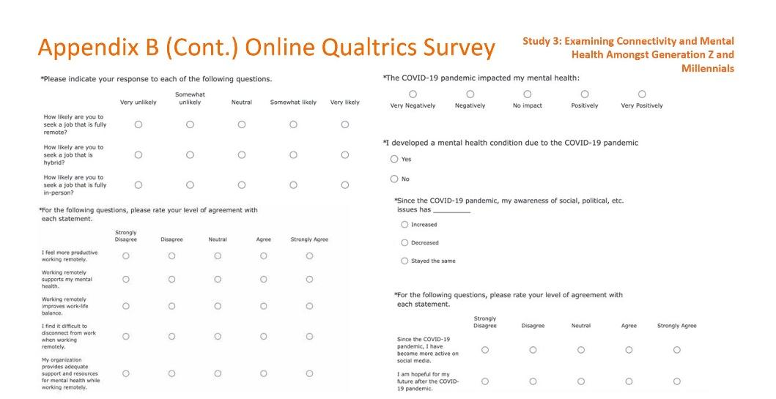

Slide 71: Appendix B (Continued)

Online Qualtrics Survey

Study 3: Examining Connectivity and Mental Health Amongst Generation Z and Millennials

Please indicate your response to each of the following questions.

Very unlikely.
Somewhat unlikely.
Neutral.
Somewhat likely.
Very likely.

How likely are you to seek a job that is fully remote?

How likely are you to seek a job that is hybrid?

How likely are you to seek a job that is fully in-person?

For the following questions, please rate your level of agreement with each statement.

Strongly disagree.
Disagree.
Neutral.
Agree.
Strongly agree.

I feel more productive working remotely.

Working remotely supports my mental health.

Working remotely improves work-life balance.

I find it difficult to disconnect from work when working remotely.

My organization provides adequate support and resources for mental health while working remotely.

The COVID-19 pandemic impacted my mental health

Very negatively.
Negatively.
No impact.
Positively.
Very positively.

I developed a mental health condition due to the COVID-19 pandemic.

Yes.
No.

Since the COVID-19 pandemic, my awareness of social, political, etc. issues has

Increased.
Decreased.
Stayed the same.

For the following questions, please rate your level of agreement with each statement.

Strongly disagree.
Disagree.
Neutral.
Agree.
Strongly agree.

Since the COVID-19 pandemic, I have become more active on social media.

I am hopeful for my future after the COVID-19 pandemic.

Slide 72: Appendix B (Continued)

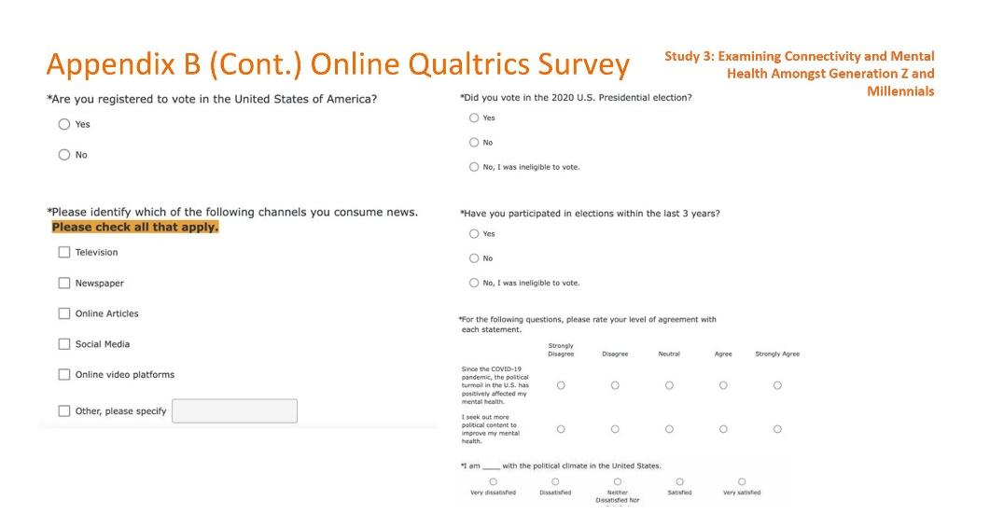

Slide 72: Appendix B (Continued)

Online Qualtrics Survey

Study 3: Examining Connectivity and Mental Health Amongst Generation Z and Millennials

Are you registered to vote in the United States of America?

Yes.
No.

Please identify which of the following channels you consume news from. (Please check all that apply.)

Television.
Newspaper.
Online articles.
Social media.
Online video platforms.
Other. (Please specify.)

Did you vote in the 2020 U.S. Presidential election?

Yes.
No.
No, I was ineligible to vote.

For the following questions, please rate your level of agreement with each statement.

Strongly disagree.
Disagree.
Neutral.
Agree.
Strongly agree.

Since the COVID-19 pandemic, the political turmoil in the U.S. has positively affected my mental health.

I seek out more political content to improve my mental health.

I am with the political climate in the United States.

Very dissatisfied.
Dissatisfied.
Neither dissatisfied nor satisfied.
Satisfied.
Very satisfied.

Slide 73: Appendix B (Continued)

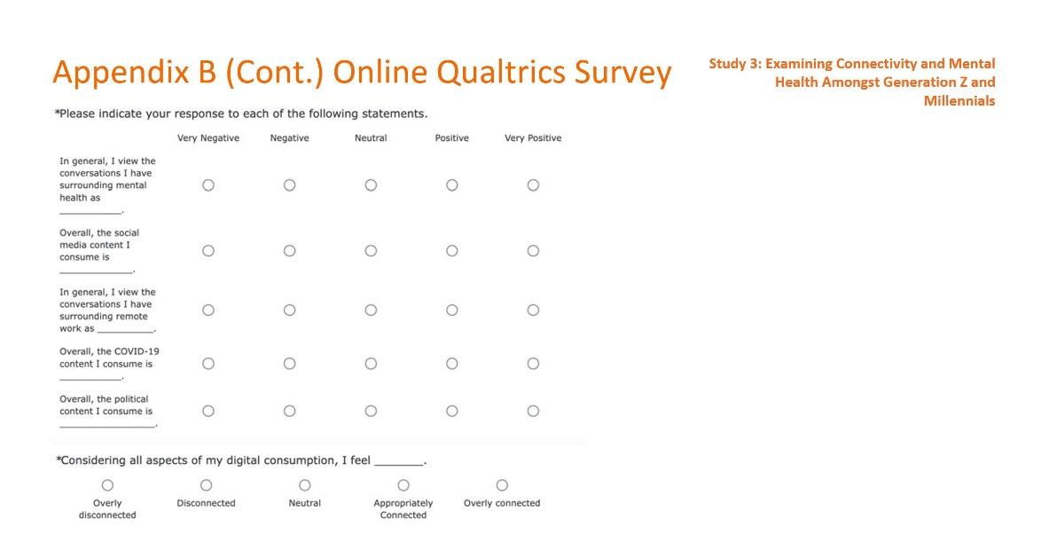

Slide 73: Appendix B (Continued)

Online Qualtrics Survey

Study 3: Examining Connectivity and Mental Health Amongst Generation Z and Millennials

Please indicate your response to each of the following statements.

Very negative.
Negative.
Neutral.
Positive.
Very positive.

In general, I view the conversations I have surrounding mental health
as

Overall, the social media content I consume is

In general, I view the conversations I have surrounding remote work
as

Overall, the COVID-19 content I consume is

Overall, the political content I consume is

Considering all aspects of my digital consumption, I feel

Overly disconnected.
Disconnected.
Neutral.
Appropriately connected.
Over connected.

Slide 74: References

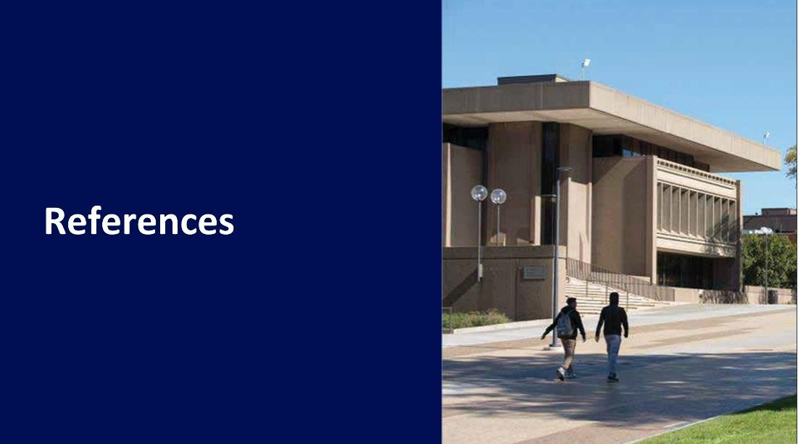

Slide 74: References

Photo of two people walking by the S.I. Newhouse School Of Public Communications at Syracuse University.

Slide 75: References

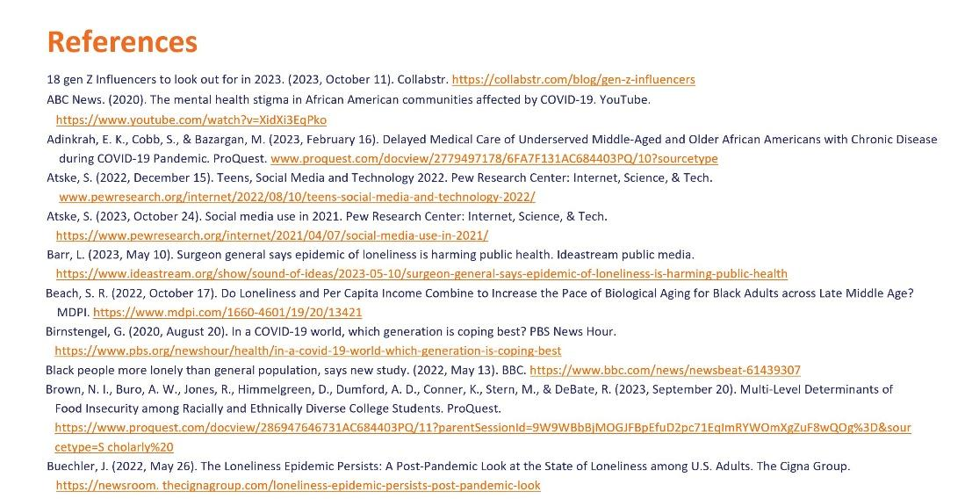

Slide 75: References

Study 1: The Impact of Loneliness Post-Pandemic and Immersed in the Upcoming Political Election

18 gen Z Influencers to look out for in 2023. (2023, October 11). Collabstr.
https://collabstr.com/blog/gen-z-influencers

ABC News. (2020). The mental health stigma in African American communities affected
by COVID-19. YouTube. https://www.youtube.com/watch?v=XidXi3EqPko

Adinkrah, E. K., Cobb, S., & Bazargan, M. (2023, February 16). Delayed Medical Care of Underserved Middle-Aged and Older African Americans with Chronic Disease during COVID-19 Pandemic. ProQuest. www.proquest.com/docview/2779497178 /6FA7F131AC684403PQ/10?sourcetype

Atske, S. (2022, December 15). Teens, Social Media and Technology 2022. Pew Research Center: Internet, Science, & Tech. www.pewresearch.org/internet/2022/08/10/
teens-social-media-and-technology-2022/

Atske, S. (2023, October 24). Social media use in 2021. Pew Research Center: Internet, Science, & Tech. https://www.pewresearch.org/ internet/2021/04/07/social-media-
use-in-2021/

Barr, L. (2023, May 10). Surgeon general says epidemic of loneliness is harming public health. Ideastream public media. https://www.ideastream.org/show/sound-of-ideas/2023-05-10/surgeon-general-says-epidemic-of-loneliness-is-harming-public-health

Beach, S. R. (2022, October 17). Do Loneliness and Per Capita Income Combine to Increase the Pace of Biological Aging for Black Adults across Late Middle Age? MDPI. https://www.mdpi.com/1660-4601/19/20/13421

Birnstengel, G. (2020, August 20). In a COVID-19 world, which generation is coping best? PBS News Hour. https://www.pbs.org/newshour/health/in-a-covid-19-world-which-
generation-is-coping-best

Black people more lonely than general population, says new study. (2022, May 13). BBC. https://www.bbc.com/news/newsbeat-61439307

Brown, N. I., Buro, A. W., Jones, R., Himmelgreen, D., Dumford, A. D., Conner, K., Stern, M., & DeBate, R. (2023, September 20). Multi-Level Determinants of Food Insecurity among Racially and Ethnically Diverse College Students. ProQuest. https://www.proquest.com/docview/286947646731AC684403PQ/11?parentSessionId=9W9WBbBjMOGJFBpEfuD2pc71EqImRYWOmXgZuF8wQOg%3D&sourcetype=S cholarly%20

Buechler, J. (2022, May 26). The Loneliness Epidemic Persists: A Post-Pandemic Look at the State of Loneliness among U.S. Adults. The Cigna Group. https://newsroom. thecignagroup.com/loneliness-epidemic-persists-post-pandemic-look

Slide 76: References (Continued)

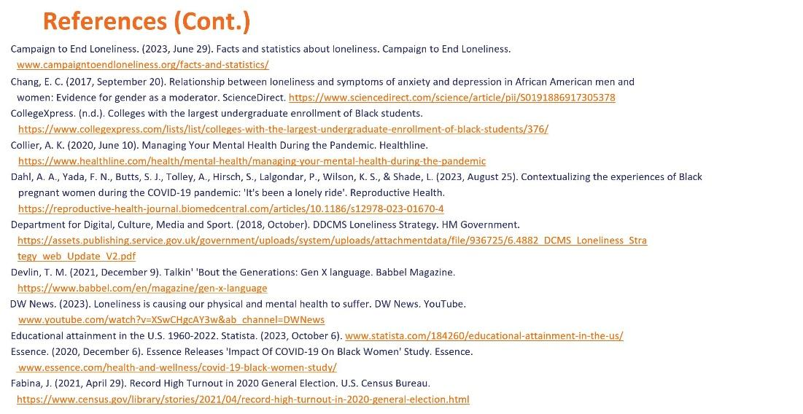

Slide 76: References (Continued)

Study 1: The Impact of Loneliness Post-Pandemic and Immersed in the Upcoming Political Election

Campaign to End Loneliness. (2023, June 29). Facts and statistics about loneliness. Campaign to End Loneliness. www.campaigntoendloneliness.org/facts-and-statistics/

Chang, E. C. (2017, September 20). Relationship between loneliness and symptoms of anxiety and depression in African American men and women: Evidence for gender as a moderator. ScienceDirect. https://www.sciencedirect.com/science/article/pii/
S0191886917305378

CollegeXpress. (n.d.). Colleges with the largest undergraduate enrollment of Black students. https://www.collegexpress.com/lists/list/colleges-with-the-largest-
undergraduate-enrollment-of-black-students/376/

Collier, A. K. (2020, June 10). Managing Your Mental Health During the Pandemic. Healthline. https://www.healthline.com/health/mental-health/
managing-your-mental-health-during-the-pandemic

Dahl, A. A., Yada, F. N., Butts, S. J., Tolley, A., Hirsch, S., Lalgondar, P., Wilson, K. S., & Shade, L. (2023, August 25). Contextualizing the experiences of Black pregnant women during the COVID-19 pandemic: 'It's been a lonely ride'. Reproductive Health. https://reproductive-health-journal.biomedcentral.com/articles/10.1186/s12978-023-01670-4

Department for Digital, Culture, Media and Sport. (2018, October). DDCMS Loneliness Strategy. HM Government. https://assets.publishing.service.gov.uk/government/upload
s/system/uploads/attachmentdata/file/936725/6.4882_DCMS_Loneliness_Strategy_web_Update_V2.pdf

Devlin, T. M. (2021, December 9). Talkin' 'Bout the Generations: Gen X language. Babbel Magazine. https://www.babbel.com/en/magazine/gen-x-language

DW News. (2023). Loneliness is causing our physical and mental health to suffer. DW News. YouTube. www.youtube.com/watch?v=XSwCHgcAY3w&ab_channel=DWNews

Educational attainment in the U.S. 1960-2022. Statista. (2023, October 6). www.statista.com/184260/educational-attainment-in-the-us/

Essence. (2020, December 6). Essence Releases 'Impact Of COVID-19 On Black Women' Study. Essence. www.essence.com/health-and-wellness/covid-19-black-women-study/

Fabina, J. (2021, April 29). Record High Turnout in 2020 General Election. U.S. Census Bureau. https://www.census.gov/library/stories/2021/04/record-high-turnout-in-2020-
general-election.html

Slide 77: References (Continued)

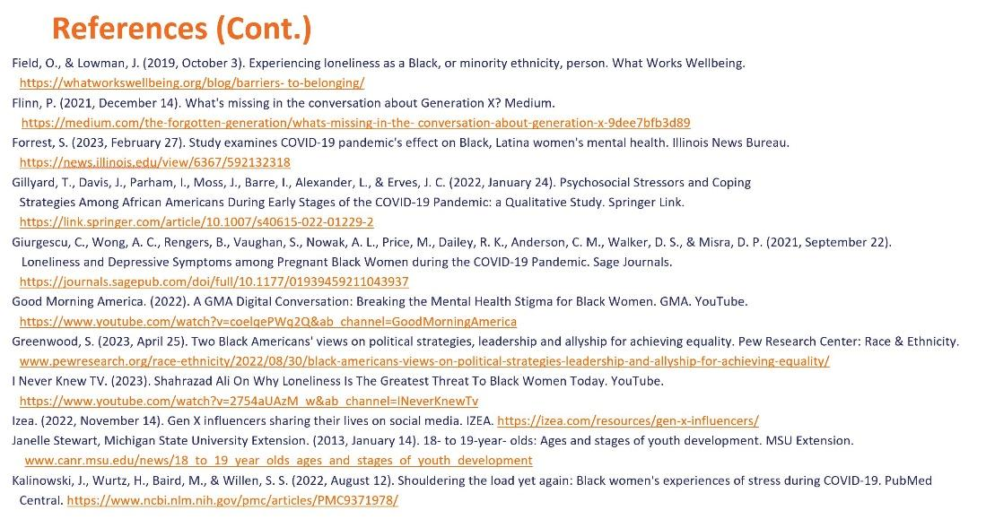

Slide 77: References (Continued)

Study 1: The Impact of Loneliness Post-Pandemic and Immersed in the Upcoming Political Election

Field, O., & Lowman, J. (2019, October 3). Experiencing loneliness as a Black, or minority ethnicity, person. What Works Wellbeing. https://whatworkswellbeing.org/blog/
barriers- to-belonging/

Flinn, P. (2021, December 14). What's missing in the conversation about Generation X? Medium. https://medium.com/the-forgotten-generation/whats-missing-in-the- conversation-about-generation-x-9dee7bfb3d89

Forrest, S. (2023, February 27). Study examines COVID-19 pandemic's effect on Black, Latina women's mental health. Illinois News Bureau. https://news.illinois.edu/view/6367/592132318

Gillyard, T., Davis, J., Parham, I., Moss, J., Barre, I., Alexander, L., & Erves, J. C. (2022, January 24). Psychosocial Stressors and Coping Strategies Among African Americans During Early Stages of the COVID-19 Pandemic: a Qualitative Study. Springer Link. https://link.springer.com/article/10.1007/s40615-022-01229-2

Giurgescu, C., Wong, A. C., Rengers, B., Vaughan, S., Nowak, A. L., Price, M., Dailey, R. K., Anderson, C. M., Walker, D. S., & Misra, D. P. (2021, September 22). Loneliness and Depressive Symptoms among Pregnant Black Women during the COVID-19 Pandemic. Sage Journals. https://journals.sagepub.com/doi/full/10.1177/01939459211043937

Good Morning America. (2022). A GMA Digital Conversation: Breaking the Mental Health Stigma for Black Women. GMA. YouTube. https://www.youtube.com/watch?v=coelqePWq2Q&ab_channel=GoodMorningAmerica

Greenwood, S. (2023, April 25). Two Black Americans' views on political strategies, leadership and allyship for achieving equality. Pew Research Center: Race & Ethnicity. www.pewresearch.org/race-ethnicity/2022/08/30/black-americans-views-on-political-strategies-leadership-and-allyship-for-achieving-equality/

I Never Knew TV. (2023). Shahrazad Ali On Why Loneliness Is The Greatest Threat To Black Women Today. YouTube. https://www.youtube.com/
watch?v=2754aUAzM_w&ab_channel=INeverKnewTv

Izea. (2022, November 14). Gen X influencers sharing their lives on social media. IZEA. https://izea.com/resources/gen-x-influencers/

Janelle Stewart, Michigan State University Extension. (2013, January 14). 18- to 19-year- olds: Ages and stages of youth development. MSU Extension. www.canr.msu.edu/news/
18_to_19_year_olds_ages_and_stages_of_youth_development

Kalinowski, J., Wurtz, H., Baird, M., & Willen, S. S. (2022, August 12). Shouldering the load yet again: Black women's experiences of stress during COVID-19. PubMed Central. https://www.ncbi.nlm.nih.gov/pmc/articles/PMC9371978/

Slide 78: References (Continued)

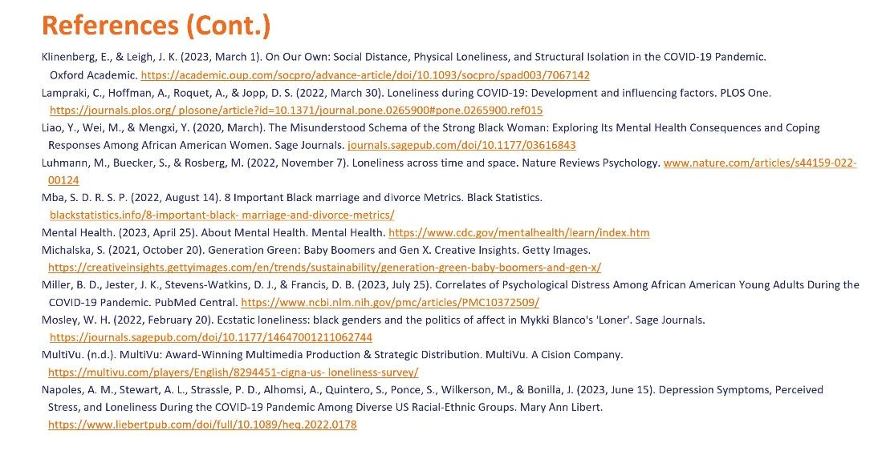

Slide 78: References (Continued)

Study 1: The Impact of Loneliness Post-Pandemic and Immersed in the Upcoming Political Election

Klinenberg, E., & Leigh, J. K. (2023, March 1). On Our Own: Social Distance, Physical Loneliness, and Structural Isolation in the COVID-19 Pandemic. Oxford Academic. https://academic.oup.com/socpro/advance-article/doi/10.1093/socpro/spad003/
7067142

Lampraki, C., Hoffman, A., Roquet, A., & Jopp, D. S. (2022, March 30). Loneliness during COVID-19: Development and influencing factors. PLOS One. https://journals.plos.org/ plosone/article?id=10.1371/journal.pone.0265900#pone.0265900.ref015

Liao, Y., Wei, M., & Mengxi, Y. (2020, March). The Misunderstood Schema of the Strong Black Woman: Exploring Its Mental Health Consequences and Coping Responses Among African American Women. Sage Journals. journals.sagepub.com/doi/10.1177/03616843

Luhmann, M., Buecker, S., & Rosberg, M. (2022, November 7). Loneliness across time and space. Nature Reviews Psychology. www.nature.com/articles/s44159-022-00124

Mba, S. D. R. S. P. (2022, August 14). 8 Important Black marriage and divorce Metrics. Black Statistics. blackstatistics.info/8-important-black- marriage-and-divorce-metrics/

Mental Health. (2023, April 25). About Mental Health. Mental Health. https://www.cdc.gov/mentalhealth/learn/index.htm

Michalska, S. (2021, October 20). Generation Green: Baby Boomers and Gen X. Creative Insights. Getty Images. https://creativeinsights.gettyimages.com/en/trends/
sustainability/generation-green-baby-boomers-and-gen-x/

Miller, B. D., Jester, J. K., Stevens-Watkins, D. J., & Francis, D. B. (2023, July 25). Correlates of Psychological Distress Among African American Young Adults During the COVID-19 Pandemic. PubMed Central. https://www.ncbi.nlm.nih.gov/pmc/articles/
PMC10372509/

Mosley, W. H. (2022, February 20). Ecstatic loneliness: black genders and the politics of affect in Mykki Blanco's 'Loner'. Sage Journals. https://journals.sagepub.com/doi/
10.1177/14647001211062744

MultiVu. (n.d.). MultiVu: Award-Winning Multimedia Production & Strategic Distribution. MultiVu. A Cision Company. https://multivu.com/players/English/8294451-cigna-us- loneliness-survey/

Napoles, A. M., Stewart, A. L., Strassle, P. D., Alhomsi, A., Quintero, S., Ponce, S., Wilkerson, M., & Bonilla, J. (2023, June 15). Depression Symptoms, Perceived Stress, and Loneliness During the COVID-19 Pandemic Among Diverse US Racial-Ethnic Groups. Mary Ann Libert. https://www.liebertpub.com/doi/full/10.1089/heq.2022.0178

Slide 79: References (Continued)

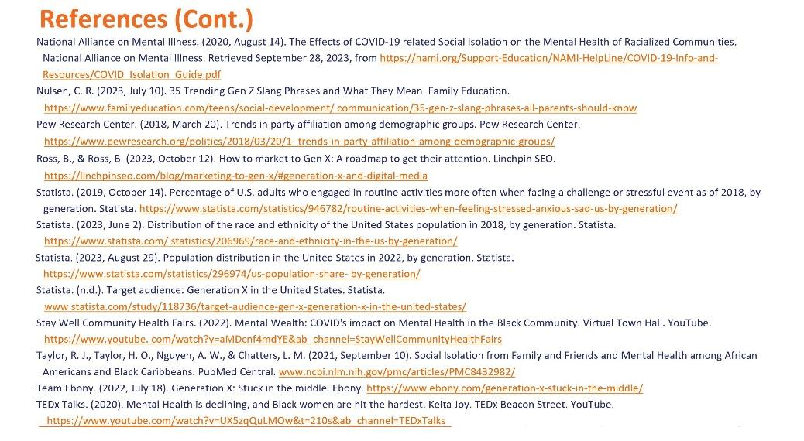

Slide 79: References (Continued)

Study 1: The Impact of Loneliness Post-Pandemic and Immersed in the Upcoming Political Election

National Alliance on Mental Illness. (2020, August 14). The Effects of COVID-19 related Social Isolation on the Mental Health of Racialized Communities. National Alliance on Mental Illness. Retrieved September 28, 2023, from https://nami.org/Support-Education
/NAMI-HelpLine/COVID-19-Info-and-Resources/COVID_Isolation_Guide.pdf

Nulsen, C. R. (2023, July 10). 35 Trending Gen Z Slang Phrases and What They Mean. Family Education. https://www.familyeducation.com/teens/social-development/ communication/35-gen-z-slang-phrases-all-parents-should-know

Pew Research Center. (2018, March 20). Trends in party affiliation among demographic groups. Pew Research Center. https://www.pewresearch.org/politics/2018/03/20/1- trends-in-party-affiliation-among-demographic-groups/

Ross, B., & Ross, B. (2023, October 12). How to market to Gen X: A roadmap to get their attention. Linchpin SEO. https://linchpinseo.com/blog/marketing-to-gen-x/
#generation-x-and-digital-media

Statista. (2019, October 14). Percentage of U.S. adults who engaged in routine activities more often when facing a challenge or stressful event as of 2018, by generation. Statista. https://www.statista.com/statistics/946782/routine-activities-when-feeling-stressed-anxious-sad-us-by-generation/

Statista. (2023, June 2). Distribution of the race and ethnicity of the United States population in 2018, by generation. Statista. https://www.statista.com/ statistics/206969/race-and-ethnicity-in-the-us-by-generation/

Statista. (2023, August 29). Population distribution in the United States in 2022, by generation. Statista. https://www.statista.com/statistics/296974/us-population-share- by-generation/

Statista. (n.d.). Target audience: Generation X in the United States. Statista. www statista.com/study/118736/target-audience-gen-x-generation-x-in-the-united-states/

Stay Well Community Health Fairs. (2022). Mental Wealth: COVID's impact on Mental Health in the Black Community. Virtual Town Hall. YouTube. https://www.youtube. com/watch?v=aMDcnf4mdYE&ab_channel=StayWellCommunityHealthFairs

Taylor, R. J., Taylor, H. O., Nguyen, A. W., & Chatters, L. M. (2021, September 10). Social Isolation from Family and Friends and Mental Health among African Americans and Black Caribbeans. PubMed Central. www.ncbi.nlm.nih.gov/pmc/articles/PMC8432982/

Team Ebony. (2022, July 18). Generation X: Stuck in the middle. Ebony. https://www.ebony.com/generation-x-stuck-in-the-middle/

TEDx Talks. (2020). Mental Health is declining, and Black women are hit the hardest. Keita Joy. TEDx Beacon Street. YouTube. https://www.youtube.com/
watch?v=UX5zqQuLMOw&t=210s&ab_channel=TEDxTalks

Slide 80: References (Continued)

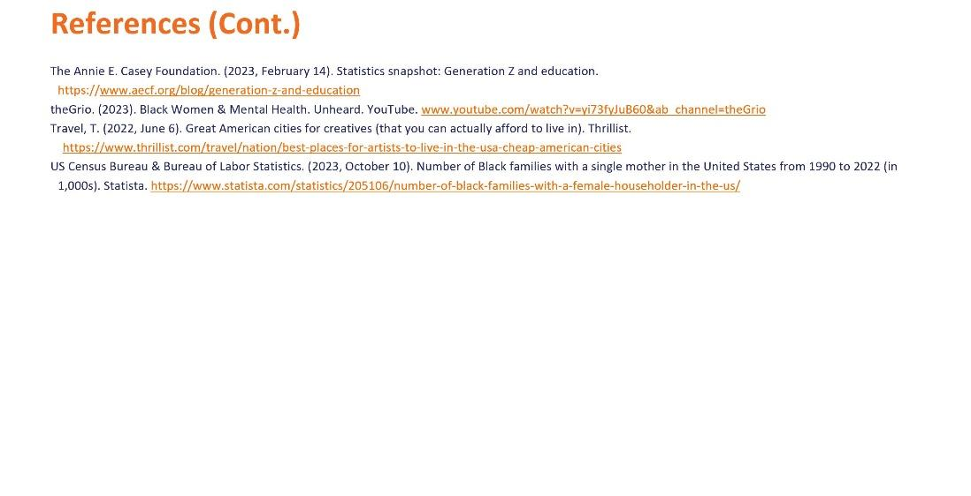

Slide 80: References (Continued)

Study 1: The Impact of Loneliness Post-Pandemic and Immersed in the Upcoming Political Election

The Annie E. Casey Foundation. (2023, February 14). Statistics snapshot: Generation Z and education. https://www.aecf.org/blog/generation-z-and-education

theGrio. (2023). Black Women & Mental Health. Unheard. YouTube. www.youtube.com/watch?v=yi73fyJuB60&ab_channel=theGrio

Travel, T. (2022, June 6). Great American cities for creatives (that you can actually afford to live in). Thrillist. https://www.thrillist.com/travel/nation/
best-places-for-artists-to-live-in-the-usa-cheap-american-cities

US Census Bureau & Bureau of Labor Statistics. (2023, October 10). Number of Black families with a single mother in the United States from 1990 to 2022 (in 1,000s). Statista. https://www.statista.com/statistics/205106/number-of-black-families-with-a-female-householder-in-the-us/

Slide 81: Sources

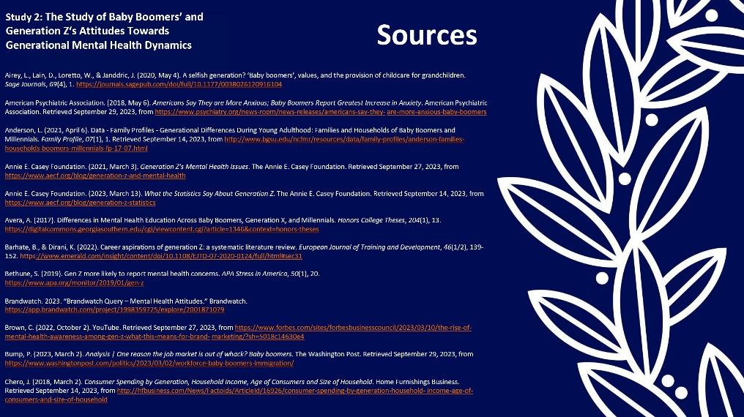

Slide 81: Sources

Study 2: The Study of Baby Boomers’ and Generation Z‘s Attitudes Towards Generational Mental Health Dynamics

Airey, L., Lain, D., Loretto, W., & Janddric, J. (2020, May 4). A selfish generation? ‘Baby boomers’, values, and the provision of childcare for grandchildren. Sage Journals, 69(4), 1. https://journals.sagepub.com/doi/full/10.1177/0038026120916104

American Psychiatric Association. (2018, May 6). Americans Say They are More Anxious; Baby Boomers Report Greatest Increase in Anxiety. American Psychiatric Association. Retrieved September 29, 2023, from https://www.psychiatry.org/news-room/
news-releases/americans-say-they- are-more-anxious-baby-boomers

Anderson, L. (2021, April 6). Data - Family Profiles - Generational Differences During Young Adulthood: Families and Households of Baby Boomers and Millennials. Family Profile, 07(1), 1. Retrieved September 14, 2023, from http://www.bgsu.edu/ncfmr/
resources/data/family-profiles/anderson-families-households-boomers-millennials-fp-17-07.html

Annie E. Casey Foundation. (2021, March 3). Generation Z's Mental Health Issues. The Annie E. Casey Foundation. Retrieved September 27, 2023, from https://www.aecf.org/
blog/generation-z-and-mental-health

Annie E. Casey Foundation. (2023, March 13). What the Statistics Say About Generation Z. The Annie E. Casey Foundation. Retrieved September 14, 2023, from https://www.aecf.org/blog/generation-z-statistics

Avera, A. (2017). Differences in Mental Health Education Across Baby Boomers, Generation X, and Millennials. Honors College Theses, 204(1), 13. https://digitalcommons.georgiasouthern.edu/cgi/viewcontent.cgi?article=1346&context=honors-theses

Barhate, B., & Dirani, K. (2022). Career aspirations of generation Z: a systematic literature review. European Journal of Training and Development, 46(1/2), 139-152. https://www.emerald.com/insight/content/doi/10.1108/EJTD-07-2020-0124/full/html#sec31

Bethune, S. (2019). Gen Z more likely to report mental health concerns. APA Stress in America, 50(1), 20. https://www.apa.org/monitor/2019/01/gen-z

Brandwatch. 2023. “Brandwatch Query – Mental Health Attitudes.” Brandwatch. https://app.brandwatch.com/project/1998359725/explore/2001871079

Brown, C. (2022, October 2). YouTube. Retrieved September 27, 2023, from https://www.forbes.com/sites/forbesbusinesscouncil/2023/03/10/the-rise-of-mental-health-awareness-among-gen-z-what-this-means-for-brand- marketing/?sh=5018c14630e4

Bump, P. (2023, March 2). Analysis | One reason the job market is out of whack? Baby boomers. The Washington Post. Retrieved September 29, 2023, from https://www.washingtonpost.com/politics/2023/03/02/workforce-baby-boomers-immigration/

Chero, J. (2018, March 2). Consumer Spending by Generation, Household Income, Age of Consumers and Size of Household. Home Furnishings Business. Retrieved September 14, 2023, from http://hfbusiness.com/News/Factoids/ArticleId/
16926/consumer-spending-by-generation-household-income-age-of-consumers-and-size-of-household

Slide 82: Sources (Continued)

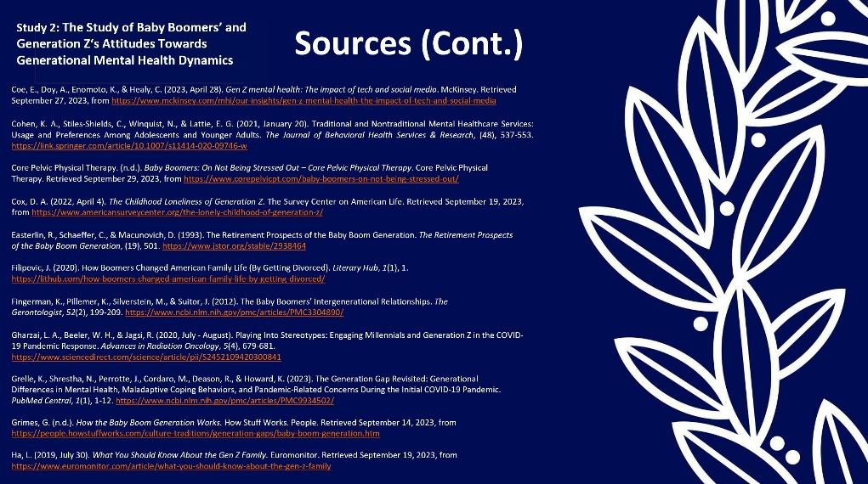

Slide 82: Sources (Continued)

Study 2: The Study of Baby Boomers’ and Generation Z‘s Attitudes Towards Generational Mental Health Dynamics

Coe, E., Doy, A., Enomoto, K., & Healy, C. (2023, April 28). Gen Z mental health: The impact of tech and social media. McKinsey. Retrieved September 27, 2023, from https://www.mckinsey.com/mhi/our-insights/gen-z-mental-health-the-impact-of-tech-and-social-media

Cohen, K. A., Stiles-Shields, C., Winquist, N., & Lattie, E. G. (2021, January 20). Traditional and Nontraditional Mental Healthcare Services: Usage and Preferences Among Adolescents and Younger Adults. The Journal of Behavioral Health Services & Research, (48), 537-553. https://link.springer.com/article/10.1007/s11414-020-09746-w

Core Pelvic Physical Therapy. (n.d.). Baby Boomers: On Not Being Stressed Out – Core Pelvic Physical Therapy. Core Pelvic Physical Therapy. Retrieved September 29, 2023, from https://www.corepelvicpt.com/baby-boomers-on-not-being-stressed-out/

Cox, D. A. (2022, April 4). The Childhood Loneliness of Generation Z. The Survey Center on American Life. Retrieved September 19, 2023, from https://www.americansurveycenter.org/the-lonely-childhood-of-generation-z/

Easterlin, R., Schaeffer, C., & Macunovich, D. (1993). The Retirement Prospects of the Baby Boom Generation. The Retirement Prospects of the Baby Boom Generation, (19), 501. https://www.jstor.org/stable/2938464

Filipovic, J. (2020). How Boomers Changed American Family Life (By Getting Divorced). Literary Hub, 1(1), 1. https://lithub.com/how-boomers-changed-american-family-life-by-getting-divorced/

Fingerman, K., Pillemer, K., Silverstein, M., & Suitor, J. (2012). The Baby Boomers’ Intergenerational Relationships. The Gerontologist, 52(2), 199-209. https://www.ncbi.nlm.nih.gov/pmc/articles/PMC3304890/

Gharzai, L. A., Beeler, W. H., & Jagsi, R. (2020, July - August). Playing Into Stereotypes: Engaging Millennials and Generation Z in the COVID-19 Pandemic Response. Advances in Radiation Oncology, 5(4), 679-681. https://www.sciencedirect.com/science/article/
pii/S2452109420300841

Grelle, K., Shrestha, N., Perrotte, J., Cordaro, M., Deason, R., & Howard, K. (2023). The Generation Gap Revisited: Generational Differences in Mental Health, Maladaptive Coping Behaviors, and Pandemic-Related Concerns During the Initial COVID-19 Pandemic. PubMed Central, 1(1), 1-12. https://www.ncbi.nlm.nih.gov/pmc/
articles/PMC9934502/

Grimes, G. (n.d.). How the Baby Boom Generation Works. How Stuff Works. People. Retrieved September 14, 2023, from https://people.howstuffworks.com/
culture-traditions/generation-gaps/baby-boom-generation.htm

Ha, L. (2019, July 30). What You Should Know About the Gen Z Family. Euromonitor. Retrieved September 19, 2023, from https://www.euromonitor.com/article/
what-you-should-know-about-the-gen-z-family

Slide 83: Sources (Continued)

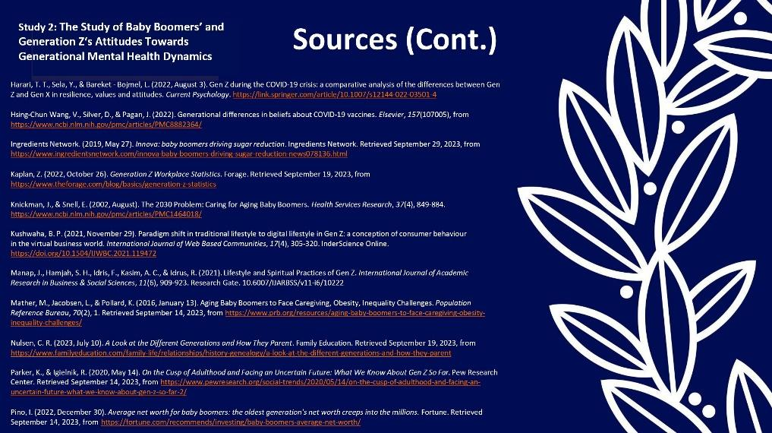

Slide 83: Sources (Continued)

Study 2: The Study of Baby Boomers’ and Generation Z‘s Attitudes Towards Generational Mental Health Dynamics

Harari, T. T., Sela, Y., & Bareket - Bojmel, L. (2022, August 3). Gen Z during the COVID-19 crisis: a comparative analysis of the differences between Gen Z and Gen X in resilience, values and attitudes. Current Psychology. https://link.springer.com/article/10.1007/
s12144-022-03501-4

Hsing-Chun Wang, V., Silver, D., & Pagan, J. (2022). Generational differences in beliefs about COVID-19 vaccines. Elsevier, 157(107005), from https://www.ncbi.nlm.nih.gov/
pmc/articles/PMC8882364/

Ingredients Network. (2019, May 27). Innova: baby boomers driving sugar reduction. Ingredients Network. Retrieved September 29, 2023, from https://www.ingredientsnetwork.com/innova-baby-boomers-driving-sugar-reduction-news078136.html

Kaplan, Z. (2022, October 26). Generation Z Workplace Statistics. Forage. Retrieved September 19, 2023, from https://www.theforage.com/blog/
basics/generation-z-statistics

Knickman, J., & Snell, E. (2002, August). The 2030 Problem: Caring for Aging Baby Boomers. Health Services Research, 37(4), 849-884. https://www.ncbi.nlm.nih.gov/
pmc/articles/PMC1464018/

Kushwaha, B. P. (2021, November 29). Paradigm shift in traditional lifestyle to digital lifestyle in Gen Z: a conception of consumer behaviour in the virtual business world. International Journal of Web Based Communities, 17(4), 305-320. InderScience Online. https://doi.org/10.1504/IJWBC.2021.119472

Manap, J., Hamjah, S. H., Idris, F., Kasim, A. C., & Idrus, R. (2021). Lifestyle and Spiritual Practices of Gen Z. International Journal of Academic Research in Business & Social Sciences, 11(6), 909-923. Research Gate. 10.6007/IJARBSS/v11-i6/10222

Mather, M., Jacobsen, L., & Pollard, K. (2016, January 13). Aging Baby Boomers to Face Caregiving, Obesity, Inequality Challenges. Population Reference Bureau, 70(2), 1. Retrieved September 14, 2023, from https://www.prb.org/resources/
aging-baby-boomers-to-face-caregiving-obesity-inequality-challenges/

Nulsen, C. R. (2023, July 10). A Look at the Different Generations and How They Parent. Family Education. Retrieved September 19, 2023, from https://www.familyeducation.com/family-life/relationships/history-genealogy/a-look-at-the-different-generations-and-how-they-parent

Parker, K., & Igielnik, R. (2020, May 14). On the Cusp of Adulthood and Facing an Uncertain Future: What We Know About Gen Z So Far. Pew Research Center. Retrieved September 14, 2023, from https://www.pewresearch.org/social-trends/
2020/05/14/on-the-cusp-of-adulthood-and-facing-an-uncertain-future-what-we-know-about-gen-z-so-far-2/

Pino, I. (2022, December 30). Average net worth for baby boomers: the oldest generation's net worth creeps into the millions. Fortune. Retrieved September 14, 2023, from https://fortune.com/recommends/investing/baby-boomers-average-net-worth/

Slide 84: Sources (Continued)

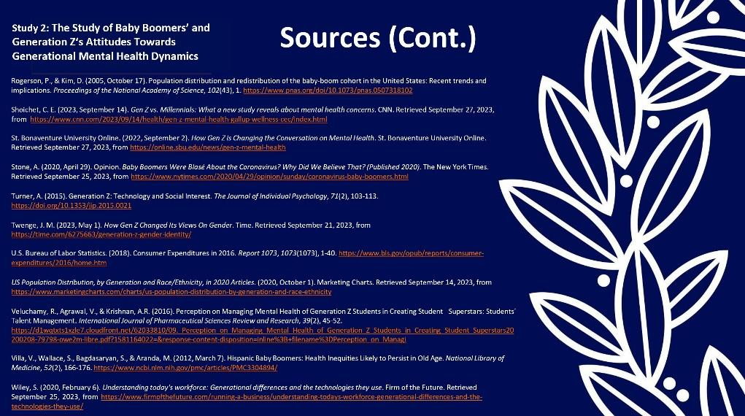

Slide 84: Sources (Continued)

Study 2: The Study of Baby Boomers’ and Generation Z‘s Attitudes Towards Generational Mental Health Dynamics

Rogerson, P., & Kim, D. (2005, October 17). Population distribution and redistribution of the baby-boom cohort in the United States: Recent trends and implications. Proceedings of the National Academy of Science, 102(43), 1. https://www.pnas.org/doi/10.1073/
pnas.0507318102

Shoichet, C. E. (2023, September 14). Gen Z vs. Millennials: What a new study reveals about mental health concerns. CNN. Retrieved September 27, 2023, from https://www.cnn.com/2023/09/14/health/gen-z-mental-health-gallup-wellness-cec/index.html

St. Bonaventure University Online. (2022, September 2). How Gen Z is Changing the Conversation on Mental Health. St. Bonaventure University Online. Retrieved September 27, 2023, from https://online.sbu.edu/news/gen-z-mental-health

Stone, A. (2020, April 29). Opinion. Baby Boomers Were Blasé About the Coronavirus? Why Did We Believe That? (Published 2020). The New York Times. Retrieved September 25, 2023, from https://www.nytimes.com/2020/04/29/opinion/sunday/
coronavirus-baby-boomers.html

Turner, A. (2015). Generation Z: Technology and Social Interest. The Journal of Individual Psychology, 71(2), 103-113. https://doi.org/10.1353/jip.2015.0021

Twenge, J. M. (2023, May 1). How Gen Z Changed Its Views On Gender. Time. Retrieved September 21, 2023, from https://time.com/6275663/generation-z-gender-identity/

U.S. Bureau of Labor Statistics. (2018). Consumer Expenditures in 2016. Report 1073, 1073(1073), 1-40. https://www.bls.gov/opub/reports/consumer-expenditures/2016/
home.htm

US Population Distribution, by Generation and Race/Ethnicity, in 2020 Articles. (2020, October 1). Marketing Charts. Retrieved September 14, 2023, from https://www.marketingcharts.com/charts/us-population-distribution-by-generation-and-race-ethnicity

Veluchamy, R., Agrawal, V., & Krishnan, A.R. (2016). Perception on Managing Mental Health of Generation Z Students in Creating Student Superstars: Students' Talent Management. International Journal of Pharmaceutical Sciences Review and Research, 39(2), 45-52. https://d1wqtxts1xzle7.cloudfront.net/62033810/09._Perception_on_
Managing_Mental_Health_of_Generation_Z_Students_in_Creating_Student_
Superstars20200208-79798-owe2m-libre.pdf?1581164022=&response-content-disposition=inline%3B+filename%3DPerception_on_Managi

Villa, V., Wallace, S., Bagdasaryan, S., & Aranda, M. (2012, March 7). Hispanic Baby Boomers: Health Inequities Likely to Persist in Old Age. National Library of Medicine, 52(2), 166-176. https://www.ncbi.nlm.nih.gov/pmc/articles/PMC3304894/

Wiley, S. (2020, February 6). Understanding today's workforce: Generational differences and the technologies they use. Firm of the Future. Retrieved September 25, 2023, from https://www.firmofthefuture.com/running-a-business/understanding-todays-workforce-generational-differences-and-the-technologies-they-use/

Slide 85: 30 Post Sources

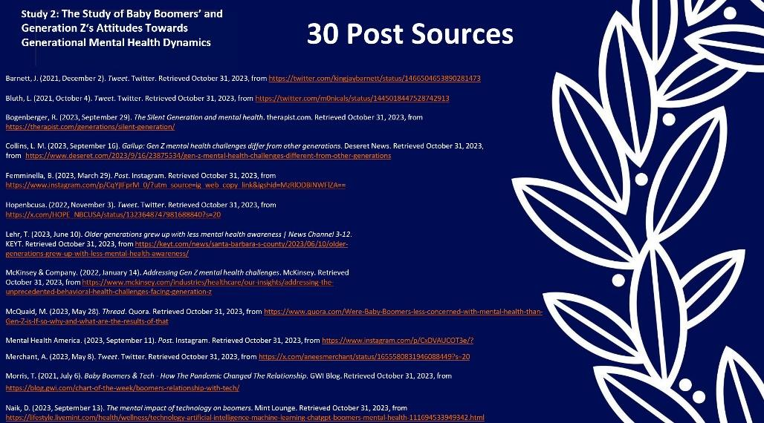

Slide 85: 30 Post Sources

Study 2: The Study of Baby Boomers’ and Generation Z‘s Attitudes Towards Generational Mental Health Dynamics

Barnett, J. (2021, December 2). Tweet. Twitter. Retrieved October 31, 2023, from https://twitter.com/kingjaybarnett/status/1466504653890281473

Bluth, L. (2021, October 4). Tweet. Twitter. Retrieved October 31, 2023, from https://twitter.com/m0nicals/status/1445018447528742913

Bogenberger, R. (2023, September 29). The Silent Generation and mental health. therapist.com. Retrieved October 31, 2023, from https://therapist.com/
generations/silent-generation/

Collins, L. M. (2023, September 16). Gallup: Gen Z mental health challenges differ from other generations. Deseret News. Retrieved October 31, 2023, from https://
www.deseret.com/2023/9/16/23875534/gen-z-mental-health-challenges-different-from-other-generations

Femminella, B. (2023, March 29). Post. Instagram. Retrieved October 31, 2023, from
https://www.instagram.com/p/CqYjIFprM_0/?utm_source=ig_web_copy_link&igshid=MzRlODBiNWFlZA==

Hopenbcusa. (2022, November 3). Tweet. Twitter. Retrieved October 31, 2023, from https://x.com/HOPE_NBCUSA/status/1323648747981688840?s=20

Lehr, T. (2023, June 10). Older generations grew up with less mental health awareness | News Channel 3-12. KEYT. Retrieved October 31, 2023, from https://keyt.com/news/
santa-barbara-s-county/2023/06/10/older-generations-grew-up-with-less-mental-health-awareness/

McKinsey & Company. (2022, January 14). Addressing Gen Z mental health challenges. McKinsey. Retrieved October 31, 2023, from https://www.mckinsey.com/industries/
healthcare/our-insights/addressing-the-unprecedented-behavioral-health-challenges-facing-generation-z

McQuaid, M. (2023, May 28). Thread. Quora. Retrieved October 31, 2023, from https://www.quora.com/Were-Baby-Boomers-less-concerned-with-mental-health-than-Gen-Z-is-If-so-why-and-what-are-the-results-of-that

Mental Health America. (2023, September 11). Post. Instagram. Retrieved October 31, 2023, from https://www.instagram.com/p/CxDVAUCOT3e/?

Merchant, A. (2023, May 8). Tweet. Twitter. Retrieved October 31, 2023, from https://x.com/aneesmerchant/status/1655580831946088449?s=20

Morris, T. (2021, July 6). Baby Boomers & Tech - How The Pandemic Changed The Relationship. GWI Blog. Retrieved October 31, 2023, from https://blog.gwi.com/
chart-of-the-week/boomers-relationship-with-tech/

Naik, D. (2023, September 13). The mental impact of technology on boomers. Mint Lounge. Retrieved October 31, 2023, from https://lifestyle.livemint.com/health/
wellness/technology-artificial-intelligence-machine-learning-chatgpt-boomers-mental-health-111694533949342.html

Slide 86: 30 Post Sources (Continued)

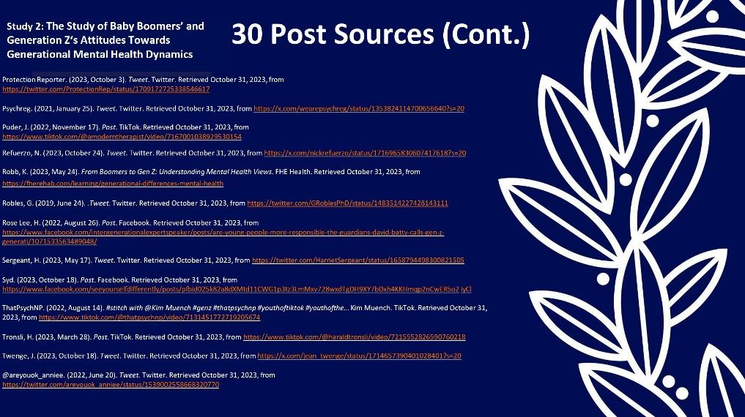

Slide 86: 30 Post Sources (Continued)

Study 2: The Study of Baby Boomers’ and Generation Z‘s Attitudes Towards Generational Mental Health Dynamics

Protection Reporter. (2023, October 3). Tweet. Twitter. Retrieved October 31, 2023, from https://twitter.com/ProtectionRep/status/1709172725338546617

Psychreg. (2021, January 25). Tweet. Twitter. Retrieved October 31, 2023, from https://x.com/wearepsychreg/status/1353824114700656640?s=20

Puder, J. (2022, November 17). Post. TikTok. Retrieved October 31, 2023, from https://www.tiktok.com/@amoderntherapist/video/7167001038929530154

Refuerzo, N. (2023, October 24). Tweet. Twitter. Retrieved October 31, 2023, from https://x.com/nickrefuerzo/status/1716965830607417618?s=20

Robb, K. (2023, May 24). From Boomers to Gen Z: Understanding Mental Health Views. FHE Health. Retrieved October 31, 2023, from https://fherehab.com/learning/
generational-differences-mental-health

Robles, G. (2019, June 24). .Tweet. Twitter. Retrieved October 31, 2023, from https://twitter.com/GRoblesPhD/status/1483514227428143111

Rose Lee, H. (2022, August 26). Post. Facebook. Retrieved October 31, 2023, from https://www.facebook.com/intergenerationalexpertspeaker/posts/are-young-people-more-responsible-the-guardians-david-batty-calls-gen-z- generati/1071533563489048/

Sergeant, H. (2023, May 17). Tweet. Twitter. Retrieved October 31, 2023, from https://twitter.com/HarrietSergeant/status/1658794498300821505

Syd. (2023, October 18). Post. Facebook. Retrieved October 31, 2023, from https://www.facebook.com/seeyourselfdifferently/posts/pfbid025k82a8dXMtd11CWG1p3tz3LmMxv728wxdTgDH9XY7bDxh4KKHmqp2nCwER5o2 iyCl

ThatPsychNP. (2022, August 14). #stitch with @Kim Muench #genz #thatpsychnp #youthoftiktok #youthofthe... Kim Muench. TikTok. Retrieved October 31, 2023, from https://www.tiktok.com/@thatpsychnp/video/7131451772719205674

Tronsli, H. (2023, March 28). Post. TikTok. Retrieved October 31, 2023, from https://www.tiktok.com/@haraldtronsli/video/7215552826590760218

Twenge, J. (2023, October 18). Tweet. Twitter. Retrieved October 31, 2023, from https://x.com/jean_twenge/status/1714657390401028401?s=20

@areyouok_anniee. (2022, June 20). Tweet. Twitter. Retrieved October 31, 2023, from https://twitter.com/areyouok_anniee/status/1539002558668320770

Slide 87: References

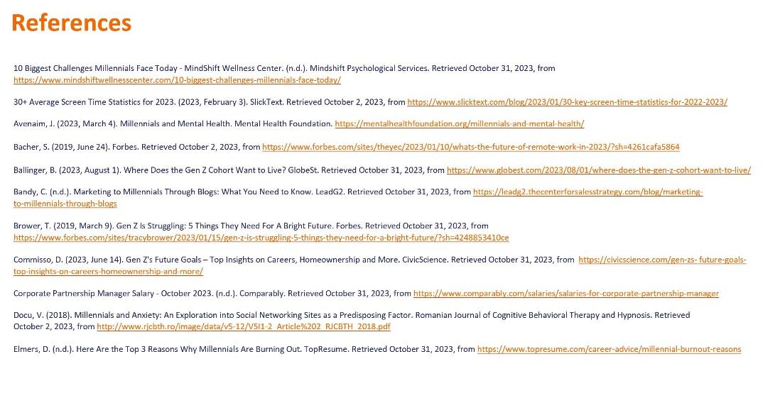

Slide 87: References

Study 3: Examining Connectivity and Mental Health Amongst Generation Z and Millennials

10 Biggest Challenges Millennials Face Today - MindShift Wellness Center. (n.d.). Mindshift Psychological Services. Retrieved October 31, 2023, from https://
www.mindshiftwellnesscenter.com/10-biggest-challenges-millennials-face-today/

30+ Average Screen Time Statistics for 2023. (2023, February 3). SlickText. Retrieved October 2, 2023, from https://www.slicktext.com/blog/2023/01/
30-key-screen-time-statistics-for-2022-2023/

Avenaim, J. (2023, March 4). Millennials and Mental Health. Mental Health Foundation. https://mentalhealthfoundation.org/millennials-and-mental-health/

Bacher, S. (2019, June 24). Forbes. Retrieved October 2, 2023, from https://www.forbes.com/sites/theyec/2023/01/10/whats-the-future-of-remote-work-in-2023/?sh=4261cafa5864

Ballinger, B. (2023, August 1). Where Does the Gen Z Cohort Want to Live? GlobeSt. Retrieved October 31, 2023, from https://www.globest.com/2023/08/01/
where-does-the-gen-z-cohort-want-to-live/

Bandy, C. (n.d.). Marketing to Millennials Through Blogs: What You Need to Know. LeadG2. Retrieved October 31, 2023, from https://leadg2.thecenterforsalesstrategy.com
/blog/marketing-to-millennials-through-blogs

Brower, T. (2019, March 9). Gen Z Is Struggling: 5 Things They Need For A Bright Future. Forbes. Retrieved October 31, 2023, from https://www.forbes.com/sites/
tracybrower/2023/01/15/gen-z-is-struggling-5-things-they-need-for-a-bright-future/
?sh=4248853410ce

Commisso, D. (2023, June 14). Gen Z's Future Goals – Top Insights on Careers, Homeownership and More. CivicScience. Retrieved October 31, 2023, from https://civicscience.com/gen-zs-future-goals-top-insights-on-careers-homeownership-and-more/

Corporate Partnership Manager Salary - October 2023. (n.d.). Comparably. Retrieved October 31, 2023, from https://www.comparably.com/salaries/salaries-for-
corporate-partnership-manager

Docu, V. (2018). Millennials and Anxiety: An Exploration into Social Networking Sites as a Predisposing Factor. Romanian Journal of Cognitive Behavioral Therapy and Hypnosis. Retrieved October 2, 2023, from http://www.rjcbth.ro/image/data/v5-12/
V5I1-2_Article%202_RJCBTH_2018.pdf

Elmers, D. (n.d.). Here Are the Top 3 Reasons Why Millennials Are Burning Out. TopResume. Retrieved October 31, 2023, from https://www.topresume.com/
career-advice/millennial-burnout-reasons

Slide 88: References (Continued)

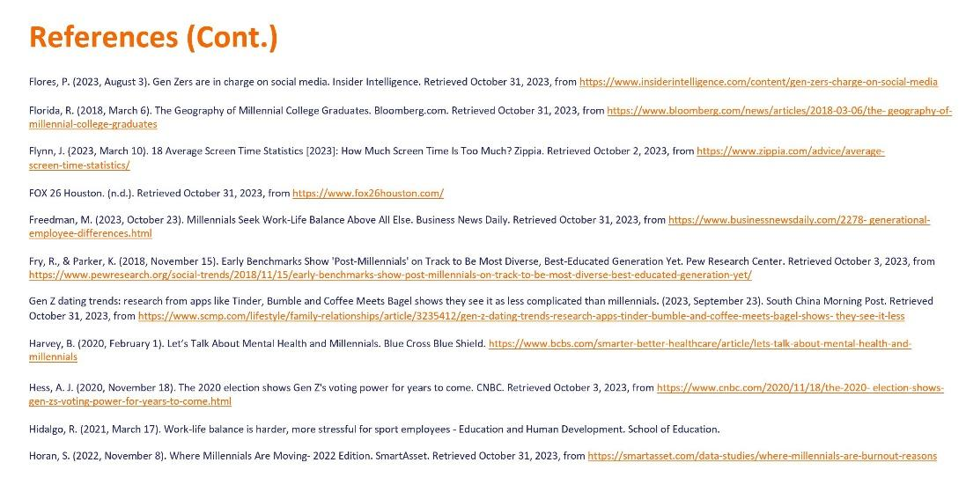

Slide 88: References (Continued)

Study 3: Examining Connectivity and Mental Health Amongst Generation Z and Millennials

Flores, P. (2023, August 3). Gen Zers are in charge on social media. Insider Intelligence. Retrieved October 31, 2023, from https://www.insiderintelligence.com/
content/gen-zers-charge-on-social-media

Florida, R. (2018, March 6). The Geography of Millennial College Graduates. Bloomberg.com. Retrieved October 31, 2023, from https://www.bloomberg.com/
news/articles/2018-03-06/the- geography-of-millennial-college-graduates

Flynn, J. (2023, March 10). 18 Average Screen Time Statistics [2023]: How Much Screen Time Is Too Much? Zippia. Retrieved October 2, 2023, from https://www.zippia.com/
advice/average-screen-time-statistics/

FOX 26 Houston. (n.d.). Retrieved October 31, 2023, from https://
www.fox26houston.com/

Freedman, M. (2023, October 23). Millennials Seek Work-Life Balance Above All Else. Business News Daily. Retrieved October 31, 2023, from https://www.businessnewsdaily.com/2278- generational-employee-differences.html

Fry, R., & Parker, K. (2018, November 15). Early Benchmarks Show 'Post-Millennials' on Track to Be Most Diverse, Best-Educated Generation Yet. Pew Research Center. Retrieved October 3, 2023, from https://www.pewresearch.org/social-trends/2018/11/15/early-benchmarks-show-post-millennials-on-track-to-be-most-diverse-best-educated-generation-yet/

Gen Z dating trends: research from apps like Tinder, Bumble and Coffee Meets Bagel shows they see it as less complicated than millennials. (2023, September 23). South China Morning Post. Retrieved October 31, 2023, from https://www.scmp.com/
lifestyle/family-relationships/article/3235412/gen-z-dating-trends-research-apps-tinder-bumble-and-coffee-meets-bagel-shows- they-see-it-less

Harvey, B. (2020, February 1). Let’s Talk About Mental Health and Millennials. Blue Cross Blue Shield. https://www.bcbs.com/smarter-better-healthcare/article/lets-talk-
about-mental-health-and-millennials

Hess, A. J. (2020, November 18). The 2020 election shows Gen Z's voting power for years to come. CNBC. Retrieved October 3, 2023, from https://www.cnbc.com/2020/11/18/
the-2020- election-shows-gen-zs-voting-power-for-years-to-come.html

Hidalgo, R. (2021, March 17). Work-life balance is harder, more stressful for sport employees - Education and Human Development. School of Education.

Horan, S. (2022, November 8). Where Millennials Are Moving- 2022 Edition. SmartAsset. Retrieved October 31, 2023, from https://smartasset.com/data-studies/
where-millennials-are-burnout-reasons

Slide 89: References (Continued)

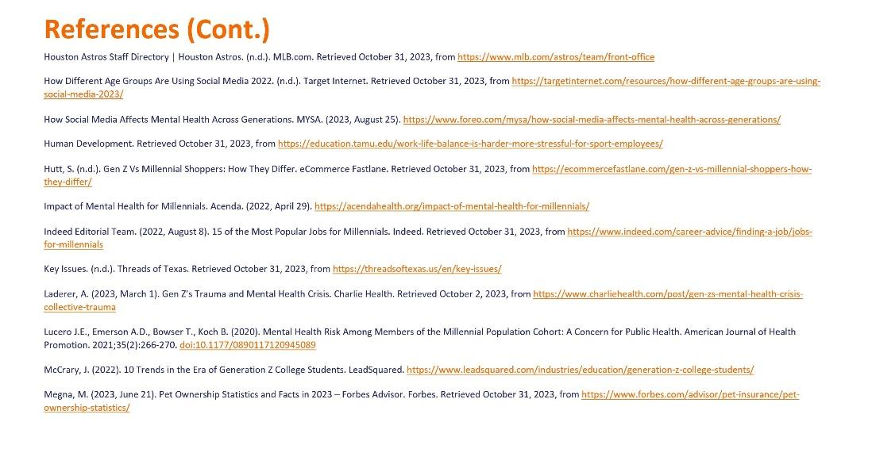

Slide 89: References (Continued)

Study 3: Examining Connectivity and Mental Health Amongst Generation Z and Millennials

Houston Astros Staff Directory | Houston Astros. (n.d.). MLB.com. Retrieved October 31, 2023, from https://www.mlb.com/astros/team/front-office

How Different Age Groups Are Using Social Media 2022. (n.d.). Target Internet. Retrieved October 31, 2023, from https://targetinternet.com/resources/
how-different-age-groups-are-using-social-media-2023/

How Social Media Affects Mental Health Across Generations. MYSA. (2023, August 25). https://www.foreo.com/mysa/how-social-media-affects-mental-health-across-generations/

Human Development. Retrieved October 31, 2023, from https://education.tamu.edu/work-life-balance-is-harder-more-stressful-for-sport-employees/

Hutt, S. (n.d.). Gen Z Vs Millennial Shoppers: How They Differ. eCommerce Fastlane. Retrieved October 31, 2023, from https://ecommercefastlane.com/
gen-z-vs-millennial-shoppers-how-they-differ/

Impact of Mental Health for Millennials. Acenda. (2022, April 29). https://acendahealth.org/impact-of-mental-health-for-millennials/

Indeed Editorial Team. (2022, August 8). 15 of the Most Popular Jobs for Millennials. Indeed. Retrieved October 31, 2023, from https://www.indeed.com/career-advice/
finding-a-job/jobs-for-millennials

Key Issues. (n.d.). Threads of Texas. Retrieved October 31, 2023, from https://threadsoftexas.us/en/key-issues/

Laderer, A. (2023, March 1). Gen Z’s Trauma and Mental Health Crisis. Charlie Health. Retrieved October 2, 2023, from https://www.charliehealth.com/post/
gen-zs-mental-health-crisis-collective-trauma

Lucero J.E., Emerson A.D., Bowser T., Koch B. (2020). Mental Health Risk Among Members of the Millennial Population Cohort: A Concern for Public Health. American Journal of Health Promotion. 2021; 35(2): 266-270. doi: 10.1177/0890117120945089

McCrary, J. (2022). 10 Trends in the Era of Generation Z College Students. LeadSquared. https://www.leadsquared.com/industries/education/generation-z-college-students/

Megna, M. (2023, June 21). Pet Ownership Statistics and Facts in 2023 – Forbes Advisor. Forbes. Retrieved October 31, 2023, from https://www.forbes.com/advisor/
pet-insurance/pet- ownership-statistics/

Slide 90: References (Continued)

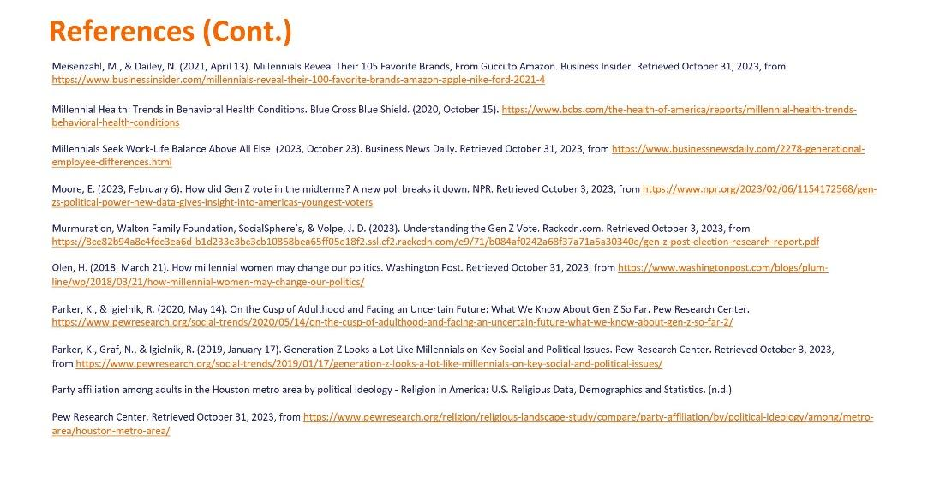

Slide 90: References (Continued)

Study 3: Examining Connectivity and Mental Health Amongst Generation Z and Millennials

Meisenzahl, M., & Dailey, N. (2021, April 13). Millennials Reveal Their 105 Favorite Brands, From Gucci to Amazon. Business Insider. Retrieved October 31, 2023, from https://www.businessinsider.com/millennials-reveal-their-100-favorite-brands-amazon-apple-nike-ford-2021-4

Millennial Health: Trends in Behavioral Health Conditions. Blue Cross Blue Shield. (2020, October 15). https://www.bcbs.com/the-health-of-america/reports/
millennial-health-trends-behavioral-health-conditions

Millennials Seek Work-Life Balance Above All Else. (2023, October 23). Business News Daily. Retrieved October 31, 2023, from https://www.businessnewsdaily.com/2278-generational-employee-differences.html

Moore, E. (2023, February 6). How did Gen Z vote in the midterms? A new poll breaks it down. NPR. Retrieved October 3, 2023, from https://www.npr.org/2023/02/06/
1154172568/gen-zs-political-power-new-data-gives-insight-into-americas-youngest-voters

Murmuration, Walton Family Foundation, SocialSphere’s, & Volpe, J. D. (2023). Understanding the Gen Z Vote. Rackcdn.com. Retrieved October 3, 2023, from https://8ce82b94a8c4fdc3ea6d-b1d233e3bc3cb10858bea65ff05e18f2.ssl.cf2.
rackcdn.com/e9/71/b084af0242a68f37a71a5a30340e/gen-z-post-election-research-report.pdf

Olen, H. (2018, March 21). How millennial women may change our politics. Washington Post. Retrieved October 31, 2023, from https://www.washingtonpost.com/blogs/plum-
line/wp/2018/03/21/how-millennial-women-may-change-our-politics/

Parker, K., & Igielnik, R. (2020, May 14). On the Cusp of Adulthood and Facing an Uncertain Future: What We Know About Gen Z So Far. Pew Research Center. https://www.pewresearch.org/social-trends/2020/05/14/on-the-cusp-of-adulthood-and-facing-an-uncertain-future-what-we-know-about-gen-z-so-far-2/

Parker, K., Graf, N., & Igielnik, R. (2019, January 17). Generation Z Looks a Lot Like Millennials on Key Social and Political Issues. Pew Research Center. Retrieved October 3, 2023, from https://www.pewresearch.org/social-trends/2019/01/17/generation-z-looks-a-lot-like-millennials-on-key-social-and-political-issues/

Party affiliation among adults in the Houston metro area by political ideology - Religion in America: U.S. Religious Data, Demographics and Statistics. (n.d.).

Pew Research Center. Retrieved October 31, 2023, from https://www.pewresearch.org/religion/religious-landscape-study/compare/party-affiliation/by/political-ideology/among/metro-area/houston-metro-area/

Slide 91: References (Continued)

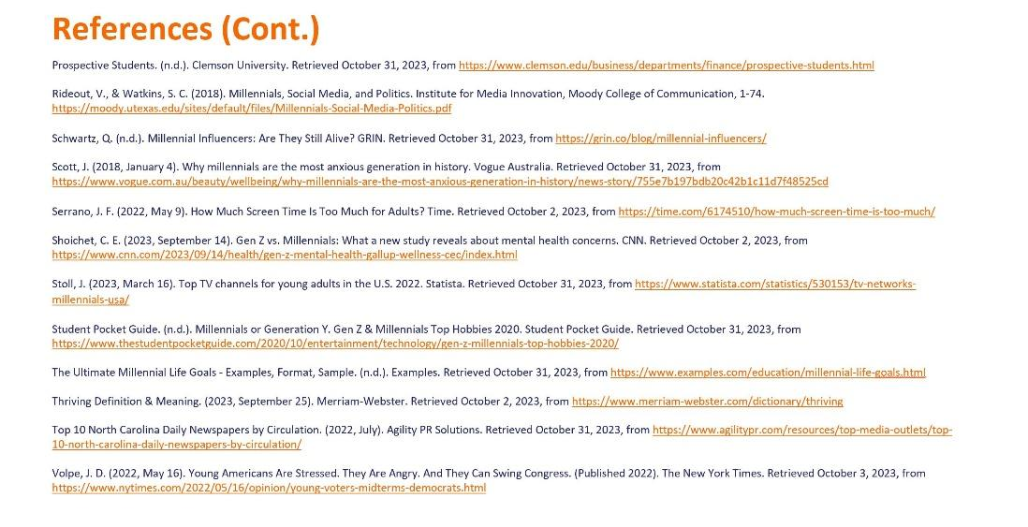

Slide 91: References (Continued)

Study 3: Examining Connectivity and Mental Health Amongst Generation Z and Millennials

Prospective Students. (n.d.). Clemson University. Retrieved October 31, 2023, from https://www.clemson.edu/business/departments/finance/prospective-students.html

Rideout, V., & Watkins, S. C. (2018). Millennials, Social Media, and Politics. Institute for Media Innovation, Moody College of Communication, 1-74. https://moody.utexas.edu/sites/default/files/Millennials-Social-Media-Politics.pdf

Schwartz, Q. (n.d.). Millennial Influencers: Are They Still Alive? GRIN. Retrieved October 31, 2023, from https://grin.co/blog/millennial-influencers/

Scott, J. (2018, January 4). Why millennials are the most anxious generation in history. Vogue Australia. Retrieved October 31, 2023, from https://www.vogue.com.au/beauty/
wellbeing/why-millennials-are-the-most-anxious-generation-in-history/news-story/755e7b197bdb20c42b1c11d7f48525cd

Serrano, J. F. (2022, May 9). How Much Screen Time Is Too Much for Adults? Time. Retrieved October 2, 2023, from https://time.com/6174510/
how-much-screen-time-is-too-much/

Shoichet, C. E. (2023, September 14). Gen Z vs. Millennials: What a new study reveals about mental health concerns. CNN. Retrieved October 2, 2023, from https://www.cnn.com/2023/09/14/health/gen-z-mental-health-gallup-wellness-cec/index.html

Stoll, J. (2023, March 16). Top TV channels for young adults in the U.S. 2022. Statista. Retrieved October 31, 2023, from https://www.statista.com/statistics/530153/
tv-networks-millennials-usa/

Student Pocket Guide. (n.d.). Millennials or Generation Y. Gen Z & Millennials Top Hobbies 2020. Student Pocket Guide. Retrieved October 31, 2023, from https://www.thestudentpocketguide.com/2020/10/entertainment/technology/gen-z-millennials-top-hobbies-2020/

The Ultimate Millennial Life Goals - Examples, Format, Sample. (n.d.). Examples. Retrieved October 31, 2023, from https://www.examples.com/education/
millennial-life-goals.html

Thriving Definition & Meaning. (2023, September 25). Merriam-Webster. Retrieved October 2, 2023, from https://www.merriam-webster.com/dictionary/thriving

Top 10 North Carolina Daily Newspapers by Circulation. (2022, July). Agility PR Solutions. Retrieved October 31, 2023, from https://www.agilitypr.com/resources/
top-media-outlets/top-10-north-carolina-daily-newspapers-by-circulation/

Volpe, J. D. (2022, May 16). Young Americans Are Stressed. They Are Angry. And They Can Swing Congress. (Published 2022). The New York Times. Retrieved October 3, 2023, from https://www.nytimes.com/2022/05/16/opinion/young-voters-midterms-
democrats.html

